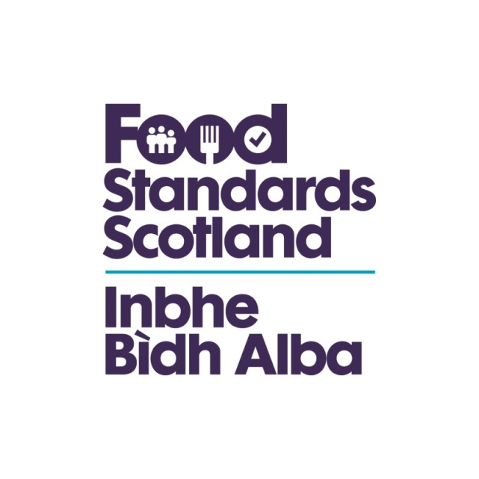
LA name & OCD Number
Food Standards Scotland
Local Authority Food Law Enforcement Services
Capacity and Capability Audit
Regulation (EU) 2017/625 Checklist – Article 12

Regulation (EU) 2017/625
Article 12
Documented control procedures
1. Competent authorities shall perform official controls in accordance with documented procedures.
Those procedures shall cover the subject areas for control procedures set out in Chapter II of Annex II and shall contain instructions for staff performing official controls.
2. Competent authorities shall have control verification procedures in place.
3. Competent authorities shall:
(a) take corrective actions in all cases where the procedures provided for in paragraph 2 identify shortcomings; and
(b) update the documented procedures provided for in paragraph 1 as appropriate.
4. Paragraphs 1, 2 and 3 shall also apply to delegated bodies and organic control authorities.
Question | Answer |  |  | Comments/Evidence | Auditor’s Notes
Does the Authority have documented procedures for:  - the objectives to be achieved  - tasks, responsibilities and duties of staff  - sampling procedures, interpretation of results and consequent decisions  - monitoring and surveillance  - action to be taken following Official controls  - verification of sampling methods  - verification of methods of analysis  - verification of detection tests | Yes/No |  |  | Document review | The Service Plan may be useful for some of these, operational documents should be available for how to do the tasks.  (Compliance) Notices, seizures, Approvals  Sampling is an area that demonstrates the C&C of a LA well
Is there a document control system for the LA’s policies and procedures? | Yes/No
Question | Answer |  |  | Comments/Evidence | Auditor’s Notes
How are reviews of documented policies and procedures :  - programmed  - achieved  - verified  - reported on  - acted on  - monitored / reviewed |  |  |  |  | There should be evidence of a regular review (programmed) of policies and procedures. Auditors should check re-issue dates.
How are ad-hoc changes made to documented policies and procedures in response to:  - new legislation?  - non-conformances highlighted during any monitoring/internal audit? |  |  |  |  | Auditors should check for recent changes, to check timeliness, and that changes are covered  by correct authorisation.
Are up to date copies of appropriate documentation including legislation and guidance available:  - at all relevant locations  - to all relevant staff  - suitably referenced | Yes/No |  |  |  | Appropriate documentation may be in an electronic format/accessible from websites – auditors should check officer access.
Question | Answer |  |  | Comments/Evidence | Auditor’s Notes
Are there any out of date documents:  - in use  - in circulation  - un-suitably stored away | Yes/No |  |  |  | Checks should be made to ensure officers are not working from uncontrolled and therefore out of date procedures/documents or legislation.
Questions on Monitoring
Does it cover monitoring of: | Monitoring of the different areas may be undertaken at differing frequencies. The aim of monitoring is to ensure compliance with official guidance, the Authority’s procedures, and for consistency of enforcement between officers. The auditor may consider making use of any third party report in assessing conformance.
Who is responsible for carrying out the monitoring? | Name(s):
Are there nominated deputies? | Yes/No |  | Name(s): |  | If not, auditors should check the arrangements for monitoring in the absence of the person responsible.
How often is it done
- state periods
- show evidence of it
- any follow up done
Officer authorisations, in line with their individual competencies/ qualifications/ training/ experience? | Yes/No | Detail: |  |  | Include details of any competency matrices used for this purpose.
Question | Answer | Comments/Evidence |  |  | Auditor’s Notes
Monitoring Compliance with:  - Food Law Code of Practice  - Interventions Code of Practice  - Revised Guidance on 853  - Internal policies/procedures?  - Other Centrally issued guidance | Yes/No  Yes/No  Yes/no  Yes/No  Yes/No |  |  |  | NB: compliance with local policies and procedures will ensure compliance with official guidance where these have been developed to reflect the national standards.
Monitoring Compliance with Inspections  - adherence to the planned inspection programme;  - priority given to inspecting businesses according to inspection ratings, compliance with Food Safety CP and FSS guidance;  - consistent assessment of inspection ratings;  - compliance with relevant inspection forms;  - compliance with internal procedures and policies;  - interpretation and follow-up action is consistent within that Authority with centrally issued guidance;  - that officers are aware of and have access to published industry codes and other centrally issued guidance;  - that in relation to food hygiene inspections: priority is given to inspecting businesses subject to Regulation (EC) 853/2004 and that officers have due regard to published UK and EU Guides to Good Practice (CP – 28.2). | Yes/No |  |  |  | Should follow FSS Monitoring Guidance  - Database management  - Scheduled and Ad Hoc checks  - All FBE’s to be included  - Risk based programme  - LA documents used effectively  - Records adequate  - Competent officer for that FBE  - 853 forms used properly  - Conditional Approvals followed  - Letters sent and are factually ok  - Non-compliance followed through  - Actions are timely  - Local Enforcement policy followed  - Deviations recorded with reasons  - Notices followed up  - Reports on quality & quantity  - Identified problems addressed  - Complaints recorded and actioned  - Service planning is reactive  - Any validation  - Any verification
- MONITORING of these:
- Alternative Enforcement Strategies? | Yes/No
- Complaints? | Yes/No
- Food sampling? | Yes/No
- Enforcement actions? | Yes/No |  |  |  | .
- Outbreaks? | Yes/No
- Food alerts? | Yes/No
- FHIS | Yes/No
- Quantitative aspects of the Service? | Yes/No |  |  |  | Examples of quantitative monitoring may include:  - No. inspections against the programme;  - No. samples against the programme;  - No. complaints/service requests outstanding;  - Response times against PIs e.g. response to service requests/issue of inspection reports.
- Monitoring of the database for data integrity and accuracy of data entry? (Including timeliness of data entries and proper use of codes). | Yes/No
- Qualitative aspects of the service? | Yes/No |  |  |  | Examples of qualitative monitoring may include:  - Consistency exercises;  - Team meetings to discuss interpretational issues;  - File audits;  - Review of paperwork;  - Prior approval of formal enforcement actions;  - Shadow/verification visits;  - Review of complaints about the Service;  - Customer satisfaction questionnaires;  - Business focus groups.
Has the procedure been implemented? | Yes/No |  |  |  | Auditors should check team meeting minutes and records of qualitative monitoring activity. Quantitative monitoring is likely to form part of regular management meeting, minutes, reports to Members and reviews against the service plan.
What examples of internal monitoring are evident and at what frequency have they been carried out?
Are records of internal monitoring maintained? | Yes/No
Where necessary have corrective actions been identified and implemented? | Yes/No |  |  |  | There should be evidence of corrective action where non-conformity is found. Continuing identification of the same problem could indicate that corrective action had not been effective.
How quickly have these been addressed? |  |  |  |  | e.g. training; revised procedures; discussion at Team Meetings etc.
Assessment of whether to take food samples | Yes/No |  |  |  | An assessment of whether to take samples, and if so what sample, should be an integral part of every primary inspection, but particularly in food manufacturing,  packing and catering businesses. [IC – 4.1.7]

