

Incident Management Framework

Version 4.1
Oct 2026
Version Control
The Resilience Manager within the Scottish Food Crime and Incidents Unit (SFCIU) at Food Standards Scotland (FSS) is responsible for maintaining this Incident Management Framework (IMF) which will be reviewed on an annual basis. Any queries/feedback relating to this document should be emailed to: resilience@fss.scot
Version | Date | Last review carried out | Next review due | Comments
1.0 | August 2018 | N/A | August 2019 | First Version
2.0 | August 2022 | August 2018 | August 2023 | Lessons learned from COVID-19 response
3.0 | February 2024 | August 2022 | August 2024 | Update to FSS contact details: remove Incidents Team landline no. & update Comms Team no.
4.0 | April 2025 | March 2025 | Jan 2026 | Full review to incorporate org restructure and incident lessons learned
4.1 | Oct 2026 | March 2025 | Nov 2026 | Minor amend: update to Foreword to reflect CEO change
Contact Details
Food Standards Scotland (FSS)
FSS operates a 24-hour response to food/feed incidents.
The Incidents Team can be contacted by:
Tel: 07881 516 867.
E-mail: incidents@fss.scot

The Communications Team can be contacted by Tel: 07818 809 629.
Food Standards Agency (England) (24-hour response)Tel: 020 7276 8448
E-mail: foodincidents@food.gov.uk
Out-of-hours calls for the declaration of an offsite nuclear emergency only should be made by telephone on Tel: 020 7276 8668.
FSA Wales (Consumer Protection Team)
Tel: 029 2067 8899 (out-of-hours Tel: 07789 926 573)
E-mail: wales.foodincidents@food.gov.uk
FSA Northern Ireland (Consumer Protection Team)
Tel: 0330 332 7149 option 4
E-mail: incidents.ni@food.gov.uk

Foreword
As outlined in the Food Standards Scotland (FSS)’s Strategy for 2021 – 2026, our mission is to be Scotland’s leading authority on food safety, standards and healthy eating; using data and evidence to provide assurance and advice that inspires consumer confidence and improves public health.

Our statutory objectives are defined in the Food (Scotland) Act 2015 and as Chief Executive of Food Standards Scotland, it is my responsibility to ensure that FSS acts to protect the public from risks to health which may arise in connection with the consumption of food. Therefore, it is vital that FSS responds in a collaborative and timely manner during food or feed incidents which may have an impact on consumers. It is our role to work closely with Local Authorities, Public Health Scotland and other health professionals, Scottish Government, Industry, Retailers and Trade Associations to minimise quickly the risk to consumers in the event of a food incident.

However, the food supply chain is a global one and FSS works closely with colleagues at the Food Standards Agency to manage incidents across the UK and internationally. A Memorandum of Understanding is in place between FSS and the Food Standards Agency to ensure liaison arrangements continue to deliver a coordinated incident handling response based on aligned principles.

Investigating and managing incidents to ensure that consumers are protected has been, and will continue to be, a crucial aspect of all our work. Protection of public health will always be a top priority and maintaining confidence in the food supply system is integral to that. We accept that meeting those objectives can cause tension with businesses involved in incidents. While we are committed to working and supporting businesses involved in incidents our approach is, and always will be, determined by levels of uncertainty: the more uncertainty there is, the more precautionary we are likely to be to protect public health. However, businesses should be assured that our response will also be proportionate and determined by the evidence we have.

This FSS Incident Management Framework (IMF) has been developed in recognition of the size and structure of our organisation and will be reviewed regularly to ensure the document continues to be fit for purpose.


Catherine Topley
Chief Executive
Food Standards Scotland

Table of Contents
Foreword 4
Abbreviations 8
1. Introduction 10
1.1 Purpose 10
1.2 Scope of response 11
1.3 Governance 12
1.3.1 Accountability 12
1.3.2 Ownership 12
1.3.3 Responsibility 12
1.3.4 Delivery 12
1.4 Definitions 13
1.5 Objectives 13
1.6 Guiding principles 14
2. Structure, roles and responsibilities 16
2.1 Response structure 16
2.2 Team descriptions 16
2.3 Incident Assessment Team (IAT) 18
2.3.1 Membership of the IAT 18
2.4 Operational Incident Team (OIT) 19
2.4.1 Membership of the OIT 20
2.4.2 OIT Members Roles and Responsibilities 21
2.5 Strategic Incident Team (SIT) 24
2.5.1 Membership of the SIT 24
2.5.2 SIT Members Roles and Responsibilities 25
2.6 Support team roles 27
2.7 Division and branch involvement 28
3. Escalation and mobilisation 31
3.1 Notification 31
3.2 Incident classification 31
3.3 Declaring an incident 32
3.4 Escalation 32
4. Risk Analysis 34
4.1 Risk Analysis Process 34
4.2 Scientific Risk Assessment 34
4.3 Risk Management 35
4.4 Risk Communication 36
5 Mode of operation 37
5.1 Activating teams 37
5.2 Facilities 37
5.4 Setting ground rules 37
5.6 Information management 38
5.6.1 Information management cycle 39
5.7 Battle rhythm 39
5.8 Concept of operation 40
5.9 Managing Concurrent Incidents 41
5.11 Ministerial Briefings 42
5.12 Stakeholder management 42
5.12.1 Birdtable Meetings 42
5.13 Clearance process 42
5.14 Resource 43
5.15 Lead Agency 43
5.15.1 Scottish Government central response 44
5.15.2 Cross border incidents 44
5.15.3 Out of hours response 44
5.15.4 Shift handover 45
6. Stand down and Post - Incident Review 45
6.1 De-escalation 45
6.2 Post Incident Review 45
6.2.1 Debrief Process 46
6.2.2 Lessons Learned 47
7. Preparedness 47
7.1 Training 47
7.2 Exercising 47
7.3 Review 48
8. Tools and templates 49
8.1 IAT Meeting Agenda 49
8.2 OIT Meeting Agenda 50
8.3 SIT Meeting Agenda 51
8.4 Information Board 52
8.5 Objectives Board 53
8.6 Decision Log 54
8.7 Issues & Actions Log 55
8.8 Situation Report 56
8.9 Stakeholder Management Matrix 57
8.10 Hot Debrief and Lessons Learned Template 58
8.11 Shift Handover Log 61
Annex A – Role Profiles 62
Annex B – Role of the Board 68

Abbreviations
APHA | Animal and Plant Health Agency
BAU | Business As Usual
BIMF | Business Incident Management Framework
CPHM | Consultant in Public Health Medicine
COBR  eRDM | Cabinet Office Briefing Rooms  electronic Record and Document Management system
EMT  FAFA  FBO | Executive Management Team  Food Alert for Action  Food Business Operator
FSA | Food Standards Agency
FSS | Food Standards Scotland
IAT | Incident Assessment Team
ICM | Incident Classification Matrix
ICP | Incident Communications Plan
IMA | Incident Management Approach
IMF | Incident Management Framework
IMP | Incident Management Plan
IMT  INFOSAN | Incident Management Team (external)  International Food Safety Authorities Network
LA | Local Authority
OGD | Other Government Department
OIT | Operational Incident Team
PHS | Public Health Scotland
PRIN | Product Recall Information Notice
RASFF | Rapid Alert System for Food and Feed
RIMP | Routine Incident Management Plan
RMDMM | Risk Management Decision Making Model
SEPA | Scottish Environmental Protection Agency
SFCIU | Scottish Food Crime and Incidents Unit
SGLD | Scottish Government Legal Directorate
SGoRR | Scottish Government Resilience Room
SHPN | Scottish Health Protection Network
SIT  SLG | Strategic Incident Team  Strategic Leadership Group
SITREP | Situation Report
SOP | Standard Operating Procedure
TNA | Training Needs Analysis
SRA | Scientific Risk Assessment
UKHSA | United Kingdom Health Security Agency
WRA | Wider Risk Assessment

1. Introduction

1.1 Purpose
This document outlines Food Standards Scotland (FSS)’s principles, processes and structures to be established when it is managing food or feed incidents. In the event of a Level 1 incident, the FSS Incidents team will follow routine incident management processes. For Level 2 and above incidents, FSS will invoke the Incident Management Framework (IMF) and the associated operational and strategic Incident Management Plans (IMPs).
Other documents and Standard Operating Procedures (SOP) and routine incident management processes exist which also contribute to incident management.

Together, these will provide the structure and guidance for the organisation to respond effectively and appropriately to any incidents or issues that have the potential to significantly impact public health, undermine confidence in the food supply system; impact adversely on FSS’s reputation or ability to operate.

The IMF sits alongside the Business Incident management Framework (BIMF) which is in place for responding to non-food/feed business incidents which FSS needs to respond to, such as business continuity or reputational incidents. Both frameworks are underpinned by FSS’s overarching Incident Management Approach (IMA). to ensure the consistent and effective management of both business related and food/feed incidents.
The components of FSS’s incident management documentation and related components are as follows in figure 1. It should be noted that separate arrangements are in place for the multi-agency investigation and control of public health incidents in Scotland, such as outbreaks of foodborne illness. The guidance includes, the Management of Public Health Incidents: Guidance on the Roles and Responsibilities of NHS Led Incident Management Teams and the Guidance on the management of outbreak of foodborne illness in Scotland.
In such cases, FSS is a member of the multi-agency Incident Management Team (IMT) established to investigate the outbreak. As shown below in figure 1, FSS’s approach and framework complement other industry specific plans and guidance.
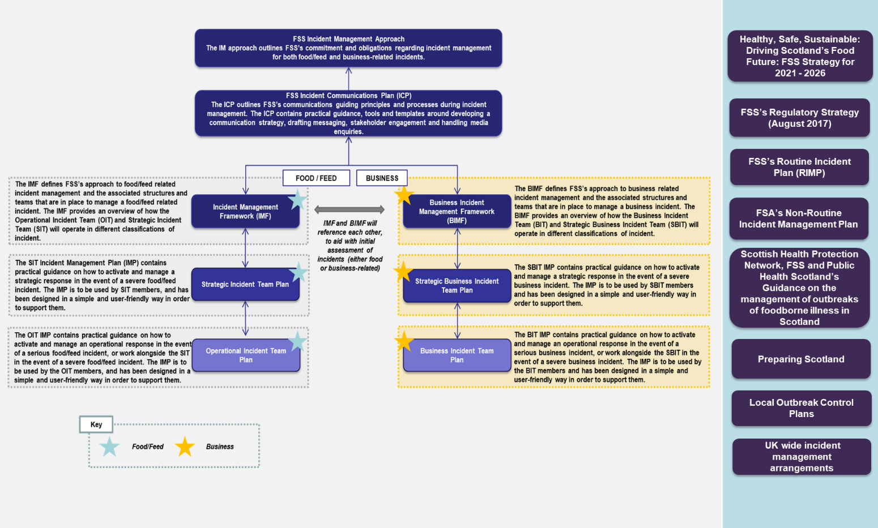
Figure 1: FSS incident management documentation & supporting documentation

1.2 Scope of response
Food/Feed incidents have the potential to impact on any individual nation within the UK or any combination of two or more. A Memorandum of Understanding is in place with the Food Standards Agency (FSA) to ensure liaison arrangements deliver a coordinated incident response across the UK. For the purposes of FSS or FSA-led Incident Management, only two jurisdictions are defined:
- FSS – Scotland
- FSA – England, Wales and Northern Ireland
The scope of an individual incident will be considered as FSA, FSS or UK-wide. Where the scope of an incident does not extend beyond either England, Wales or Northern Ireland, the incident will be managed by FSA, and information about such incidents shared with FSS. Where the scope of the incident does not extend beyond Scotland, the incident will be managed by FSS, and information about such incidents shared with FSA.

If an incident originates in Scotland or is initially led by FSS, and escalates to a UK-wide incident, FSS will continue to lead the incident by mutual agreement, unless it is agreed that it is more appropriate for FSA to lead. The FSA’s Incident Management Plan defines how incidents led by FSA will be managed.

On occasion when the situation is complex and the organisational lead (FSS or the FSA) is unclear, a decision tree matrix can be used as a guide to help identify the most appropriate organisation to lead based on the information available at the time. The decision tree matrix is available from the OIT IMP.
There are also specific arrangements in place outlining FSS’s involvement in incidents led by other agencies (i.e. FSA, Public Health Scotland and UKHSA, etc).

1.3 Governance

1.3.1 Accountability
Ultimate accountability for incident management at FSS sits with the Chief Executive. All Heads of Divisions have a responsibility to ensure the Incident Management Framework and Incident Management Plans are followed and adhered to by their staff.
The FSS Board is responsible for the strategic direction of the organisation and for supporting the Strategic Leadership Group (SLG) in its leadership function. An overview of the role of the Board in incident management can be found in Annex B.

1.3.2 Ownership
Changes and updates to the IMF/IMPs will be conducted by the Resilience Manager, who is also responsible for coordinating a regular training and emergency exercising programme. Any changes to the IMF will be passed to the Strategy Forum for awareness and/or approval, where required.

1.3.3 Responsibility
Local Authority (LA) Environmental Health Professionals have responsibility for enforcing legal food safety and standards requirements and verifying compliance with the appropriate regulations in the majority of food businesses across Scotland. From 1 April 2021, FSS is responsible for carrying out official controls and enforcement of feed law in Scotland as stated in The Feed (Transfer of Functions) (Miscellaneous Amendments) (Scotland) Regulations 2020. This piece of legislation provides FSS the power to delegate functions to a qualifying third party therefore in some areas of Scotland, FSS is delegating feed official control delivery to local authorities on its behalf. Food establishments which require additional veterinary supervision (i.e. abattoirs, cutting plants, and game handling establishments) are approved and subject to enforcement by FSS. The Food Safety Act 1990 and Regulation (EC) 178/2002 provide the framework of food law applicable in Scotland commonly used by LA Environmental Health Professionals and FSS.

1.3.4 Delivery
FSS has issued a Code of Practice on behalf of Scottish Ministers which provides directions and clear guidance to LAs on the execution and enforcement of Food Law, including the investigation of incidents and outbreaks of food borne illness. FSS is responsible for carrying out official controls (this includes sampling and inspections) and enforcement of feed law. The Official Control delivery section of the FSS website outlines the OC procedures for Feed Delivery.
Food Business Operators (FBOs) are required to inform the LA (or FSS in the case of an FSS enforced establishment) immediately when they have reason to believe that food which it has imported, produced, processed, manufactured or distributed does not comply with food safety requirements, and/or when it may be injurious to human health. Competent authorities should also be notified in the event of a breach of food information law and there are similar requirements in the legislation which apply to feed. This can be done by completing the incident report form found on the FSS website.

1.4 Definitions
The following definitions are used by FSS:
Food/Feed Incident: any event where, based on the information available, there are concerns about actual or suspected threats to the safety, quality or integrity of food/feed or fraud that could require intervention to protect consumers’ interests.

FSS’s existing definition

1.5 Objectives
The overarching principle guiding FSS’s incident management response is the protection of public health with respect to food and feed intended to be placed on the market.
The objectives of incident management at FSS are to:
- Successfully identify and manage food or feed incidents
- Provide informative advice to consumers during food or feed incidents
- Act as the coordinating body and work closely with key stakeholders when leading food or feed incidents.

1.6 Guiding principles
The overarching purpose of incident management at FSS is public health and consumer protection. To ensure FSS responds in line with the objectives outlined in Section 1.5, the following principles will guide all incident management response activities and is applicable to each and every level of the response.
People | Consumer Focused  Public health and consumer protection in relation to food safety, standards & authenticity will be at the forefront of every response. All decisions will revolve around their safety, and response teams will remain empathetic throughout the incident and commit to providing the necessary welfare to those affected.
Preparedness | Plans and procedures  FSS shall have effective plans and procedures in place to guide them in the event of food/feed incidents affecting Scotland, or reputational incidents affecting the organisation. These plans shall be reviewed on a regular basis to ensure they remain fit for purpose.
Preparedness | Professionally trained and competent staff  For all those who may be involved in managing an incident, FSS will ensure that staff are sufficiently trained and competent to undertake the role they have been given. Appropriate training will take place on a regular basis.
Response | Precautionary principle  At FSS, the precautionary principle should guide all elements of incident management, including the decision to activate the incident response teams. Levels of precaution will be determined by the degree of uncertainty but be proportionate. It is better to over-react, then stand-down resources as more information becomes available, rather than delay mobilisation and the tactical/strategic response.
Response | Transparency  As far as it is possible, without releasing confidential information, FSS’s incident management response will be driven by transparency and openness to ensure effective and proactive communication flows with all stakeholders are in place.
Response | Speed of response  All aspects of the incident response (i.e. decision-making, communication and information flow) should be conducted in a timely manner. Our decisions and actions should support compliant businesses and be effective at dealing with non-compliant ones. Incident response teams may be required to make difficult decisions, often on the basis of partial or incomplete information. While a speedy response is vital, it is crucial that decision-making is evidence-based, transparent and recorded.
Response | Regulation and policy  In line with FSS’s Strategy, FSS will ensure all legal obligations are considered and there is consistent and proportionate application of the law when making risk management decisions.
Reputation | Considering our stakeholders  At FSS, stakeholders should be factored into the strategic decision-making process required to manage an incident at all times. Consideration must also be given to how these decisions will impact stakeholders critical to FSS’s success (including, although not limited to, the general public, employees, Scottish Government, PHS, LAs, media, etc.).
Reputation | Proactive communication  Where possible, FSS will take a proactive approach to incident management, ensuring that the organisation is seen by key stakeholders as the authoritative source of information in relation to the situation.

2. Structure, roles and responsibilities
FSS manages many food incidents every year. FSS operates a two tier incident management structure, as shown in Figure 2 below. In many cases, the Incidents Team will respond to incidents using their Level 1 routine procedures. However, if a more coordinated operational response is required, an Operational Incident Team (OIT) may be invoked. In the event strategic direction is required to coordinate and manage the situation, a Strategic Incident Team (SIT) may be formed. The Food Incidents section of the Food Law Code of Practice outlines the roles of LAs during incident management. The FSS Feed Manual outlines the role of FSS as competent authority for feed incidents. Figure 2: Food Incident Management structure

2.1 Response structure
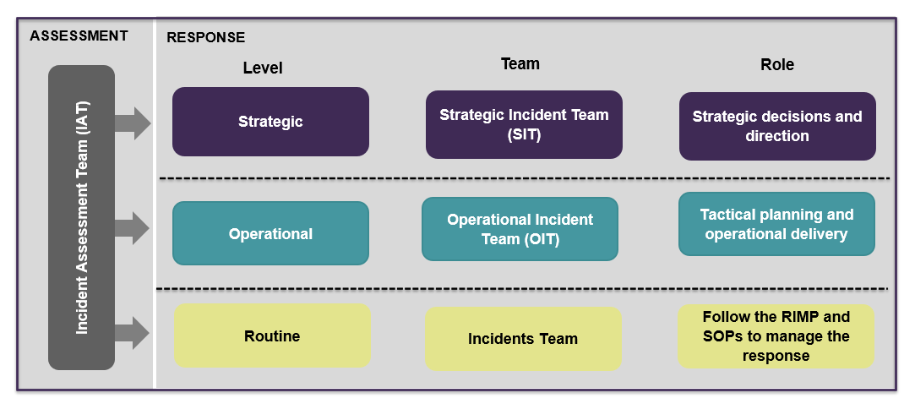

2.2 Team descriptions
IAT | IAT: The role of the Incident Assessment Team (IAT) is to consider the potential implications of a situation, including threat to public safety, FSS’s operations and reputation. The IAT then agrees on the classification of the incident if required, and follows the processes in place to activate the OIT as needed. The IAT can also be used to facilitate internal discussions to coordinate and agree FSS’s position when supporting a multi-agency IMT response.
OIT | OIT: The role of the OIT in the initial stage of the incident will be to support and manage the operational and tactical response to the incident, including incident management, information gathering, tactical planning, internal and external communications, and stakeholder engagement.
SIT | SIT: The SIT primarily consists of FSS Senior Managers from the ELT and DGG and, where necessary, representatives from central and local Government groups and strategic industry stakeholders. The SIT provides high-level strategic leadership and direction to the OIT, evaluating future risks and ensuring appropriate actions are taken.  The SIT supports the OIT in managing its response including strategic communications, reputation management, senior stakeholder engagement, keeping Ministers informed, preparing for any legal implications, leading the recovery, and horizon scanning to identify any upcoming or potential risks. The SIT is also responsible for liaising with and briefing the FSS Board.

2.3 Incident Assessment Team (IAT)
The IAT may be activated in the event that it is unclear what level an incident is (following completion of the Classification Matrix) and when further information, discussion and clarification is required. The role of the IAT is to:
- Form as required to identify the situation and consider the potential implications, including threat to public safety, FSS’s operations and reputation.
- Agree on the classification of the incident using the matrix, as necessary.
- Consider the organisational incident lead (FSS or the FSA) if unclear, when required.
- Facilitate internal discussions to coordinate FSS’s position before multi-agency response meetings.
- Consider the activation the OIT, as required and liaise with Facilitator, as appropriate you decide not to activate a formal response, document the rationale supporting the IAT’s decision on CLIO.

2.3.1 Membership of the IAT
The IAT comprises core team members, additional team members and optional external support, as shown in Figure 3 below. The IAT is usually chaired by the Incident Manager, who may instead nominate a senior experienced member of the Incidents team to chair in his/her/their place. Figure 3: IAT membership
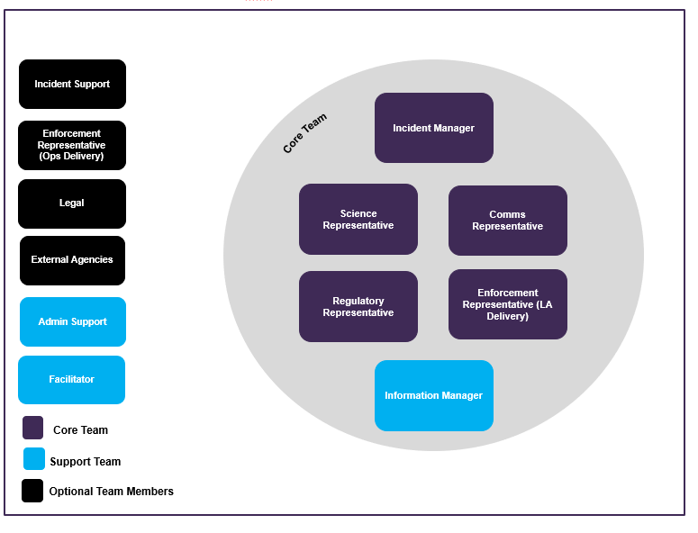

2.4 Operational Incident Team (OIT)
Once the Incident Manager or IAT decide an OIT is required due to the incident classification (Level 2 or above), the Facilitator or Information Manager is then responsible for mobilising the OIT. During a Level 2 incident, where the OIT is the most senior incident team to be established, the OIT’s responsibilities are to:
  - Coordinate the tactical and operational response to the incident.
  - Hold an initial meeting to understand the situation, set team objectives and identify the salient issues.
  - Formulate a plan of how to manage the incident.
  - Inform the EMT and the SLG that the OIT has been mobilised and provide the rationale.
  - Set the ‘battle rhythm’ for the response and communicate this to the team (i.e. when meetings will take place and when updates are expected).
  - Carry out operational tasks to manage the incident i.e. traceability mapping, development of food sampling plans in conjunction with LAs, liaising with FBOs and retailers as appropriate.
  - Identify and engage with stakeholders, including the use of ‘Birdtable’ briefings for stakeholders.
  - Consider the communication response required.
  - Ensure that information is captured and managed using CLIO by liaising with the Information Manager/Facilitator.
  - Ensure that high quality updates and briefings are provided to the EMT and SLG throughout the response via SFCIU Daily Management meeting documentation and a Situation Report, if requested.
  - Sign off communication lines/press releases as per the ICP
  - Continue to assess the incident throughout the response to determine:
    - If the incident classification remains the same (or whether escalation/de-escalation is required).
    - Whether FSS should remain the lead organisation.
- Identify any lessons learned throughout the incident and aim to address any immediate issues which are impacting the response, if possible
  - Decide when to stand down the response and communicate to the team and wider business, as appropriate.

Additionally, in the event of a Level 3 or 4 incident (where a SIT is established to manage strategic considerations), the OIT should also:

- Ensure the OIT Chair and Incident Manager attend SIT meetings to act as the link between the OIT and SIT teams.
- Complete the actions as directed by the SIT.
- Identify appropriate people to attend externally led incident meetings, if required i.e. PHS, FSA, Animal and Plant Health Agency (APHA) and UKHSA.

2.4.1 Membership of the OIT
The OIT comprises of core team members, optional team members, as shown in Figure 4 below. For each OIT role a primary, secondary and reserve staff member has been identified and these are listed in the FSS Critical Response Role document. When the primary staff member is not available, the secondary staff member should be contacted and so on. It is important to note the roles listed below are roles to be adopted during an incident, and should not be confused with Business as Usual (BAU) job titles.
It is expected that the Head of Scottish Food Crime and Incidents Unit (SFCIU) will assume the role of OIT Chair and the Incident Director at the SIT. Each Manager attending the OIT may also decide to invite a deputy manager from their branch to support operational discussions.

In the event of a multi-agency response, or if specialist expertise is required to advise the team, the OIT is able to invite Subject Matter Experts (SMEs) from external agencies into the OIT as additional resource. Figure 4: OIT Membership
Core Roles
Optional attendees

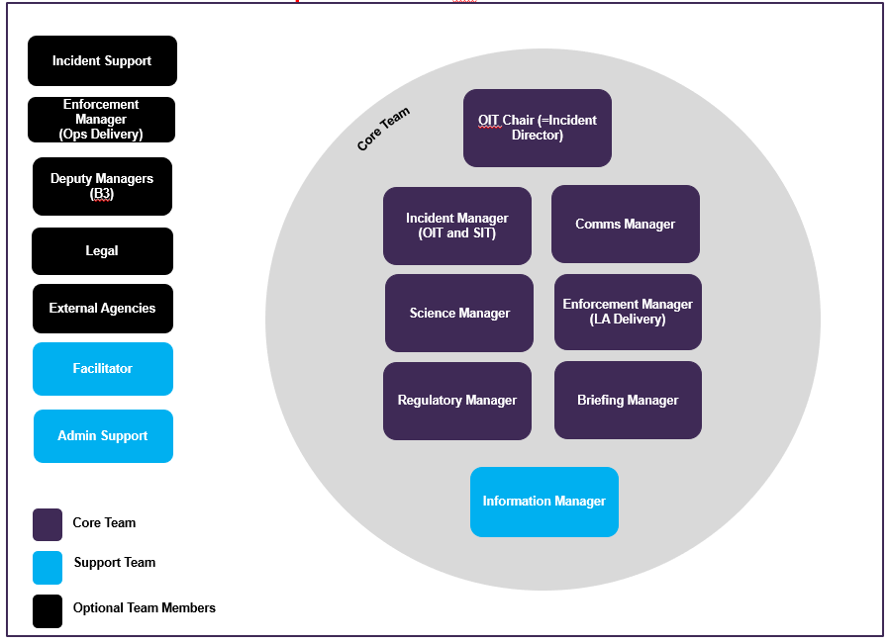

2.4.2 OIT Members Roles and
A brief overview of the responsibilities of OIT members can be found below. Full role cards and a list of the nominated individuals who could assume these roles can be found in the OIT IMP. Support team roles can be found in section 2.6.
OIT Chair  (= Incident Director) | The OIT Chair is responsible for leading the team and chairing OIT meetings. The Chair sets the overall operational objectives for the OIT. The role should be assumed by a senior figure who has the authority to approve decisions, actions and messaging. The OIT Chair has ultimate responsibility for decision making in the OIT.  The OIT Chair attends SIT meetings in the role of Incident Director, to act as the link between the OIT and SIT teams.
Incident Manager  (OIT and SIT) | The Incident Manager is responsible for the operational management of the incident and for the implementation of relevant incident decisions taken by the OIT, and for the delivery of the incident investigation.  This role should be fulfilled by the Head of Incidents or an experienced member of SFCIU. The Incident Manager is also a member of SIT to support the OIT Chair/Incident Director and provide detailed knowledge of the incident investigation/response.
Enforcement Manager  (LA Delivery) | The Enforcement Manager (LA Delivery) is responsible for recommending appropriate Risk Management options on which the OIT can act.  This role should be fulfilled by a senior manager from the LA Delivery branch during all incidents.
Enforcement Manager  (Operational Delivery) | The Enforcement Manager (Operational Delivery) is responsible for recommending appropriate Risk Management options on which the OIT can act.  This role is only required during an incident involving a FSS approved establishment, and where specialist Veterinary advice and/or animal feed advice is required by the OIT.  This role should be fulfilled by a senior representative from the Operational Delivery branch (i.e. Head Veterinarian or Field Veterinary Advisor), as required.
Science Manager | The Science Manager is responsible for identifying the relevant scientific evidence required to produce the Scientific Risk Assessment (SRA).  This role is responsible for developing the SRA which establishes the potential risk of a food/feed incident to human health. This is considered by the Incident Manager (or the IAT, if mobilised) when carrying out the incident classification, and by the OIT to determine the most suitable risk management options.  This role will be fulfilled by a Scientist from the Risk Assessment team within the Science Division or a suitably qualified Scientist from an external organisation as required.
Comms Manager | The Communications Manager is responsible for overseeing all aspects of FSS’s communication response, including the development of messaging, communication materials (internal and external) and coordination of the stakeholder engagement matrix.  This role should be fulfilled by a senior manager of the communications team.
Regulatory Manager | The Regulatory Manager is responsible for representing the Regulatory Policy division on the OIT and inputting into the operational risk management from a policy perspective by providing information on legislative requirements/breaches.  This role should be fulfilled by a senior manager in the Regulatory Policy division.
Briefing Manager | The Briefing Manager is responsible for providing briefings for ministers and stakeholders and establishing Birdtable meetings, as required.  This role should be fulfilled by Head of Private Office or nominated deputy.
Deputy Managers | The OIT managers may decide to invite additional colleagues. The Deputy Managers (B3) are responsible for providing operational and technical expertise and support to the OIT Managers throughout the response, as requested.
Incident Support | Incident Support is responsible for investigating the incident, acting as the main point of contact within the Incidents Team and supporting the Incident Manager in any way required.  This role must be fulfilled by a member of SFCIU trained in Incident Management.
Legal Rep | The Legal representative is responsible for providing any necessary legal advice to the OIT in relation to the impacts of any decision and risk management approach made by the OIT.  This role will be fulfilled by a representative from the Scottish Government Legal Division (SGLD).
External Agency | External Agency representatives are responsible for providing any intelligence, information or expertise required to the OIT. Their attendance at an OIT also aims to facilitate effective liaison and management of a multi-agency incident.  These roles will be fulfilled by members of relevant agencies as required (e.g. FSA, PHS, LAs, UKHSA, and APHA).

2.5 Strategic Incident Team (SIT)
STRUCTURE & ROLES
The SIT is mobilised by the Facilitator during an incident which is classed as a Level 3 or above. The SIT’s responsibilities are to:
- Provide leadership and direction in the effective and timely response and management of a Level 3 or 4 incident.
- Identify strategic issues (i.e. reputation, political, industry etc.) and establish any key areas where further information is needed.
- Conduct scenario planning in order to establish any worst case options and possible remediation.
- Develop response strategy based on issues identified.
- Develop and agree communication strategy and sign off key messages and communications materials.
- Provide strategic direction to the OIT.
- Identify strategic stakeholders and develop stakeholder engagement strategy.
- Review briefing materials i.e. ministerial briefings.
- Ensure the OIT is performing and sufficiently resourced to respond effectively.
- Consider impacts of incident on BAU activity and take decision about how this will be managed.
- Identify any lessons learned throughout the incident and aim to address any immediate issues which are impacting the response, if possible.
- Decide when to stand down the response and communicate to the team and wider business.

2.5.1 Membership of the SIT
The SIT comprises of core team members, additional team members and optional external support. Each SIT role has an identified primary and secondary member as outlined in the FSS Critical Response Role Document. It is important to note the roles listed below are incident roles, and should not be confused with BAU job titles.
The Deputy CEO is the primary SIT Chair. The Chief Executive Officer (CEO) will not be responsible for chairing the SIT meetings in order to allow for his/her/their focus to remain on stakeholder engagement and oversee BAU activities, if required.
In the event that specialist expertise is required to advise the team, the SIT is able to invite experts into the SIT as additional resource. Figure 5: SIT membership
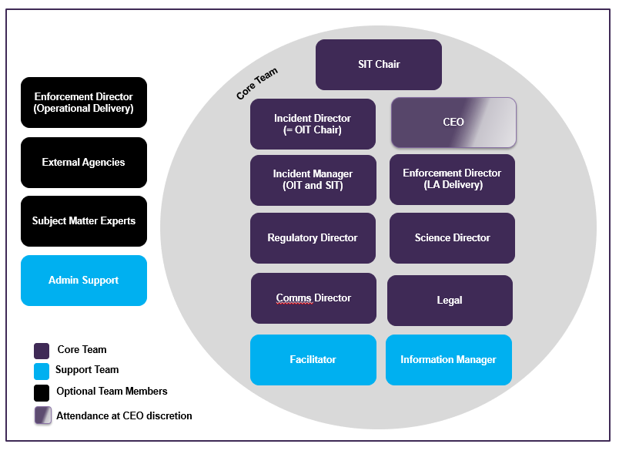

2.5.2 SIT Members Roles and Responsibilities
A brief overview of the responsibilities of SIT members is below. Full role cards can be found in the SIT IMP. Support team roles can be found in section 2.6.
SIT Chair | The SIT Chair leads the SIT and chairs the meetings. The Chair sets the overall strategy and objectives for the SIT. The role should be assumed by a senior figure within the business who has the authority to approve strategy, actions and messaging. They should have extensive leadership experience and remain calm under pressure. This role will ordinarily be assumed by the Deputy Chief Executive with the Head of SFCIU as the deputy.
Incident Director (=OIT Chair) | The Incident Director is responsible for the overall tactical and operational management of the incident during a level 3 or 4 incident.  During a level 3 or 4 incident, they will request a SIT is convened. The Incident Director will also chair the OIT and act as liaison between the SIT and OIT.  This role should be assumed by the Head of SFCIU who has oversight of food incidents and crime, as required.
Incident Manager  (OIT and SIT) | The Incident Manager is responsible for supporting the Incident Director and providing any detailed information about the food chain investigation to help inform strategic decision making.  This role also attends OIT and acts as liaision between SIT and OIT.  This role should be assumed by the Head of Incidents (or nominated deputy).
CEO | If in attendance, the CEO is responsible for briefing strategic stakeholders, acting as the organisation’s spokesperson (if appropriate) and leading the organisation as a whole. The CEO is responsible for briefing the chair/vice-chair of the FSS Board.
Enforcement Director  (LA Delivery) | The Enforcement Director (LA Delivery) is responsible for representing the LA Delivery team on the SIT.  This role should be fulfilled by the Head of LA Delivery, as required.
Enforcement Director  (Operational Delivery) | The Enforcement Director (Operational Delivery) is responsible for representing the Operational Delivery branch on the SIT.  This role is only required during an incident involving a FSS-approved establishment, or where specialist Veterinary advice and/or animal feed advice is required by the SIT.  This role should be fulfilled by the Head of the Operational Delivery branch, as required.
Science Director | The Science Director is responsible for representing Science Division on the SIT and advising on the scientific risk assessment.  This role will be fulfilled by the Head of the Science Division.
Comms Director | The Communications Director is responsible for representing the Communications team on the SIT and for developing the communications strategy in Level 3 & 4 incidents.  This role will be fulfilled by the Head of Communications and Marketing (or nominated deputy).
Regulatory Director | The Regulatory Director is responsible for representing the Regulatory Policy division on the SIT.  This role will be fulfilled by the Head of the Regulatory Policy (or nominated deputy).
Legal Rep | The Legal representative is responsible for providing any necessary legal advice to the SIT in relation to the incident or the impacts of any decisions made by the SIT.  This role will be fulfilled by a representative from the SGLD.
External Agency | External Agency representatives are responsible for providing any intelligence, information or expertise required to the SIT.  These roles will be fulfilled by members of relevant agencies as required (i.e. FSA, PHS, APHA, UKHSA and LAs, etc).
Subject Matter Experts | Subject Matter Experts can attend SIT meetings as required to provide specialist advice depending on the nature of the incident.  These roles can be fulfilled by internal or external subject matter experts as required.

2.6 Support team roles
The roles below are present in both the OIT and SIT, and are critical to the success and smooth running of the operation.
Facilitator | The Facilitator is the guardian of the incident management process, and  ensure the functional running of both meetings. They act as the ‘right-hand’ to the OIT and SIT chairs and provide pre-meeting briefs to the Chairs, if requested.  The Facilitator supports the OIT and SIT meeting chairs as required and ensures all information is captured (i.e. decisions are recorded and actions are logged by the Information Manager on CLIO.). The Facilitator will ensure the team has the correct representation, as requested by the Chair. The Facilitator will also make sure the information management process is being followed to support with effective decision-making.  The Facilitator also maintains the Information Board & Objectives Board in the OIT and SIT.  There could be occasions when it is deemed adequate for only an Information Manager to support the OIT without the Facilitator. This decision should be made by the OIT Chair. For example level 2 incidents.  This role may be assumed by a member of the Incident Support team or trained member of staff, who’s well versed in the IMF and incident management.
Information Manager | The Information Manager maintains the Issues & Actions Log and Decision Log for the OIT and SIT. The Information Manager is responsible for recording the issues raised by the incident and assigning the corresponding actions with clear owners and deadlines. The Information Manager also records decisions made by the OIT/SIT alongside the rationale supporting those decisions. This role is responsible for uploading all meeting documents and outputs onto CLIO.  On the occasion when OIT is supported by the Information Manager only, the individual will also maintain the Information Board and Objectives Board.  This role should be assumed by a trained member of staff who’s well-versed in the IMF, incident management and CLIO.
Admin Support | The Admin Support role is responsible for conducting any additional administrative tasks on behalf of the OIT/SIT to ensure the meetings run smoothly. For example, uploading meeting documents to CLIO, etc.  This role should be assumed by a trained member of staff.

2.7 Division and branch involvement
The division and branch teams will provide appropriate resource, support and advice to the incident response teams, as required. Incident Management is a fundamental priority for FSS and should be prioritised over non-urgent business as usual work.

SFCIU | The Scottish Food Crime and Incidents Unit (SFCIU) is the incidents, investigations, prevention, and intelligence gathering arm of FSS. It focuses on tackling food crime and maintaining consumer protection. The unit comprises of:  - a dedicated Incidents team which conduct the food chain investigation to ensure that FSS acts in a timely manner during incidents which may have an impact on consumers  - a dedicated Food Crime Intelligence Bureau, which analyses, develops and deals with information intelligence received from members of the public, food business operators and industry whistle-blowers  - an Investigations Team which investigates reports of food crime and non-compliance  - a Support Team which covers incident prevention and resilience  SFCIU’s responsibilities include working closely with a range of stakeholders including LAs, public health professionals, Scottish Government, Industry, FBOs and Trade Associations to quickly minimise the risk to consumers in the event of a food incident.  During an incident, members of SFCIU will fulfil the Incident Manager (OIT and SIT), Incident Support and OIT Chair/Incident Director roles, as well as oversight of the IMF process and procedures. SFCIU is responsible for coordinating the overall incident response as necessary.
Science Division (Risk Assessment) | The Science Division - Risk Assessment team is responsible for developing strategies for reducing foodborne illness in Scotland; generating and evaluating evidence to support FSS’s remit relating to food safety and consumer protection, and; ensuring FSS policy and operational functions are underpinned by robust scientific evidence.  During an incident, members of Science Division will fulfil the roles of Science Manager/Director. The Science Division - Risk Assessment team is responsible for providing the Scientific Risk Assessment (SRA) during incidents. Where additional input is required to complete the SRA, the Science Division – Risk Assessment team will act as the main scientific point of contact with any subject matter experts in order to obtain the necessary information to complete the SRA.
Regulatory Policy | The Regulatory Policy division is responsible for: developing Scottish legislation and influencing emerging updates to retained EU law to provide a legislative risk management framework to protect Scottish consumers interests with respect to the safety and authenticity of food and feed; providing regulatory policy advice to Scottish Ministers, internal and external stakeholders on the requirements of EU and Domestic Food and Feed law, and; internal engagement within FSS supporting the other branches as required.  During an incident, senior members of the Regulatory Policy division will fulfil the roles of Regulatory Manager/Director depending on the nature of the incident. It is also responsible for providing appropriate regulatory policy advice to determine effective and appropriate risk management options to the OIT and SIT.
Operational Delivery | The Operations Delivery branch is responsible for approving and enforcing slaughterhouses, cutting plants and game handling establishments, as those facilities require the presence of an Official Veterinarian. Operational Delivery also approves plants with on-site cold stores, minced meat, meat preparation or meat products establishment. However, if they’re stand-alone establishments, LAs will assess them.  During an incident involving an approved establishment where FSS is the enforcing authority, Operational Delivery is responsible for assuming the role of the Enforcement Manager/Director in the OIT/SIT.  Operational Delivery will lead veterinary risk assessments and it is also responsible for liaising with the relevant external agencies (e.g. APHA, SG) in order to acquire a SRA when veterinary information is required.  Operational Delivery is also responsible for providing appropriate Risk Management options when a FSS enforced establishment is involved.
LA Delivery | The LA Delivery division is responsible for: ensuring effective delivery of official controls relating to food safety, feed safety and food standards by working with local authorities and delivery bodies; developing an enforcement framework for Scotland to ensure delivery of policy relating to food safety, feed safety, food standards, authenticity and labelling, and; leading projects specific to delivery of local authority functions.  During an incident, LA Delivery is responsible for providing appropriate expertise and advice to the OIT and SIT in determining effective risk management options in the context of existing food and feed regulation.
Communications | The Communications and Marketing division is responsible for developing and delivering all internal and external communications for FSS and for managing FSS’s reputation.  During an incident, members of the Communications and Marketing division are responsible for fulfilling the roles of Communications Manager/Director in the OIT and SIT. These roles will produce proactive and reactive communication materials relating to the incident to inform the public and consumers, while assessing the communication and potential reputational risk for FSS. It will also manage internal communications with FSS staff and other key stakeholders.

3. Escalation and mobilisation
STRUCTURE & ROLES

3.1 Notification
Incident notification could originate from a range of different sources including internally by FSS operations authorised officers in the field, FSA, LAs, emergency services, Other Government Departments (OGD), industry, FBOs & consumers. International incident notification may also originate from the EU Commission, Member States directly via the Rapid Alert System for Food and Feed (RASFF) system and from other countries via the International Food Safety Authorities Network (INFOSAN).

3.2 Incident classification
The incident level descriptions diagram below outlines the four potential types of incident. Figure 6: Incident Level Descriptions
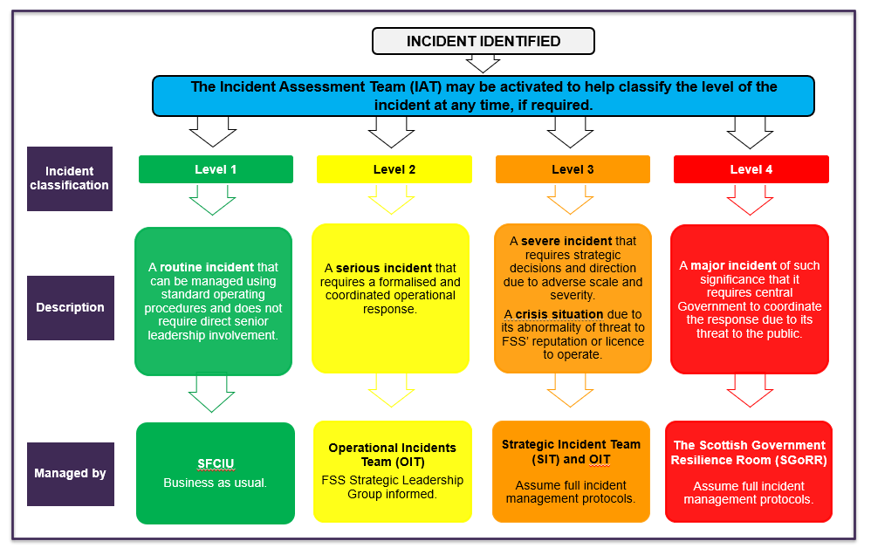
Once notified of an incident, the Incidents Team should classify the incident using the Incident Classification Matrix (ICM). This is available in the OIT and SIT IMPs. This tool should be used to help assign a level to the incident and determine the most appropriate response (i.e. if an OIT is required). This tool can be referred to throughout an incident should the situation change and more information becomes available. In the event the classification cannot be assigned due to lack of information or where clarity is required, an IAT should be established to discuss the matter further and seek advice from a multi-disciplinary team.
If the incident is classified as a Level 1 the IAT disbands and no further action is needed. If the incident is classified as a Level 2 or above the IAT disbands and forms an OIT (and SIT if required).

While considering the most appropriate incident classification, the precautionary principle should always be applied to ensure our statutory objectives to protect public health and other consumer interests from food-related risks are met.

3.3 Declaring an incident
Any member of the Incidents Team can classify an incident. However, if there is uncertainty over the level of an incident, the IAT can be formed to gain a more complete assessment of the situation from the information available. The role of the IAT Chair will be assumed by the Incident Manager who will classify the incident with the help of the IAT.
The decision to declare a Level 4 can be made only by SIT and will be based on evidence, size, scale and impact on public health, and is likely to be in response to liaison with multi-agency partners (i.e. Scottish Government, Police Scotland etc.). In the event a Level 4 is provisionally assigned by FSS not as a direct response of notification by a multi-agency partner, the SIT Chair will contact SGoRR immediately.

3.4 Escalation
ESCALATION & MOBILISATION
The incident escalation flowchart details the process for escalating an incident after notification. Figure 7: Incident escalation flowchart
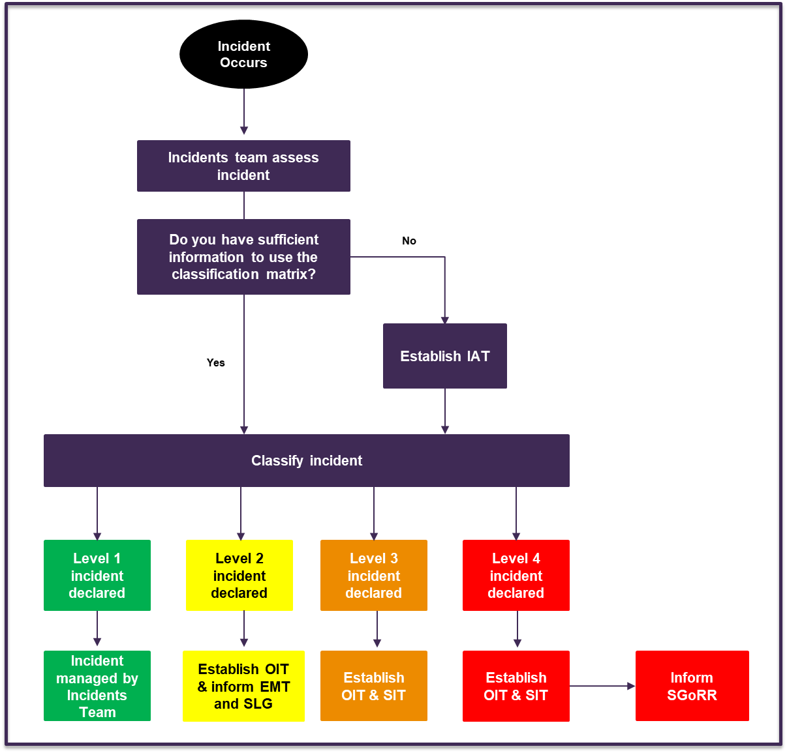

4. Risk Analysis

4.1 Risk Analysis Process
The Risk Analysis process is central to FSS’s incident management process. Its effective application helps prevent, mitigate and manage food and feed incidents in Scotland.
In line with Retained Regulation (EC) 178/2002, Risk Analysis at FSS consists of a three stage process:
- Risk assessment: The risk assessment process consists of two phases:
- The Scientific Risk Assessment (SRA) involves scientifically assessing the risk of the hazard(s) presented by the incident. This process is undertaken by the Risk Assessment Team in FSS Science Division who may request support from FSA’s risk assessment team depending on the nature of the incident.
  - As outlined in Regulation 178/2002, in some cases a SRA alone cannot provide all the information on which a risk management decision should be based and other factors should also be considered. Therefore, the Wider Risk Assessment (WRA), which involves assessing other legitimate factors like the wider political, reputational, regulatory and commercial aspects of the situation will also take place. During a Level 2 incident, this process is undertaken collectively by other members of the OIT. In a Level 3 or above incident, this is done collectively between the OIT and SIT.
- Risk management: this process involves the consideration of the control and prevention measures available, based on the results of the risk assessments and in liaison with the relevant LA. The most proportionate and appropriate risk management option should be decided upon by the OIT collectively. However, if a risk management decision cannot be made at the OIT or if strategic oversight is required, this should be escalated to the SIT.
- Risk communication: sharing of information to interested parties (such as consumers, FBOs, other responding agencies etc.) in regards to the risk management decision including the findings of the risk assessment process.

4.2 Scientific Risk Assessment
While carrying out the scientific risk assessment, FSS will operate in line with the Codex Alimentarius (Retained Regulation 178/2002) and the process will consist of the following four steps: hazard identification; hazard characterisation; exposure assessment, and risk characterisation.
The Science Division (Risk Assessment) will complete/act as the main scientific point of contact for the SRA. In an event where veterinary risk assessment is required Operational Delivery will lead in liaison with the Risk Assessment team. This process may be ongoing throughout the incident depending on the evidence available and the complexity of the science.
The Science Manager/Director (fulfilled by members of the Science Division) at the OIT/SIT is responsible for updating the teams on the status of the SRA during meetings.
Depending on the nature of the incident and the contaminant involved, specific scientific expertise may be required. A list of specialists is included in the OIT IMP.

4.3 Risk Management
Once the relevant risk assessments have been undertaken, the OIT should work together to decide on the most appropriate risk management decision.
The Risk Management Decision Making Model in Figure 8 has been developed to guide the OIT through the process of gathering information, assessing the risks, considering other contextual factors and making a risk management decision. Effective risk management is the collective responsibility of the OIT. However, accountability sits with the OIT Chair. Figure 8: Risk Management Decision Making Model

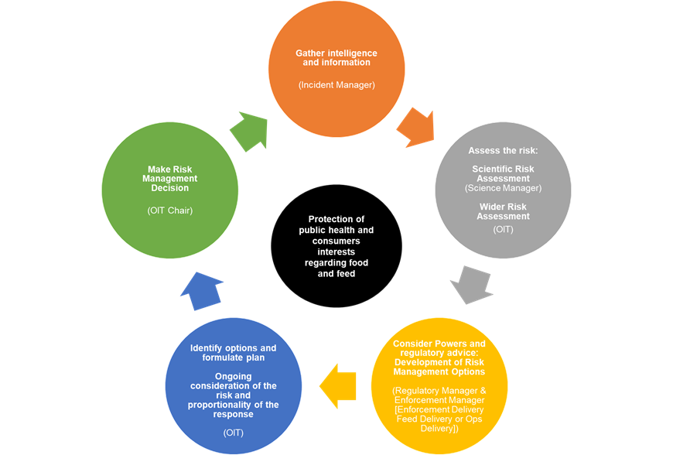

1. Gather intelligence and information [Incident Manager]
The Incidents team is responsible for gathering the necessary incident information and storing it on CLIO.
2. Assess the risk
- Scientific Risk Assessment [Science Manager]
Using the information gathered by the Incidents team, the Risk Assessment Team in the Science Division should complete a SRA based on the available information and specific questions asked by the Incident Manager.
- Wider Risk Assessment [OIT]
In a Level 2 incident, the remainder of the OIT should conduct the WRA to inform risk management decision making. In a Level 3 or above incident, this should be done alongside the SIT. If the risk includes the potential for food fraud, consider obtaining input from a public analyst to help determine any potential risks.
3. Development of risk management options [LA Delivery, Operational Delivery and Regulatory Policy]
The Enforcement Delivery, Operational Delivery (ops and feed) and Regulatory Policy teams are then responsible for considering the appropriate powers, policy and legislation, and providing appropriate risk management options to the OIT for consideration.
4. Identify options and formulate the risk management plan [OIT]
The OIT should then discuss Risk Management options available regarding the protection of public health and wider consumer interest in relation to food and feed. Representatives from different branches that form the OIT are responsible for helping to formulate the plan, and ensuring the risk management options available remain appropriate and proportionate.
5. Make risk management decision [OIT Chair]
The OIT Chair is then responsible for making a risk management decision based on the evidence and advice available.

4.4 Risk Communication
FSS will communicate with its stakeholders using a number of communication channels, including but not limited to:
- Email and Text Alerts
- Website statements
- Social media platforms
- Ministerial briefings
- Media releases
- Press conferences / media briefings
- Internal communications channels
The communication process is coordinated by the Communications and Marketing division, although other members of the response may be responsible for carrying out the communication with stakeholders. Further information on this process is included in FSS’s Incident Communications Plan (ICP).

5 Mode of operation

5.1 Activating teams
Once an incident has been declared, the Incident Manager should notify the Facilitator and/or Information Manager, and request they activate the appropriate teams. The Facilitator should refer to the Critical Response Roles document to identify and then notify the primary (or deputy/reserve if the primary is unavailable) for all core team members, and any required optional/external attendees.
Response team meetings are likely to be held using Microsoft Teams. The Facilitator and/or Information Manager will identify meeting dates (with as much notice as possible) and issue calendar invites (with agendas) to all necessary OIT and SIT responders. The Facilitator and Information Manager can also request to set up Microsoft Teams Channels for the OIT and SIT and add team members. The channel can be used to provide any ad hoc updates and discussion only outside of meetings. All documents and allocation of actions should be done via CLIO.

5.2 Facilities
FSS has identified and equipped rooms in key locations to serve as incident management rooms should the need arise. Unless otherwise stated, the designated incidents room for both the OIT and SIT will be located permanently at:
Incidents Room, 3rd Floor, Pilgrim House, Old Ford Rd, Aberdeen AB11 5RL
In conjunction with the other support role functions, it is the responsibility of the Facilitator and Information Manager to ensure the incidents room is set up with the appropriate resource and equipment once a Level 2 or above incident has been declared, if required.

5.4 Setting ground rules
Meetings should be scheduled with as much notice as possible and prioritised by all FSS employees, taking priority over BAU meetings. The Facilitator should monitor participants’ responses to each meeting and work with team members and any external organisations to ensure each role is represented, and assign deputies where required. The Facilitator and/or Information Manager should contact any team member who does not reply to a calendar invite to confirm their attendance.
The Facilitator should aim to allow 60 minutes for all meetings, and should use discretion to delay/postpone meetings if required (e.g. urgent/critical information is due/key people cannot make the meeting). The first meeting may also take longer to gather all relevant incident information.
The following meeting etiquette principles should be adhered to in all SIT/OIT meetings:
- Attendance: All required team members should prioritise OIT/SIT meetings over BAU activities and attend all meetings as required. If you are unable to attend a meeting for any reason, the Chair and Facilitator should be informed, and a deputy nominated to fulfil the role.
- Timekeeping: All team members should arrive promptly to OIT/SIT meetings.
- Agendas: Standard agendas should be followed for all OIT and SIT meetings. These can be found in section 8 and the OIT/SIT IMPs.
- Respect: All team members should have the opportunity to speak without being interrupted, and be allowed to fulfil the role they have been assigned.
- Technology: All mobile phones should be silenced (unless on-call).
- Cooperation: All team members should ensure they help and assist the support team in the information management process. This means speaking clearly and the OIT/SIT Chairs pausing the meeting as required to clarify decisions, issues, actions, owners and deadlines. Members are encouraged to introduce themselves clearly using their preferred gender pronouns.

5.6 Information management
The use of FSS’s information management system, CLIO, during any incident is vital to store all key and official sensitive information and record team meeting outputs, including the decisions made and the allocation of actions. All FSS response team members should be trained and able to competently use CLIO. CLIO is a secure system and acts as an audit trail for the incident. Any external agencies who don’t have access to CLIO will receive all information and documentation via email (clearly marked with the appropriate security classification).
5.6.1 Information management cycle
The information management cycle details the information management process in both the OIT and SIT. Figure 11: Information management cycle
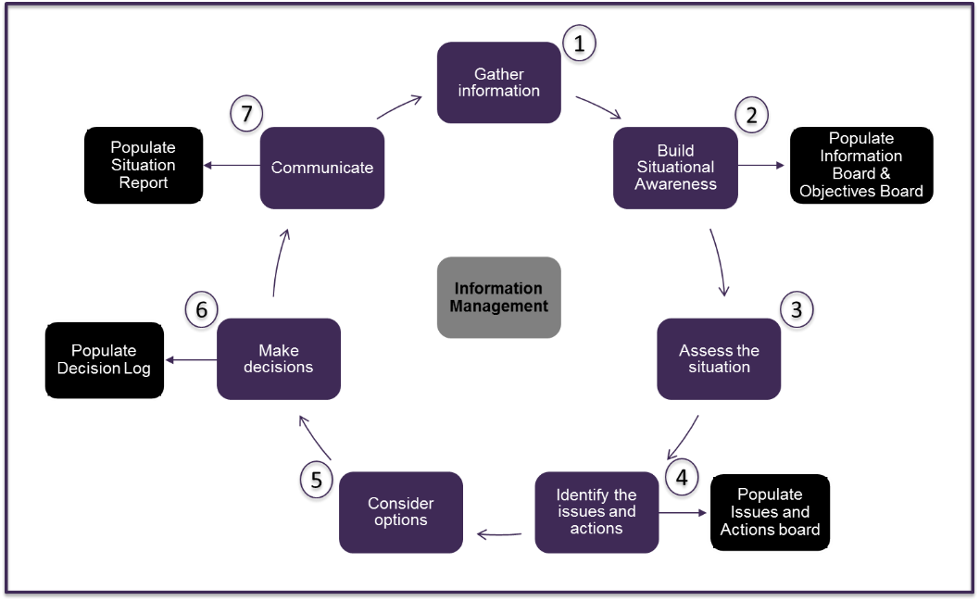

5.7 Battle rhythm
The OIT and SIT Chairs, in liaison with the Facilitator, must establish a ‘battle rhythm’ that defines when & how meetings are to be held, and when the team will conduct updates and briefings and consider any external meetings etc. This may follow one of the following options:
- Meeting on a pre-defined basis i.e. every 90 minutes, 09:00 daily etc., or
- At a different time and pace depending on the nature and speed of the incident.
Although the battle rhythm is usually set early in an incident, it can change as the incident develops and should be reviewed throughout an incident.

5.8 Concept of operation
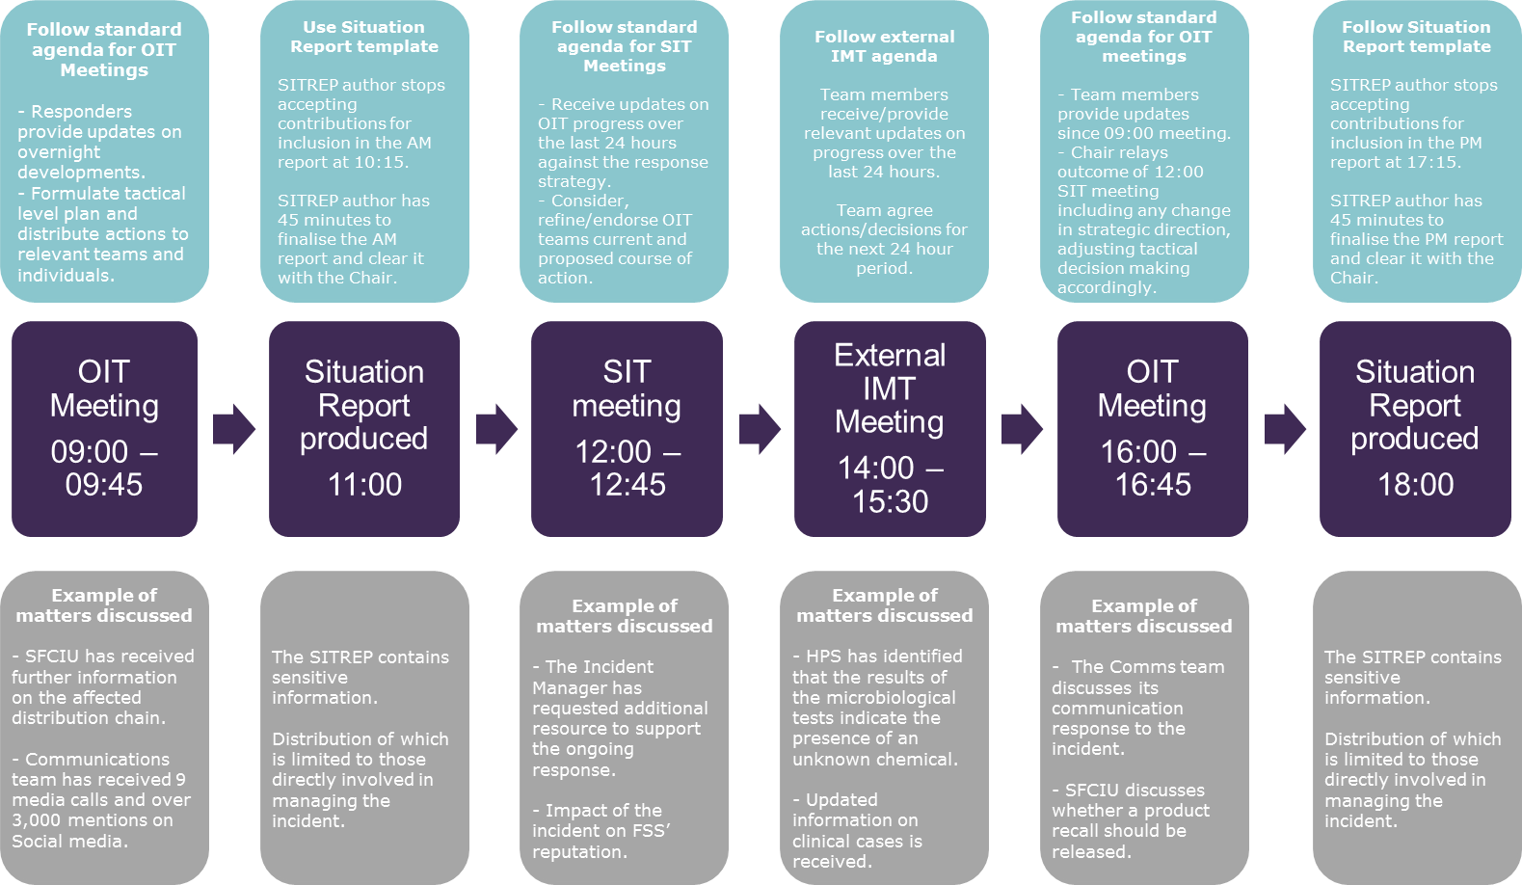
The process below is an example battle rhythm for a Level 3 incident with an externally led IMT active. This is an example of how the processes could work.

5.9 Managing Concurrent Incidents
FSS may need to manage multiple incidents at any given time, requiring additional resources and response teams to balance competing priorities. This is particularly true for senior leadership roles where individuals may be members of multiple response teams (e.g. the Strategic Business Incident Team (SBIT) and the SIT) when responding to food/feed and business incidents simultaneously, or where two separate incidents require strategic decisions and direction. The uncertain and pressurised nature of incidents mean that it is difficult to recommend a prescriptive solution to manage concurrent incidents. However, there are guiding principles that should be considered:
- The Facilitators in each response team will liaise with the respective Chair to allocate resources, resolve any conflicting demands, and identify cross-cutting issues that may require collaboration between the different response teams.

- Ultimately, all decisions related to the prioritisation and resources during concurrent incidents will be made by the SLG.

- Every role within FSS’s response teams (for food/feed and business incidents) have assigned capable deputies (primary, secondary and reserves), which are outlined in the internal critical roles response document. This will provide further resilience for FSS to resource the response to multiple incidents, if required.

Figure 10 (indicative daily response rhythm when responding to concurrent incidents) illustrates a possible approach to managing concurrent incidents through the establishment of daily response rhythms – in this case for two different Level 3 incidents as an example. This approach is indicative, and the Facilitator, in agreement with the OIT/SIT chairs, should consider the requirements of each response and set the appropriate ‘battle rhythm’.
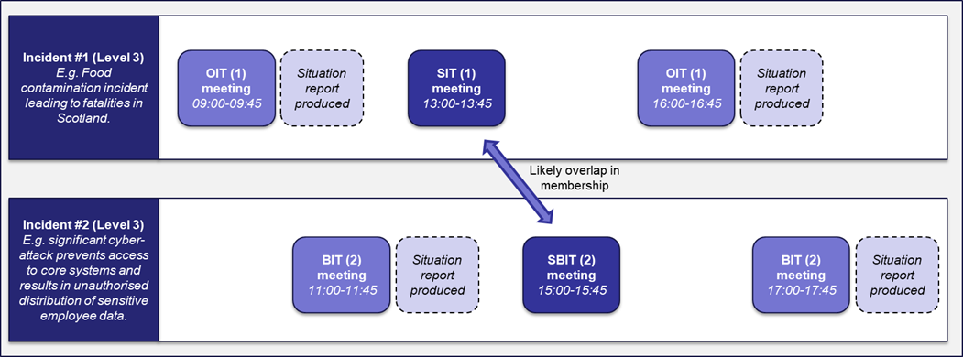

5.10 Communication
The ICP should be consulted for all internal/external communication processes and materials. The ICP can be found on FSS’s website and is maintained by the FSS Communications and Marketing division.

5.11 Ministerial Briefings
The Briefing Manager is responsible for developing ministerial briefings with support from the OIT Communications Manager, as required. Once developed, ministerial briefings should be approved by the SIT Chair. If the SIT has not been activated, the briefing should be approved by the OIT Chair.

5.12 Stakeholder management
The OIT Communications Manager is responsible for the coordination of stakeholder communication and maintaining the stakeholder engagement matrix. This does not mean they are responsible for contacting all stakeholders, but are responsible for the coordination and updating of the documentation. The Communications Manager should attend each OIT meeting with a populated stakeholder matrix, and assign OIT members (and SIT where needed) as owners for each stakeholder. Individuals are then responsible for contacting relevant stakeholders in a timely fashion.
In the event that it is deemed beneficial to brief stakeholders collectively, a Birdtable meeting may be established.

5.12.1 Birdtable Meetings
Birdtable meetings facilitate the effective management of the incident by ensuring communication between all major stakeholders and partners. The aim of these meetings is to provide brief situation reports on all aspects of the incident to those concerned in its management, which may include OGDs, delivery partners and external stakeholders, to encourage a coordinated and cooperative response.
The Briefing Manager is responsible for establishing Birdtable meetings in liaison with the OIT Communications Manager. During a Level 2, the OIT Chair is responsible for chairing Birdtable meetings when the SIT has not been activated. More information can be found in the OIT IMP.

5.13 Clearance process
The OIT/SIT Chair has ultimate sign off and decision making capability within each team during incident management for Level 2 and 3 incidents. Consideration should be given when issuing any joint organisation communications to ensure all relevant approvals are sought, including with the FSA, PHS and UKHSA, etc.
During Level 4 incidents, where SGoRR is established, it is likely that external communication and stakeholder messaging would be discussed with the Scottish Government and cleared in conjunction with the SIT chair and SGoRR.

5.14 Resource
As outlined in the FSS/FSA MoU, assistance can be can be obtained from FSA to support incident response roles, if required. In addition, specialist advice may be sought from FSA, UKHSA, SEPA, SG, DEFRA or APHA, depending on the incident type.
During a prolonged event it will be necessary to consider staff welfare and wellbeing as a priority due to potential changes in circumstances and working arrangements. All OIT and SIT members deputies and reserves can support surge capacity and long running incident responses. The responsibility to ensure sufficient resourcing sits with both OIT and SIT Chairs and the Facilitator who can liaise with FSS’s HR team should additional support be required.

5.15 Lead Agency
Depending on the nature of the incident, FSS may or may not be the organisation leading the incident. This depends on a number of factors, some of which are outlined in the table below.
- In situations when FSS is the lead agency, the battle rhythm can be set by the Facilitator, in conjunction with OIT/SIT Chairs, early in the response.
- When FSS is not the lead agency, the Facilitator must take external IMT/FSA/SGoRR meetings (as applicable) into account when setting the internal battle rhythm. A suggested battle rhythm during a Level 3 incident with an external IMT formed is detailed in section 5.8.

Situation | Lead Agency | FSS’s role
A Scottish outbreak of foodborne illness, which leads to the activation of the Incident Management Team (IMT) | PHS leads the response  A Consultant in Public Health Medicine (CPHM) is appointed to lead the IMT If it is a UK wide incident UKSHA will lead the response. | Coordinates the Scottish food incident response with Local Authorities.  Attend IMT meetings/ chairs food sub-group as required.
UK wide incident with distribution across the UK including Scotland. | FSA leads the response in accordance with FSA Non- routine Incident Management Plan. | FSS are core representatives at FSA operational and strategic response meetings from the outset following establishment of incident response structure in line with UK-wide incident management arrangements.
An incident which originates in Scotland with no distribution outside Scotland | FSS leads the response. | Manage the incident in accordance with FSS’s IMF and procedures.
An incident which originates in Scotland with distribution outside Scotland | FSS will continue to lead the incident, unless it is mutually agreed that it is more appropriate for the FSA to lead. | Manage the incident in accordance with FSS’s IMF with FSA reps in attendance / FSS representatives join FSA incident meetings, as required (whichever is applicable)
A level 4 incident that requires the activation of the Scottish Government Resilience Room (SGoRR) | SGoRR leads the response | Adhere to FSS’s IMF and to provide food safety advice to SGoRR. FSS CEO is the nominated rep at SGoRR meetings.  It is expected that FSS’s IMF and procedures will be invoked.
The below table outlines the designated lead agencies in a variety of potential incident scenarios.

5.15.1 Scottish Government central response
MODE OF OPERATION
When the scale or complexity of an incident is such that some degree of central government co-ordination or support becomes necessary, Scottish Government will activate its emergency response arrangements through the SGoRR in line with Preparing Scotland Guidance. Ministers would expect senior FSS representation at this meeting with the relevant authority and accountability. This is likely to be the FSS Chief Executive or nominated deputy. They will be expected to provide detailed information about the ongoing incident and are encouraged to invite a colleague who will have a full understanding of the tactical & operational issues.

5.15.2 Cross border incidents
Cross border incidents require constant communication and coordination between FSS and FSA. Liaison between the teams should be made immediately, and at the appropriate levels. The precautionary principle should be applied here, in order to ensure sufficient resource and expertise early on in an incident.

5.15.3 Out of hours response
A member of the SLG and EMT (all heads of divisions), the Incidents Team and Communications and Marketing team are all on call 24/7 as standard.

5.15.4 Shift handover
The template in section 8 can be used to provide timely, consistent and comprehensive updates to all team members, particularly during handover for a change of shift. It can either be completed in detail or the template can be used as an agenda/prompt for a verbal handover if needed.
The shift handover should be staggered in order to ensure all team members are not replaced at the same time. It is also advisable to have the person coming on shift shadow the outgoing team member for an agreed period of time in order to familiarise themselves with the incident updates and latest information. CLIO can also be used as a useful reference to provide background information.

6. Stand down and Post - Incident Review

6.1 De-escalation
The classification of an incident should be re-assessed throughout the response. In the event that the classification of an incident changes or the requirements for managing the incident reduce, a de-escalation plan should be considered by the teams. The decision to de-escalate will be taken by the most senior team that was set up to lead the response i.e. If a SIT was established, then the SIT will decide whether it is appropriate to de-escalate.
The Chair of the most senior team leading the response will review any outstanding actions to ensure it is appropriate to de-escalate and/or close the incident.
If a decision is made that a FSS response is no longer appropriate, the stand down process will be initiated. All response level changes will be communicated formally both internally and externally to those involved in the response and with FSS staff, if required. An incident’s closure and rationale should be recorded on CLIO.

6.2 Post Incident Review
Upon return to business as usual, each significant incident should be used as an opportunity to assess, learn, rebuild and adapt where necessary.
Post-incident reviews take place for 10% of Level 1 incidents and will take place for all Level 2 and above incidents. Members of the associated IAT, OIT and SIT will be responsible for participating in and contributing to these reviews. Additional stakeholders may also be invited to contribute as appropriate.
This activity will assist FSS’s ability to secure long-term recovery from the incident and further enhance its incident preparedness capability.

6.2.1 Debrief Process
Following Scottish Government’s National Debriefing and Lessons Protocol, the post incident review process should begin immediately after the closure of the incident by:
- Circulation of the debrief template (section 8) to all response team members and relevant stakeholders to consider in advance of a debrief session – no later than one week after the incident has closed.
- A cold debrief session should take place – ideally no sooner than two weeks and no later than six weeks after the incident has closed. This will allow time for the divisions and external organisations involved to complete their own internal debriefs. A formal debrief should be conducted by a senior member of FSS staff (C1/C2) who was not involved in the incident response (if possible) and supported by the Resilience Manager (Incident Support Team).
- A Post Incident Review Report should be complied by the Resilience Manager and circulated to response team members and relevant stakeholders (if appropriate) detailing recommended actions and timescales to address issues identified – no later than eight weeks after the incident has closed.

The overall aims of a debrief are to:
- Identify challenging aspects and consider what did not work well
- Identify the positive points and what worked well
- Identify key areas for improvement
Additional questions below can guide a team discussion and they can also be used in conjunction with, or as an alternative to, completing individual forms:
- What did not work well, causing problems, unplanned events and failings?
- How effective was communication within and between teams handling the incident?
- In what ways, if at all, could the incident have been avoided or reduced in magnitude from a reputation management perspective?
- What worked well during the incident response?
- Which actions/resources made a difference in our response? Which actions/resources might have made a difference if they had/had not been available?
- How did you feel during the response e.g. in relation to the shift length, strain on resources, allocation of business as usual responsibilities etc.?
- How well did our Incident Management Frameworks work? Does anything need to change to make the process/tools more effective?
- To what extent was our communication and stakeholder engagement strategy/approach successful in managing this incident? How could it have been improved?
- What is our assessment of any news media coverage generated as a result of the incident and its impact on the organisation: staff? general public? Scottish and/or UK Governments? Reputation?
- In what ways, if at all, could we have managed media coverage more effectively?
- What would we do differently if we had to do it all over again?

6.2.2 Lessons Learned
All team members will be encouraged to consider any lessons when the topic is covered as a standing agenda item at OIT and SIT meetings. This is to address any issues that may require immediate action during an incident, as well as longer terms lessons to be considered post incident.
All lessons captured during and after the incident will be incorporated into a Post Incident Review Report and transferred onto FSS Lessons Learned Log, which is managed by the SFCIU’s Incident Support Team. The log is reviewed on a monthly basis by the SFCIU Incident Support Team. This is part of our continuous improvement approach and will ensure relevant actions are taken forward in a timely manner to support any recovery phase or future incident. Individual timescales to achieve each action will be detailed on the Lessons Learned Log with the aim of completing all actions within 12 months from an incident’s closure.

7. Preparedness

7.1 Training
Training Needs Analysis (TNA) will identify the requirements for training, from initial induction training through to regular training activity for all FSS staff. This will allow FSS to identify and train all staff who have a role to play in responding to an incident. Those nominated as primaries, secondary or reserves staff at the OIT/SIT are required to undergo mandatory incident management training before fulfilling a role on either team and take part in subsequent familarisation training as defined by the TNA.
Those required to be part of the OIT or SIT should have this reflected in their business roles & responsibilities.

This training requirement applies to all relevant existing FSS staff, staff promoted into new roles, and all staff recruited in the future.

Training will be the responsibility of the Resilience Manager and supported by SFCIU’s Incident Support Team and will aim to take place annually.

7.2 Exercising
An annual programme of selective training opportunities (internal & external) will be identified and delivered to ensure FSS is prepared to deal with incidents. These opportunities will build on the initial familiarisation training and provide progressive exercises, from desktop discussions to full scale simulations. These sessions will be followed by a detailed exercise report, and any recommendations for further improvement will be captured in the master lessons learned log for action.

7.3 Review
The IMF and other documentation will be reviewed as follows:
- An administrative review of the FSS Critical Response Roles document and key contact details every three months by the Resilience Manager.
- Following its invocation and in the event that any areas for development have been identified.
- Following an emergency exercise in the event that any areas for development have been identified.
- In the event that significant re-structuring take places within the organisation.
- A management review of the IMF principles & policies by the EMT and SLG as result of any of the above activities.
- Reviews of the IMF and its version control will be recorded at the beginning of the document.

8. Tools and templates

8.1 IAT Meeting Agenda
The IAT Meeting Agenda should be used by the Incident Manager (as the meeting Chair) during every IAT meeting.
The agenda will support the team to build situational awareness, obtain initial thoughts on incident classification and receive key updates from IAT team members. This will enable team members to agree the final incident classification and decide the appropriate course of action (i.e. whether an OIT and/or SIT should be activated).
The IAT Meeting Agenda can be found internally in eRDM.
At the end of every meeting, a list of actions and assigned owners/deadlines should be completed and captured in the Decision Log and the Issues & Actions Log. All meeting documents and agreed decisions and actions should be uploaded to CLIO.
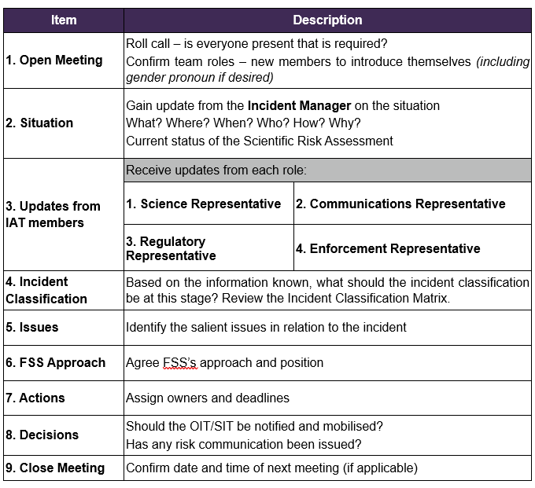

8.2 OIT Meeting Agenda
The OIT Meeting Agenda should be used by the OIT Chair during every OIT meeting. The agenda will support the team to build situational awareness, obtain initial thoughts on incident classification and receive key updates from division representatives/external agencies as required. The agenda also prompts the OIT to consider the appropriate course of action (i.e. whether the current incident classification is appropriate, or whether further escalation/de-escalation is required). The OIT Meeting Agenda can be found internally eRDM.
At the end of every meeting, a list of outstanding issues, actions and assigned owners/deadlines should be completed and captured in the Issues & Actions Log. Decisions with the associated rationale should also be captured in the Decision Log. A SitRep should also be produced (or updated) by the Information Manager at the end of each OIT meeting, as requested. All meeting documents and agreed decisions and actions should be uploaded to CLIO.

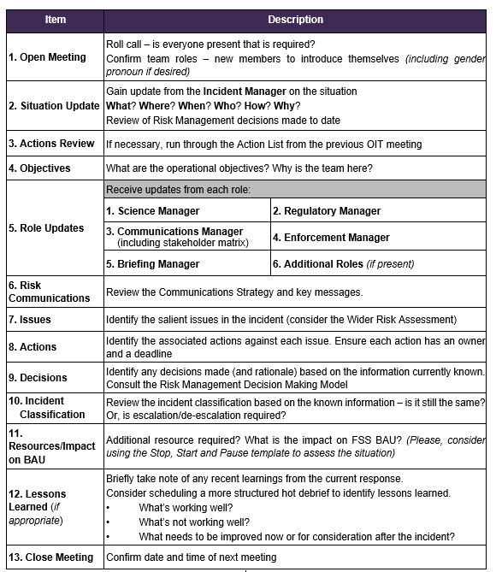

8.3 SIT Meeting Agenda
The SIT Meeting Agenda should be used by the SIT Chair during every SIT meeting.
The agenda will support the team to build situational awareness, obtain initial thoughts on incident classification and receive key updates from division representatives/external agencies as required. The agenda also prompts the SIT to consider the appropriate course of action (i.e. whether the current incident classification is appropriate, or whether further escalation to SGoRR/de-escalation is required). The SIT Meeting Agenda can be found internally eRDM.
At the end of every meeting, a list of outstanding issues, actions and assigned owners/deadlines should be completed and captured in the Issues & Actions Log. Decisions with the associated rationale should also be captured in the Decision Log. A SitRep should also be produced (or updated) by the Information Manager at the end of each SIT meeting, as requested. All meeting documents and agreed decisions and actions should be uploaded to CLIO.

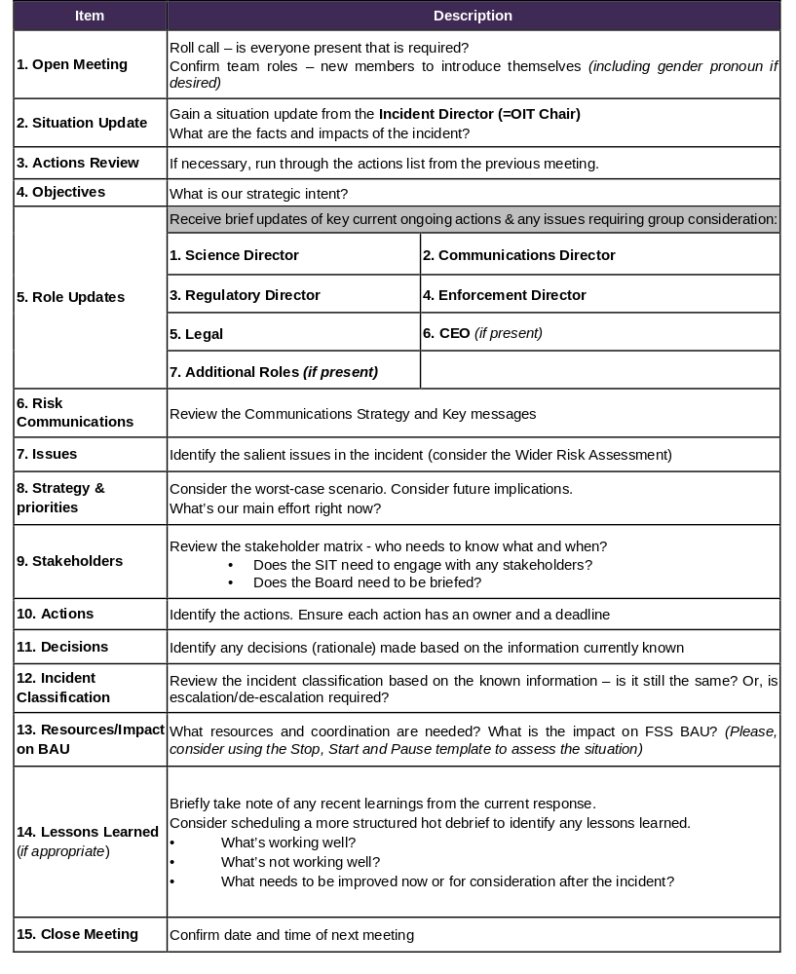

8.4 Information Board
The Information Board should be displayed in the incident room and uploaded to CLIO (when working remotely). The template is available internally in eRDM.
The Facilitator should capture the key information and be referred to during the course of the meeting by the relevant Chair, to ensure the team objectives are driving the response to the incident.

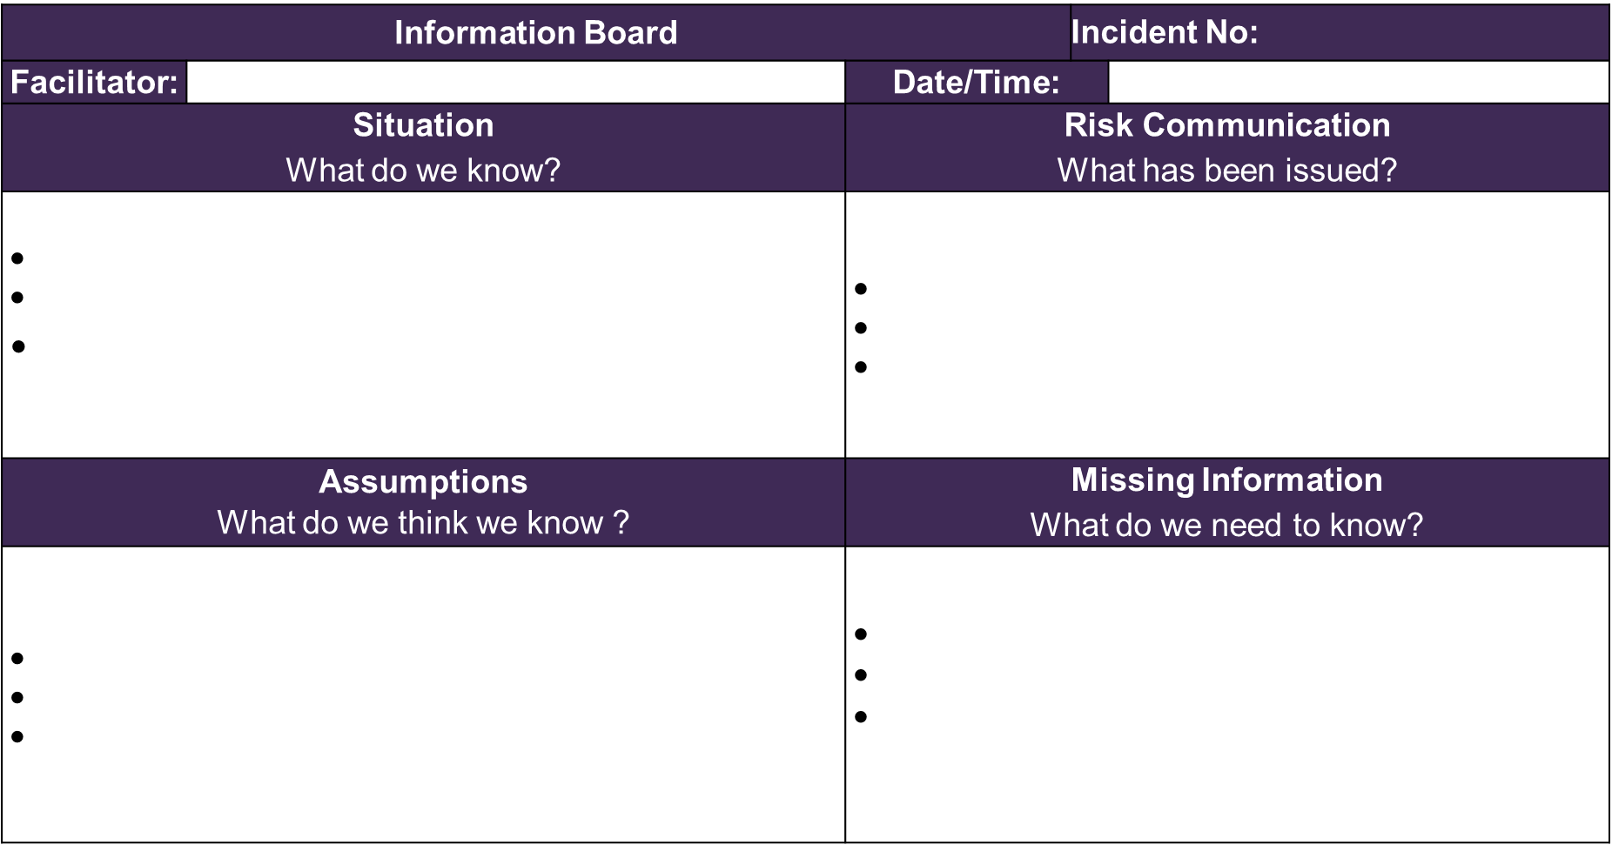

8.5 Objectives Board
The Objectives Board should be populated and managed by the Facilitator and uploaded into CLIO. This should be available on CLIO throughout the response and updated in line with FSS’s operational and strategic incident objectives. The template is available in eRDM.
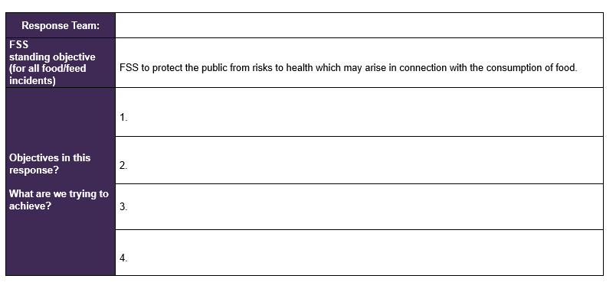

8.6 Decision Log
The Decision Log should be populated and managed by the Information Manager and uploaded onto CLIO after every meeting and each decision recorded too. This serves as an audit log of decisions made during an incident. The template is available internally in eRDM.

The Decision Log should have the decisions made by the OIT/SIT, as well as the rationale/justification for the decisions based on the information known at that time. New information should also be captured in the log, which provides a record of the known information at the point at which a decision was made. The date should be included next to each decision and new information recorded.

The Decision Log should be signed by the Chair (with the signature printed/provided electronically). The Information Manager should download this document and save as a new version in eRDM to be edited and saved in CLIO once complete and approved after each meeting.

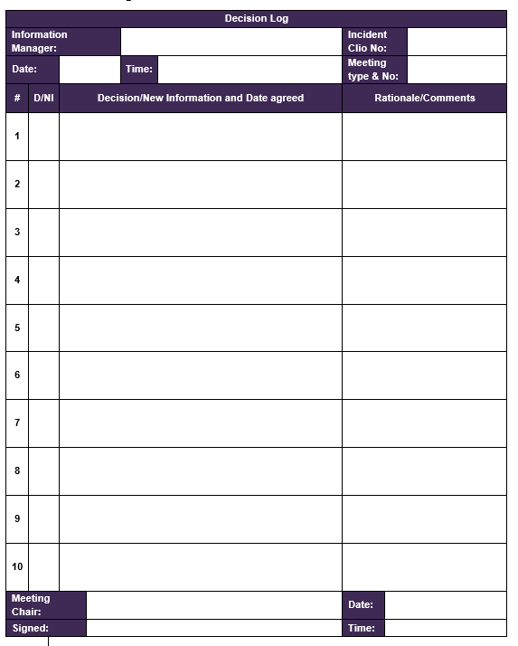

8.7 Issues & Actions Log
The Issues & Actions Log should be populated and managed by the Information Manager (and Admin Support as required) during each SIT and OIT meeting. The template log is available internally in eRDM, which includes a list to keep track of meeting attendance to assist with the allocation of an action owner and a section to summarise the key issues.
Each action should have a deadline and its status kept updated using the drop down list on the template. The Information Manager is expected to run through each action at meetings to gain an update on its status from the action owner, and then summarise any new actions agreed at the end of the meeting.
The Information Manager should download this document and save as a new version in eRDM to be edited and saved in CLIO once complete and approved after each meeting.
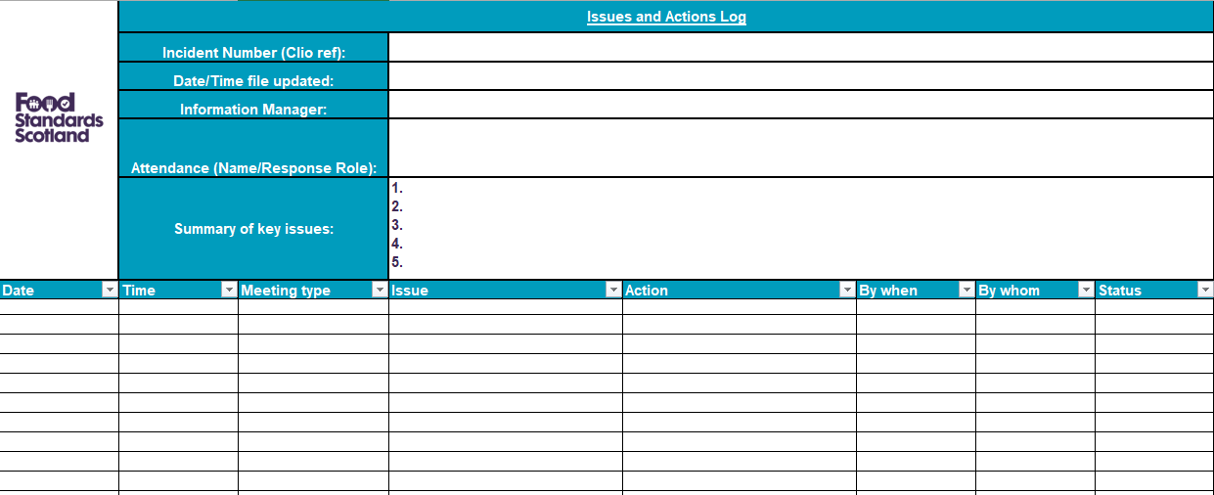

8.8 Situation Report

The Situation Report (SitRep) PowerPoint template is available internally in eRDM and is designed to provide an overview of the current situation. This includes a snapshot of the incident; key issues and potential risks that each team faces; current actions and response activities, collate any enquiries received in relation to the incident (if required) and; the time of the next meeting and report. The SitRep should be populated and updated by the Information Manager (and Admin support as required). This will include input from each role in the OIT/SIT team as needed.

During an incident, the OIT and/or SIT Chairs should agree with the Facilitator whether a Situation Report (SitRep) is required in addition to the Information Board, or whether the Information Board alone is sufficient. Where required, the frequency and timing of SitRep updates should be agreed. Once completed, the Information Manager should upload the SitRep to CLIO and circulate it to the agreed distribution list.

8.9 Stakeholder Management Matrix
The Stakeholder Management Matrix provides an overview of the internal and external stakeholders involved in the incident and it is available internally in eRDM. The OIT Communications Manager is responsible for populating and maintaining the matrix. It should be stored on CLIO.

It is not the Communications Manager’s responsibility to make contact with all stakeholders. This task will be delegated to the most appropriate person within FSS.

The Communications Manager will bring the most up-to-date matrix to OIT meetings to update the team on the current stakeholder engagement status.

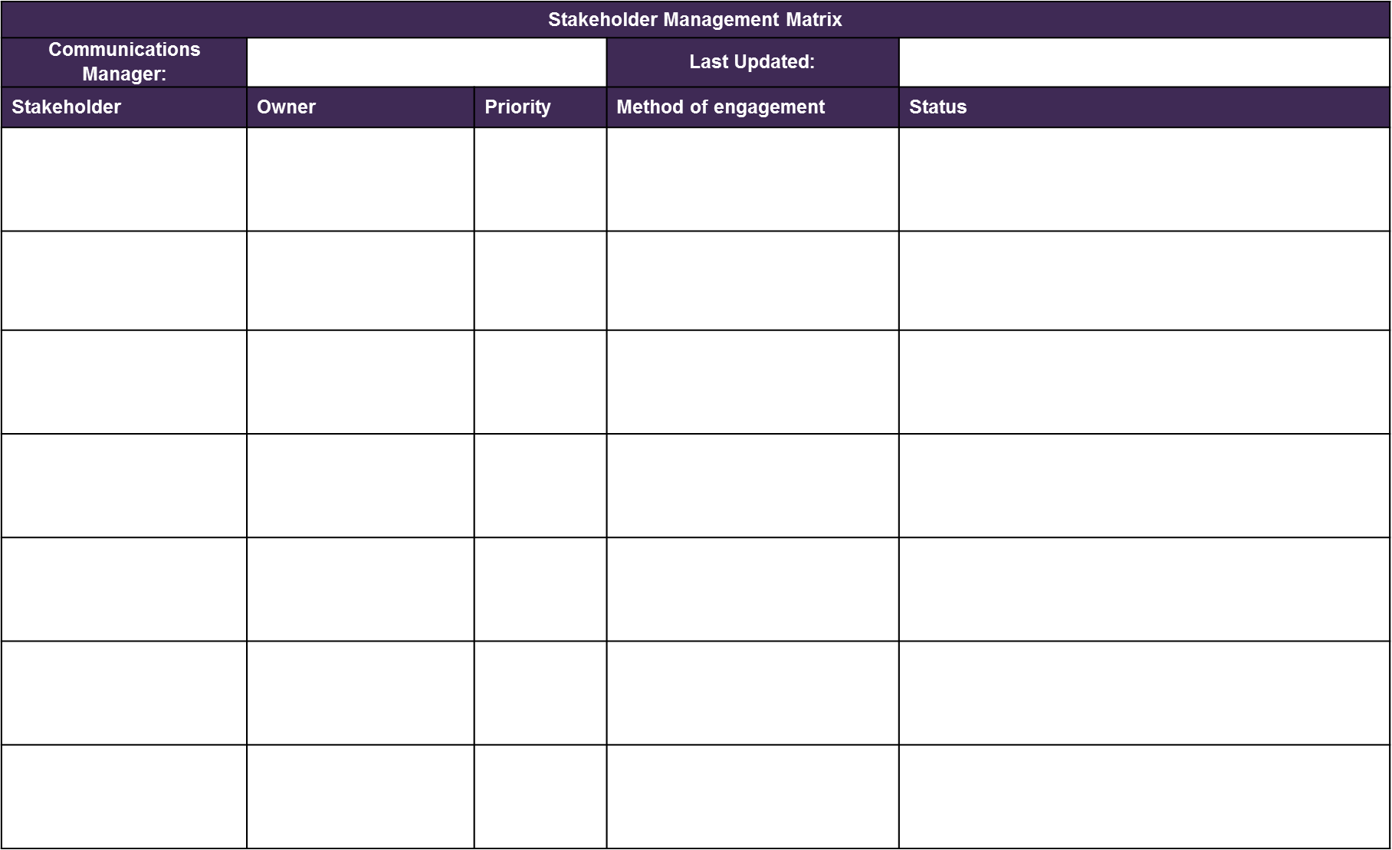

8.10 Hot Debrief and Lessons Learned Template
A blank version of the hot debrief and lessons learned templates are available internally in eRDM. The Facilitator is responsible for completing the templates with input from all team members when the topic is covered as an agenda item during and after an incident.
The Facilitator and/or Information Manager should circulate the template to all response team members and relevant stakeholders to consider immediately after the closure of an incident. This is to allow them to capture any initial feedback while it is front of mind and in advance of a formal debrief session. The Facilitator should download this document and save as a new version in eRDM to be edited and saved in CLIO once complete.

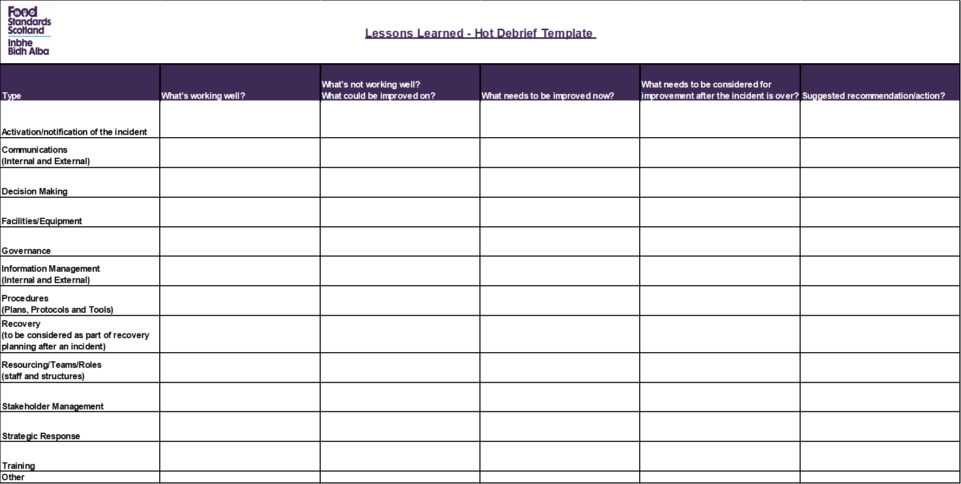

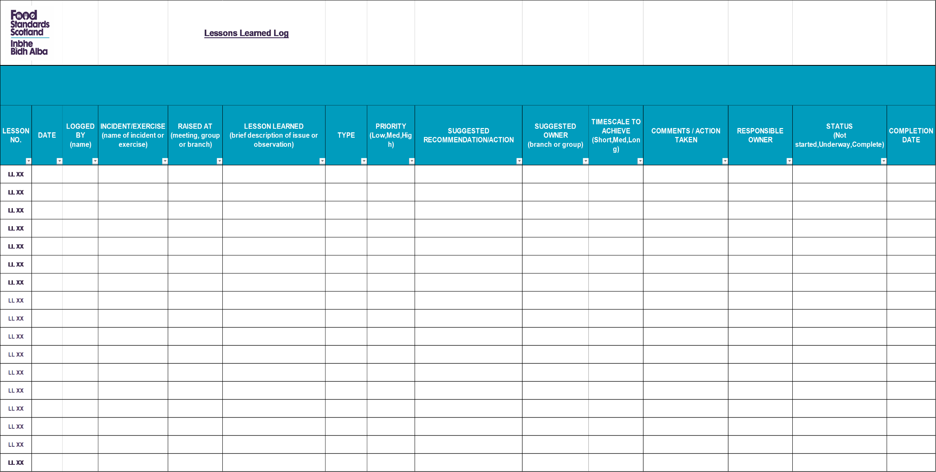

8.11 Shift Handover Log
OIT and SIT team members should use the Shift Handover Log to support them as they handover to a team member and it is available internally in eRDM. The template is designed to provide structure to the handover process and prompt the team members to give a full briefing when they handover.
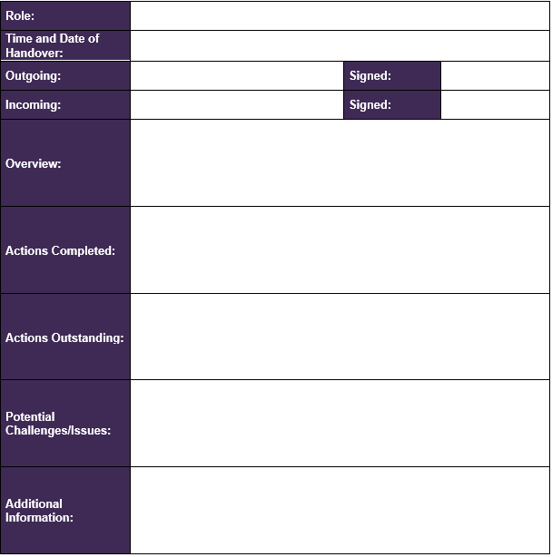

Annex A – Role Profiles
The following role profiles provide an overview of the required experience, skills and level of seniority required for each incident management position as part of FSS’s Incident Management Framework.
Role | Profile
OIT Chair (= Incident Director) | - Senior figure within the Incidents Team  - Good leadership skills with the ability to effectively and efficiently run team meetings  - Calm under pressure  - Well established relationships across FSS divisions.  - Familiar with and trained to use CLIO.
Incident Manager (=OIT and SIT) | - Member within the Incidents Team  - Good level of knowledge and experience of food and feed incidents  - Is able to provide a succinct brief on the incident situation  - Holds good relationships with operational stakeholders  - Calm under pressure  - Extensive knowledge of CLIO
Communications Manager | - Member of the Communications and Marketing division  - Considers incidents and crises through the lens of the public  - Is able to provide the OIT with a succinct brief on any communication or reputational issues  - Experience of risk mapping and scenario planning  - Extensive knowledge of FSS’s stakeholder external landscape  - Extensive knowledge of internal communications and engagement with staff during an inicdent  - Able to assess the potential reputational impact for FSS  - Calm under pressure  - Familiar with and trained to use CLIO.
Science Manager | - Member of the Science Division  - Has extensive scientific knowledge and experience in relation to food and feed incidents  - Is able to provide the OIT with a succinct brief on any scientific issues  - Has good communication skills and is able to effectively act as the link between the OIT and the supporting branch team  - Familiar with and trained to use CLIO.
Enforcement Manager – Local Authority (LA)  Enforcement Manager – Operational Delivery (Ops & Feed) | - Member of the Local Authority division  - Has extensive enforcement knowledge and experience in relation to food and feed incidents  - Familiar with relevant regulations and guidance i.e. Code of Practice, food and feed regulations.  - Is able to provide the OIT with a succinct brief on any enforcement and operational issues  - Has good communication skills and is able to effectively act as the link between the OIT and the supporting branch team  - Familiar with and trained to use CLIO.
Regulatory Manager | - Senior member of the Regulatory Policy Division  - Has extensive regulatory knowledge and experience in relation to food and feed incidents  - Is able to provide the OIT with a succinct brief on any regulatory issues  - Has good communication skills and is able to effectively act as the link between the OIT and the supporting branch team  - Familiar with and trained to use CLIO.
Briefing Manager | - Member of Private Office  - Has experience and knowledge of engaging with and preparing ministerial briefings  - Excellent writing and communication skills  - Familiar with and trained to use CLIO.
Deputy Managers | - Extensive knowledge of the operational detail in their division/branch.  - Excellent communications skills  - Able to support their manager at the OIT  - Familiar with and trained to use CLIO.
Incident Support | - Good experience and knowledge of food/feed incidents  - Extensive knowledge of CLIO  - Able to support the Incident Manager at the OIT
SIT Chair | - Must be the Deputy Chief Executive and Head of SFCIU as the deputy.  - Extensive leadership experience with the ability to lead the SIT through the process of making strategic decisions efficiently  - Calm under pressure  - Ability to consider incidents and crisis through a wider lens and awareness of organisational impact and reputational issues.  - Has the ability to adapt their leadership style to bring the best out of the team during challenging periods  - Authority to approve strategy, actions and messaging  - Relationship with priority external stakeholders  - Good level of understanding of food and feed incidents  - Good level of understanding of business functions and their responsibilities  - Familiar with and trained to use CLIO.
Incident Director (= OIT Chair) | - Senior figure within the business or SFCIU i.e. Head of SFCIU  - Good leadership skills with the ability to effectively and efficiently run team meetings  - Has good communication skills and is able to provide the SIT with a succinct brief on the situation  - Has good organisational skills and is able to effectively act as the link between the SIT and OIT  - Well established relationships with the Incidents Team and Incident Support Team  - Calm under pressure  - Familiar with and trained to use CLIO.
Incident Manager (= OIT and SIT) | - Senior figure within SFCIU i.e. Head of Incidents  - Has good communication skills and is able to provide the SIT with additional key information and details about the food chain investigation to help inform decision making  - Good level of knowledge and experience of food and feed incidents  - Has good organisational skills and is able to effectively act as the link between the SIT and OIT  - Calm under pressure  - Extensive knowledge of CLIO.
CEO | - Extensive leadership experience with the ability to support the SIT Chair through the process of making decisions efficiently, if required  - Calm under pressure  - Extensive knowledge of their business functions/subject areas to advise on strategy, actions and messaging in relation to these functions  - Strong relationship with key stakeholders  - Good level of understanding of food and feed incidents  - Act as FSS’s media spokesperson during certain incidents, as required  - Familiar with and trained to use CLIO.
Communications Director | - Senior representative of the Communications and Marketing Division  - Thinks strategically and is aware of the potential impact of an incident on industry and the wider economy  - Considers issues and crises through the lens of the public and what is in the best interests of consumers  - Able to advise on the strategic direction of communications during an incident and how the media narrative may impact on FSS’s reputation  - Extensive knowledge of internal communications and engagement with staff during an incident  - Extensive knowledge of FSS’s stakeholder external landscape  - Familiar with and trained to use CLIO.
Enforcement Director – Local Authority (LA) | - Senior representatives of the LA Delivery and Operational Delivery divisions  - Subject matter expert  - Strong relationships with external stakeholders, including LAs and industry bodies  - Extensive knowledge of relevant regulations and guidance i.e. Code of Practice, food and feed regulations.  - Ability to apply strategic perspective to the incident  - Familiar with and trained to use CLIO.
Enforcement Director – Operational Delivery (Ops & Feed)
Science Director | - Senior representative of their division  - Subject matter expert  - Strong relationships with operational personnel within their division  - Ability to apply strategic perspective to the incident  - Familiar with and trained to use CLIO.
Regulatory Director | - Senior representative of their division  - Subject matter expert  - Strong relationships with operational personnel within their branch  - Ability to apply strategic perspective to the incident  - Familiar with and trained to use CLIO.
Legal | - Senior member of the SGLD  - Considers issues and crises from a legal perspective  - Understanding of FSS objectives, and how these can be achieved within the constraints of legal considerations  - Good writing skills  - Confident – able to deal with objections to advice provided to FSS, and advise against suggested actions that may pose a legal risk  - Experience and understanding of food and feed incidents  - Well organised, with a high attention to detail
Facilitator | - Visible and well respected figure within the organisation  - Excellent organisational skills with a high attention to detail  - Relationship with, and understanding of, key internal division  - Good time management  - Able to summarise information efficiently  - Confident and competent in handling several tasks simultaneously  - Is comfortable engaging with the senior level of the organisation  - Has an excellent understanding of FSS’s incident management processes  - Familiar with and trained to use CLIO.
Information Manager /  Admin Support | - Good communication and writing skills  - Able to summarise information efficiently  - Well organised with a high attention to detail  - Good level of IT proficiency and adept at using CLIO  - Familiar with FSS’s incident management processes  - Good time management  - Confident and competent in handling several tasks simultaneously  - Uses initiative – able to assess and address administrative requirements without direction  - Familiar with and trained to use CLIO.

Annex B – Role of the Board
 | Responsibilities
Role of the Board -  Incident Management | - Risk: Review and agree FSS’s incident risk appetite annually for the Executive and how this may be impacted during an incident  - Governance: Review FSS’s Incident Management Framework to determine the appropriate response structure and be assured that procedures are in place to deliver consumer protection  - Assurance: gain assurance that FSS can effectively manage incidents through receiving updates on:  - training and exercising takes place as appropriate to build incident management capability within the organisation  - continuous improvement is in place and lessons are learnt from recent incidents and reflected in future updates of the Incident Management Framework and plans.  - Board preparedness: participate in incident management emergency exercises, where appropriate  During incidents, the Board supports the Executive and receives assurance in the following ways:  - Stakeholders: where appropriate, support with stakeholder engagement, for instance with Ministers, Members of Scottish Parliament or industry  - Reputation: support Executive actions to protect public health during an incident, whilst ensuring FSS’s reputation as a trusted organisation remains intact.  - Assurance: Through the Chair, or CEO, receive assurance that the incident is being prosecuted in accordance with the Incident Management Framework.
Role of the Chair  The Chair acts as the key liaison between the Executive and the remainder of the Board during incident management. | The responsibilities of the Chair, or their deputy, are as follows:  - Act as the link between the Executive and the Board  - In discussion with the CEO, determine if and when the Board should be briefed on issues and incidents that constitute a level 3 and above or may escalate to cause significant concern  - Support the Executive in strategic stakeholder management (i.e. Members of Scottish Parliament) on incident and crises, as required  - Act as FSS’s media spokesperson during certain incidents, as required.  - Act as a sounding board for the CEO, as required.



INTENTIONALLY BLANK

http://eur-lex.europa.eu/LexUriServ/LexUriServ.do?uri=OJ:L:2002:031:0001:0024:en:PDF

