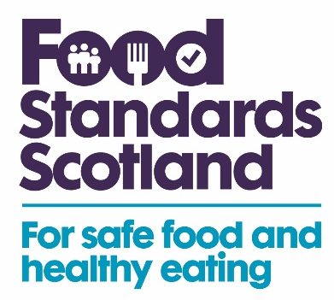

FSS Funded LA Food Sampling Programme 2026 - 27

Food type | Premises type | Testing parameters | Samples
Pistachio nuts | Retail | Salmonella | 50
Botanical/fibre supplements (moringa, green powders, psyllium etc) | Retail | Salmonella, labelling check inc. health claims | 50
Fresh Herbs | Retail | Salmonella, STEC, L. mono, B. cereus | 50
RTE sliced meats | Retail | Listeria monocytogenes, hygiene indicators | 50
Chilled, dairy-based desserts | Retail | L. monocytogenes, Bacillus cereus, Staphylococcus aureus, Salmonella, hygiene indicators | 50
Dubai and Dubai-style chocolate | Retail | Salmonella | 50
Plant based meat analogues | Retail | Aflatoxins, T2, HT2 | 40
Plant based protein powders | Retail | Acrylamide | 40
Jams, preserves | Retail | Sulphur dioxide (both as preservative and allergen), soluble solids, sugar content | 40
Oriental-style take aways | Caterers | Monosodium glutamate, salt | 40
Maize products - corn flakes, taco shells, tortilla chips | Retail | GMO event MIR-162 | 40
Dry Pasta | Retail | Cadmium | 40
Oat-based products | Retail | Aflatoxins, Ochratoxin A, DON, T2, HT2, Fumonisins, ZON | 40
Slushed ice drinks | Retail and caterers | Glycerol content | 40
Dubai and Dubai-style chocolate | Retail | Peanut (allergen), aflatoxins, labelling check | 40
Feta cheese | Retail | Presence of cow's milk (for authenticity) | 40
Tahini | Retail | Presence of peanut (allergen) | 40

