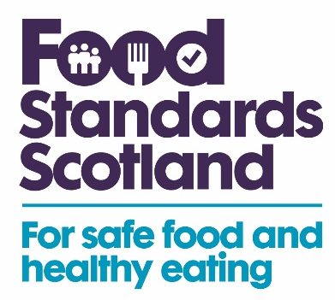

Annex 4.8 Notice of Revocation of Registration/Approval
The Feed (Hygiene and Enforcement) (Scotland) Regulations 2005 - Regulation 11
Notice of Revocation of Registration/Approval∗

1. To: …………………………………………………………………………………. (Feed Business Operator)
At: ……………………………………………………………………………………………………………….
……………………………………………………………………….. (Address of Feed Business Operator)
Name of feed business: …………….…………………………………………….......................................
Address of feed business: …………………………………………………………………………………...
………………………………………………………………………………………………………………………
2. You are hereby given notice that with effect from the [enter date revocation to be effective
from], your approval/ registration is revoked in relation to [here enter the activity (ies) for which the approval/registration is held] at [enter the address of the establishment(s) to which the revocation applies] because Food Standards Scotland is satisfied [insert one of the following three reasons here:
(1) the activity has ceased at the establishment,
(2) the establishment has not complied with the relevant requirements for the activity being undertaken stated in column one of the tables below, required by the Regulations,
(3) that serious deficiencies have been identified and/or production has had to be repeatedly stopped and furthermore that you are unable to give to the authority guarantees that future production will comply with European Community rules.]

To regain your approval/registration you must take remedial action, to the satisfaction of Food Standards Scotland, which is listed in column two of the attached schedule and reapply to Food Standards Scotland for approval/registration as appropriate.
Served on you on ……………………………………………………………………………………(date)
Signed: …………………………………………………………………………. …. (Authorised Officer)
Name in capitals: ……………………………………………………………………….......................
Address:………………………………………………………………............................
Tel: ………………………………………………………………………………………………………...
Email: ………………………………………………………………………………………………………
[* Officer to delete as appropriate]

Annex 4.8 Notice of Revocation of Registration/Approval (Reverse)

Right of Appeal

Take notice that under Regulation 13 of the Feed (Hygiene and Enforcement) (Scotland) Regulations 2005, you have a right to appeal to the Sheriff against the decision of Food Standards Scotland to revoke your registration/approval at (here enter the address of the establishment(s) to which the revocation applies). You must make your appeal within one month of the date on which this notice was served on you. If you are considering making an appeal, you are strongly advised to seek prompt legal advice.

Privacy Statement
Your personal information will be collected by Food Standards Scotland as required by Regulation (EC) 183/2005. This is be done in line with the General Data Protection Regulations (GDPR) and Data Protection Act 2018. For further information about how FSS handles your personal information, refer to our Privacy Notice on FSS website.

Annex 4.8 Notice of Revocation of Registration/Approval (Schedule)
Column 1  Relevant/essential conditions/duties not being complied with | Column 2  Action required to ensure compliance
[Enter appropriate reference to the Regulation (EC) 183/2005 - Feed Hygiene] | [Enter appropriate detail]

Carrying out these activities without the appropriate approval/registration is an offence under the Feed (Hygiene and Enforcement) (Scotland) Regulations 2005 and could result in prosecution.

