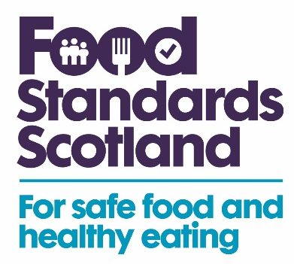

Notice of Suspension of Registration/Approval

The Feed (Hygiene and Enforcement) (Scotland) Regulations 2005 – Regulation 9
Notice of Intention to Suspend Registration/Approval∗

1. To: ……………………………………………………………………………… (Feed Business Operator) At: ………………………………………………………………………………………………………………..
……………………………………………………………………….. (Address of Feed Business Operator)

Name of feed business: …………….…………………………………………….......................................

Address of feed business: …………………………………………………………………………………...
………………………………………………………………………………………………………………………

Food Standards Scotland gives notice that on the [enter date suspension is to take effect from], the [enter the full name of the enforcement authority], proposes pursuant to regulation 9 mentioned above and Article 14 of Retained EU Regulation 183/2005 to suspend your approval/registration to [enter the activity(ies) for which the approval/registration is held] at [enter the address of the establishment(s) to which the suspension applies] because Food Standards Scotland is not satisfied that the relevant/essential conditions/duties stated in column one of the table in the attached schedule, required by the Regulations, are being complied with.

2. In order for the suspension to be lifted, you must take the remedial action listed in column two of the attached schedule, to the satisfaction of Food Standards Scotland. If the required remedial action has not been carried out to the satisfaction of Food Standards Scotland within twelve months of the operative date mentioned in paragraph 2 the approval/registration will be revoked without further notice.

Served on you on…………………………………………………….…………(date)

Signed: ……………………………………………………....…..(Authorised Officer)
Name in capitals: ……………………………………………........................................
Address:………………………………………………………………...............................
Tel: …………………………………………………………………………………………..
Email: ………………………………………………………………………………………………..

[* Officer to delete as appropriate]
Right of Appeal.

Take notice that under Regulation 13 of the Feed (Hygiene and Enforcement) (Scotland) Regulations 2005, you have a right to appeal to the Sheriff against the decision of Food Standards Scotland to suspend your registration/approval at [enter the address of the establishment(s) to which the suspension applies]. You must make your appeal within one month of the date on which this notice was served on you. If you are considering making an appeal you are strongly advised to seek prompt legal advice.

Privacy Statement
Your personal information will be collected by Food Standards Scotland as required Retained EU Regulation 183/2005. This is be done in line with the General Data Protection Regulations (GDPR) and Data Protection Act 2018. For further information about how FSS handles your personal information, refer to our Privacy Notice on FSS website.

Notice of Suspension of Registration/ Approval (schedule)

Column 1  Relevant/essential conditions/duties not being  complied with | Column 2  Action required to ensure compliance
[Enter appropriate reference - refer to the Retained EU Regulation 183/2005 - Feed Regulations] | [Enter appropriate detail]

