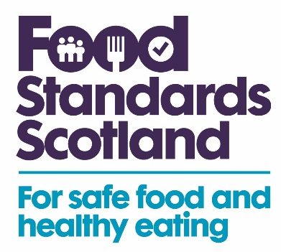

FSS Funded LA Food Sampling Programme 2025 - 26

Food type | Premises type | Testing parameters | Samples
Tomatoes | Retailers | Salmonella | 57
Ready to eat salad leaves | Retailers | Salmonella  Listeria monocytogenes  Shiga toxin-producing E. coli | 57
Beansprouts | Retailers | Salmonella  Listeria monocytogenes  Shiga toxin-producing E. coli | 57
Unpasteurised French cheese | Retailers, Caterers | Salmonella  Listeria monocytogenes  Shiga toxin-producing E. coli | 57
Sunflower, sesame and chia seeds | Retailers | Salmonella | 57
Oat ‘milk’ | Retailers | Bacillus cereus | 57
Vegan cheese alternatives | Retailers | Salmonella, Listeria monocytogenes | 57
Imported tomatoes and peppers | Retailers | Cadmium | 57
Eggs | Retailers | PFAS | 57
Dried Figs | Retailers | Aflatoxins, Ochratoxin A | 57
Fresh or frozen tuna or mackerel | Retailers | Histamine | 57
Flaxseed (linseed) | Retailers | Cadmium | 57
Magnesium, calcium or iron supplements | Retailers | Accuracy of declaration, Health claims, Labelling | 57
Sunflower or rapeseed oil | Caterers | Fatty Acid Methyl Esters (for authenticity) | 57
Garlic powder or granules | Retailers | Peanut, Gluten | 57
Dairy-free Indian takeaway meals | Caterers | Milk | 57

