Action Note 2025/11/01: Chapter 2.7: SRM Controls
BSE Negligible Risk (NR) status

Purpose

This Action Note (AN) is to inform all Authorised Officers (AOs) of the European Union’s (EU) recognition of Scotland, England and Wales as having Bovine Spongiform Encephalopathy (BSE) Negligible Risk (NR) status, and to outline the implications for Food Standards Scotland (FSS) Official Controls (OC) and trade activities.

This AN replaces AN 2025/06/01 which is now revoked.

Background

On 29 May 2025, Scotland, England and Wales were recognized by the World Organisation for Animal Health (WOAH) as having BSE NR status, previously they were recognised as controlled risk (CR). Northern Ireland (NI) achieved NR status in 2017.

This changed the definition of Specified Risk Material (SRM) for bovine animals that originated in these countries, and some tissues were no longer designated as SRM and required to be disposed as category 1 animal by-product (ABP) under domestic legislation.

The EU did not automatically recognise the BSE NR status, as their process for recognition required the amendment of Commission Decision 2007/453/EC, which was estimated to take around 6 months. FSS, FSA, Defra and Industry representatives working in partnership agreed to recommend industry to continue applying CR requirements to protect the trade with the EU.

The EU has now formally recognised Scotland, England and Wales as having BSE NR status. Commission Implementing Decision (EU) 2025/2208, amending the Annex to Commission Decision 2007/453/EC as regards the BSE status of certain regions of the United Kingdom, was published on the 4th of November 2025 and will become legally binding from the 24th of November 2025.

SRM definition for CR, undetermined risk, and NR countries can be found in Regulation (EC) No 999/2001, Annex V, Division 1 and 2 and are also resumed in Annex 1 below.

Please note there are no changes to the SRM definition in sheep and goats.

Procedure

From the 24th of November 2025, animals from Scotland, England and Wales may be processed under NR requirements and their products exported to the EU and NI.

FBOs will still be required to remove and dispose as SRM the skull (excluding the mandible), brain, eyes and spinal cord of bovines over 12 months of age. Other tissues no longer defined as SRM under NR status can be disposed as ABP Category 2 or 3, or, when harvested hygienically, be sold for human consumption (with the exception of the tonsils, which require removal under Regulation 853/2004, Annex III, Section I, Chapter IV, paragraph 16 (a)).

FBOs will need to update their current standard operating procedures (SOPs) and HACCP based procedures accordingly, before they can implement any changes to their operations and / or products.

Animals originating from regions or countries that are not recognised as having BSE NR status (such as Isle of Man, Guernsey or Greece) would still require the removal of SRM as defined for controlled or undetermined BSE risk status and identify any over 30 months (OTM) bovine carcases, half carcases or quarters with a red striped label. OTM carcases, half carcases or quarters will need to be sent to cutting establishments authorised to remove SRM vertebral column.

Cattle and carcases from countries or regions not recognised as NR

While most animals slaughtered in the UK will have a UK origin, and imported meat should be free of SRM, there is still a possibility that animals or carcases (including half carcases or quarters) from controlled or undetermined BSE risk countries or regions enter the UK.

All EU countries except Greece are recognised as NR, Greece is currently CR.

Isle of Man and Guernsey have an undetermined BSE risk, and animals and their meat may be imported, mainly to England, for processing. Therefore, it is crucial that FBOs consider how these animals and their meat could be identified as part of their intake and SRM controls.

Animals from Isle of Man and Guernsey can be identified by their ear tags:

- Isle of Man: tags contain the 3-leg logo or the Crown. Number always starts with UK 01.
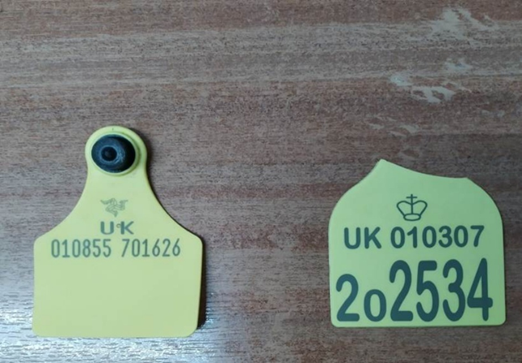

- Guernsey: tags contain the gold lions logo. Number always starts with UK 02.

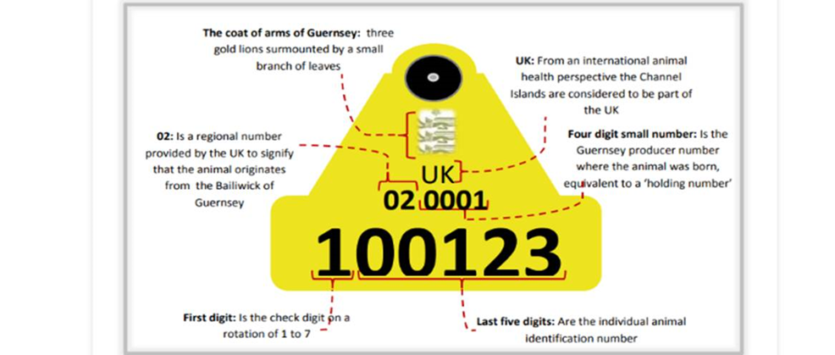

Export Health Certificates (EHCs) and supporting documentation

From the 24th of November 2025, OVs and COs will be able to certify that the country or region of origin of the meat is classified in accordance with Commission Decision 2007/453/EC as a country or region posing a negligible risk, when meat is originating from Scotland, England or Wales.

Also from this date, OVs and COs will be able to certify that animals were born, continuously reared and slaughtered in a country or region classified in accordance with Decision 2007/453/EC as a country or region posing a negligible BSE risk, when animals were born, raised and slaughtered in Scotland, England and/or Wales. This can be certified even when animals were slaughtered before the 24th of November, as on the day of the certification the country will be classified as NR.

OVs issuing Support Health Attestations (SHAs) and EHCs should ensure that the relevant sections are certified in point II.1.8, depending on the origin of the animals and meat. To achieve this, OVs should ensure that FBOs have systems in place to identify animals and meat originating from countries or regions under controlled and undetermined BSE risk, in particular animals and meat arriving from Isle of Man, or Guernsey.

New bovine SHA templates to be used from the 24th of November 2025 can be found in SharePoint, Export folder: SG - FSS Operational Delivery - OD Documents - Exports - All Documents.

Notes for guidance (NFG) for EHC 8368 (Fresh meat intended for human consumption, excluding mechanically separated meat, of domestic bovine animals to the European Union and Norther Ireland), will be amended by DEFRA to reflect the above changes.

It is also important to remember that other importing countries may have their own requirements regardless of the BSE risk status recognition by WOAH or the EU. For instance:

- Japan only accepts meat from under 30 months (UTM) bovine animals and still requires the removal of tonsil material from tongues,
- South Africa requires removal of all nervous and lymphatic tissue;
- and USA maintains their own list of the BSE statuses and accepts applications to determine status.

In slaughterhouses, the FBO is responsible to ensure that any red striped labelled carcase, when appropriate, is either dispatched to an authorised cutting plant or exported with the red label to the destination country before signing the certificate for that meat.

Summary
From the 24th of November 2025, the European Union will officially update Commission Decision 2007/453, recognising England, Scotland, and Wales as having BSE NR status. This update means that:

  - Products derived from bovine animals in GB using NR status controls can now be exported to the EU and Northern Ireland.
  - SRM handling and certification requirements for export to the EU and NI will now align with regulations that applies to countries under NR status.
  - FBOs should now update their HACCP and SOPs to reflect NR status for both domestic and export markets.
  - Some British territories and some imported cattle are still not NR and are still to be treated accordingly.

Field Staff are required to:

- Note the contents of the Action Note, plant attending OVs to ensure that the Action Note is read by all FSS staff, and this is noted in the Action/ Information Log.
- Discuss the contents of the Action Note with those FBOs processing bovines in their attending plants and ensure any changes in processing or products is supported by SOPs and HACCP based procedures.
- Print a copy of this note for the plant file.

This Action Note will be:

- Uploaded to the Action Note Live Folder and Operations tracker log on SharePoint.
- Forwarded to Website mailbox (websiteteam@fss.scot) for publication on our website.

The Action Note will remain live until either incorporated in the SMOC or revoked.
Copies of the live and revoked Action Notes can be found on SharePoint.

Action Note drafted by | Action Note agreed by | Published | Revoked
Albert Conca | Miriam Diaz | Chris Quick
12/11/2025 | 21/11/2025 | 21/11/2025

Annex 1 – SRM definition for animals originating from a country or region with a controlled (CR) or negligible (NR) BSE risk

Tissues designated as SRM (Regulation 999/2001, Annex V, 1 (a) & 2) | CR status | NR status
Skull, brain and eyes (excluding the mandible) of bovines over 12m of age | SRM | SRM
Spinal cord of bovines over 12 months | SRM | SRM
Vertebral column (excluding the vertebrae of the tail, the spinous and transverse processes of the cervical, thoracic and lumber vertebrae and the median sacral crest and wings of the sacrum, but including the dorsal root ganglia, or bovines over 30 months) | SRM | NOT SRM
Tonsils of all ages | SRM | NOT SRM
Mesentery including mesenteric fat, mesenteric ganglion complex and mesenteric nerves of bovines of all ages | SRM | NOT SRM
Caecum of all ages | SRM | NOT SRM
Last 4 m of the small intestine of bovines of all ages (small intestine comprises of duodenum, jejunum and ileum) | SRM | NOT SRM

Action/Information Log
Action Note Number: 2025-11-01
SMOC Chapter: Chapter 2.7 SRM Controls
Implementation Date: 24-11-2025

(Signing the charter below certifies that the Action/Information has been read and understood)
Print Name | Designation | Date | Signature

