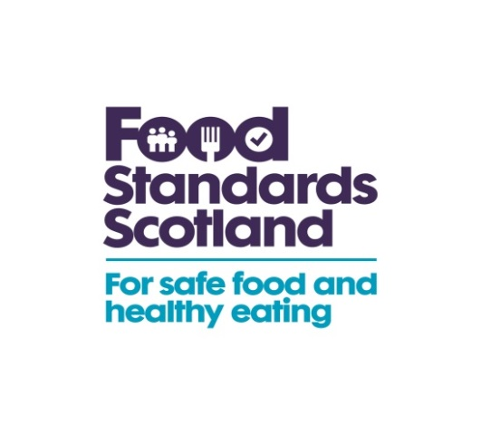

Launching Friday, 17 June 2016

Nothing Spoils Summer like Pink Chicken!

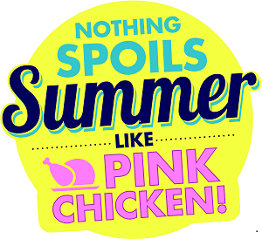

We hope you’ll be able to support Food Standards Scotland’s campaign to increase awareness of the risks of food poisoning when barbecuing chicken over the summer season.

This toolkit includes:

- Stats and facts on why this campaign is needed

- Information on when and where the campaign is running

- Suggestions for how you can get involved

- Suggested tweets and posts

- A press release

Why is an awareness campaign needed?
- The campaign was created in response to evidence which shows that increases in barbecuing, and chicken purchase and consumption during June-August, coincide with peaks in Campylobacter infection, which is the most common form of food poisoning in Scotland.
- There are more than 6,000 reported Campylobacter cases in Scotland each year (some estimates put the figure at nine times as many due to under-reporting of the illness).
- Of these reported cases, 60-80% of Campylobacter infections are attributed to a chicken source.
- The campaign will encourage people in Scotland to check that chicken is properly cooked to ensure they, and their friends and family, don’t come down with Campylobacter poisoning.
- Research conducted by Kantar Worldpanel identified that around half (50%) of barbecued food is eaten by people under the age of 34.

Who are the target audience for this campaign?
Scottish consumers under the age of 34, and in particular (but not exclusive to) young men. This is based on research from Kantar Worldpanel which identified that around half (50%) of barbecued food is eaten by people under the age of 34, and is particularly popular with young adult males. FSS research has also shown that this group are less aware of or concerned about Campylobacter.

What would we like you to tell people?

- The latest campaign highlights some simple steps everyone can take to reduce the risk of becoming ill through eating chicken that hasn’t been prepared or cooked properly.
- Always make sure: there’s no pink meat, the juices run clear, and it’s cooked to 75°C.
- When you’re cooking any kind of meat on the barbecue, make sure coals are glowing red with a powdery grey surface as this means they’re hot enough.
- Different cuts of chicken will take different times to cook through – put larger pieces and bone in cuts on the barbecue first to make sure they’ve enough time to cook.
- Before serving, always remember to check that there is no pink meat, and that it’s steaming hot in the centre.
- FSS recommends using a meat thermometer if you can to make sure it’s reached a safe temperature (75°C).
- It’s also a good idea to cook chicken in the oven first and finish it off on the barbecue for flavour.
- Always use separate tongs, utensils and plates for raw and cooked chicken, and regularly wash hands.
- Food poisoning can be contracted through chicken which is not properly cooked, contamination between raw chicken and cooked foods, poor hygiene, or food which has been left in the warmth for bacteria to grow.
- More than three-quarters of people in Scotland don’t worry about food poisoning.

When will the campaign run?

The campaign will run from Friday 17th June to Sunday 7th August.

Our ambition

To increase awareness of, and reduce complacency about, the risks of food poisoning when cooking chicken outdoors over the summer season, particularly when barbecuing with family and friends.

To encourage uptake of specific food hygiene actions and motivate behavioural change amongst our target audience.

What marketing is happening?

The media channels for FSS’s new summer BBQ Food Safety Campaign will include:
- 48-sheet and 6-sheet digital outdoor posters.
- A radio advert.
- Videos featuring on digital platforms such as YouTube, Spotify, Instagram, Twitter, Facebook and Adludio.
- Website landing page with a campaign badge.
- Press release with accompanying Pink Chicken imagery.
- A toolkit for stakeholders such as Local Authorities.

1. Outdoor posters

2. Campaign badge

3. Radio advert

4. Video link

60 sec - https://youtu.be/BqtqJi_6U9E
20 sec playlist - https://youtu.be/oUa-0B2Hphc
Instructions to embed the campaign video on your own website:
- follow the above link to our YouTube video
- click the 'Share' button below the video
- click the 'Embed' button next to the link they show you
- copy the iframe code given and paste it into the html (source code) of your web page.

Suggested Activities

From Friday 17th June you can:

- Use the campaign hashtag #pinkchicken

- Connect with us: Twitter: @FSScot, Facebook Page: Food Standards Scotland, Instagram: @FSScot, YouTube: Food Standards Scotland

- Interact with our humorous pink chicken troll on Twitter

Pink Chicken troll
FSS has created the character of ‘Pink Chicken’ who’s a nuisance to Scottish consumers trying to enjoy their summer. His Twitter profile (@PinkChickenScot) will launch on Friday, 17 June and he’s out to ‘troll’ (annoy) people online who support the messages behind FSS’s Pink Chicken campaign which minimise Scottish consumer’s risks of contracting Campylobacter infection this summer.

To the public, it will appear as if this character is pestering FSS and its stakeholders in the live environment however his ‘trolls’ will be pre-determined and stakeholders who have agreed to be involved will see and approve these posts from Pink Chicken in advance, as well as have time to prepare their own ‘reaction’ in advance.
An example of one of Pink Chicken’s ‘trolls’ to FSS is: ‘@FSScot Scotland better watch out as I’m planning on visiting a record amount of BBQs this year - don’t forget to send a postcard from your sick bed!’
An example reply from FSS is: ‘Don’t let @PinkChicken beat his record number of visits to BBQs in Scotland this year, follow our simple tips here foodstandards.gov.scot/pinkchicken for a safe and enjoyable summer’
Each Local Authority is welcome, and we’d love as many as possible, to be part of the ‘play’ if they are on Twitter. Please email FSS Social Media and Communications Manager, Holly McLennan holly.mclennan@fss.scot by COP Monday, 20 June 2016 if you’re interested in being part of the fun, where you will receive more information on how you too can easily help raise awareness and motivate behaviour change in your area.
In addition, FSS will put up a pinned Twitter post on Monday 20 June which will call upon stakeholder to retweet a post stating that ‘pink chicken spoils summer’. It will attempt to ‘shut pink chicken down’ if we get 100 retweets by the end of the week. There will also be the hashtag #shutpinkchickendown
- Signpost our online resource using the campaign badge with the weblink behind, http://www.foodstandards.gov.scot/pinkchicken

- Link from your website to our video on YouTube - see video link above with instructions

Social media

Twitter, Facebook and Instagram are great ways to engage directly and build relationships with consumers. We’ll be looking out for your tweets and will join in, including retweeting, where we can.

Below are some suggested posts/tweets to help you get the conversation started:

- We’re supporting @FSScot Pink Chicken BBQ Food Safety Campaign to minimise Campylobacter infection risk (foodstandards.gov.scot/pinkchicken) #pinkchicken

- Nothing spoils summer like #pinkchicken follow @FSScot for more info (foodstandards.gov.scot/pinkchicken)

- When barbecuing chicken, follow the @FSScot simple advice. Make sure: there’s no pink meat, the juices run clear, and it’s cooked to 75 °C #pinkchicken

Further advice and assistance on social media can be obtained from the FSS Social Team by contacting Holly McLennan at: Holly.McLennan@fss.scot

Website/ Newsletter Copy

For more information on cooking and food preparation see our tips, attached, which are also on FSS’s campaign web page foodstandards.gov.scot/pinkchicken

Press Release and images

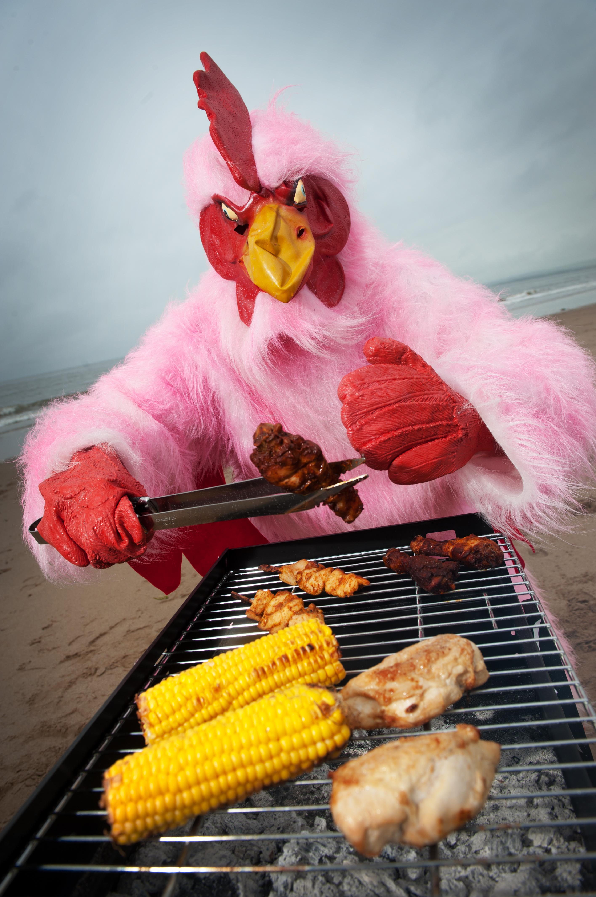
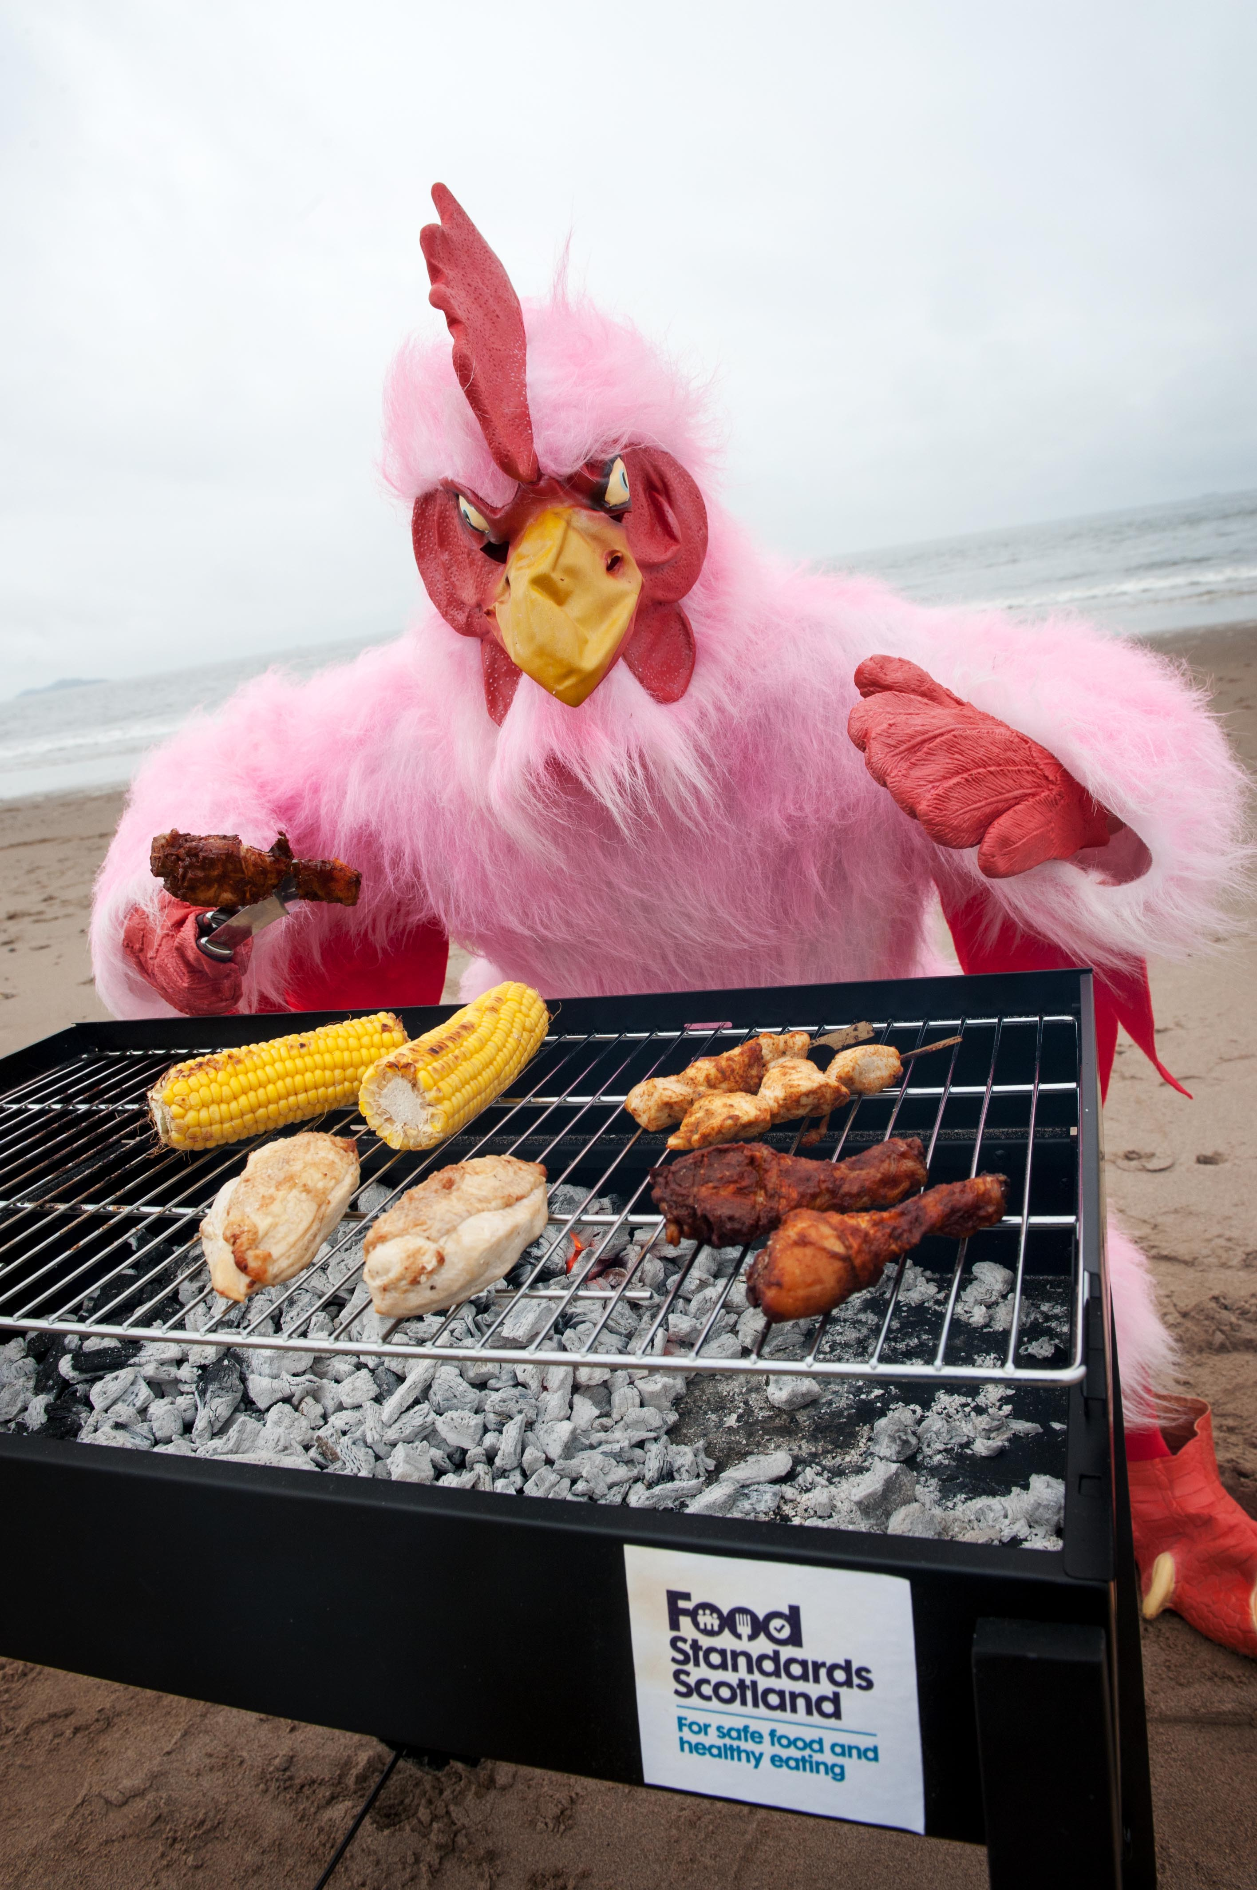
Press Release for LAs to use (please insert name and position of spokesperson to quote)

EMBARGO: Friday, 17 June 2016

People in (insert location) urged to watch out for ‘Pink Chicken’ in new BBQ Food Safety Campaign

As people in (insert area) keep their fingers crossed for more barbecue weather, (insert Local authority) are supporting Food Standards Scotland (FSS)’s summer BBQ food safety campaign: ‘Nothing spoils summer like Pink Chicken’.

Scotland’s public sector food body’s memorable campaign which will see a Pink Chicken go about Scotland creating mayhem and ‘spoiling summer’. This is in response to evidence which shows that increases in barbecuing and chicken purchase and consumption during June-August coincide with peaks in Campylobacter infection, which is the most common form of food poisoning in Scotland.

FSS highlighted that there are more than 6,000 reported Campylobacter cases in Scotland each year, with some estimates putting the actual figure at nine times as many due to under-reporting of the illness. Research has shown that 60-80% of Campylobacter infections in Scotland can be attributed to a chicken source.

(insert LA) is encouraging people in (insert area) to check that chicken is properly cooked to ensure they, and their friends and family, don’t come down with food poisoning. Research conducted by Kantar Worldwide Panel identified that around half (50%) of barbecued food is eaten by people under the age of 34, and is particularly popular with younger men.

(Insert name and position from LA) said: “Food poisoning can really spoil summer but there are some simple ways of reducing the risks of getting ill, which is why we’re getting behind this campaign. Always make sure there’s no pink meat in the chicken, the juices run clear and it’s cooked to 75°C. Watch out for that pink chicken!”

Jacqui McElhiney from FSS said: “We really don’t want food poisoning ruining people’s enjoyment, so when you’re cooking any kind of meat on the barbecue, make sure coals are glowing red with a powdery grey surface as this means they’re hot enough. Also, bear in mind that different cuts of chicken will take different times to cook through - put larger pieces and bone in cuts on the barbecue first to make sure they have enough time to cook. We recommend using a meat thermometer if you can to make sure it’s reached a safe temperature (75°C). It’s also a good idea to cook chicken in the oven first and finish it off on the barbecue for flavour.

There’s lots of advice on our website at foodstandards.gov.scot to help you reduce the risks of food poisoning and spoiling your summer BBQ.”

ENDS

Notes to editors

Further stats

- Campylobacter is a bacterium that causes food poisoning and the last annual retail survey (published by Food Standards Agency in 2015) found that as much as 73% of all chicken sold in shops was contaminated.
- There are at least 6,000 cases of Campylobacter poisoning in Scotland every year. Some estimates put the figure at nine times as many due to under-reporting of the illness.
- Cases of Campylobacter peak during the summer months.
- Around half of barbecue food is eaten by people aged 34 or under, and is particularly popular with young males.
- Over three-quarters of people in Scotland aren’t worried about food poisoning.
- Symptoms of Campylobacter poisoning include diarrhoea, abdominal pain, fever and in some cases also nausea and vomiting. For some people, Campylobacter poisoning can result in serious illness including irritable bowel syndrome (IBS), reactive arthritis and, in rare cases, Guillain-Barré syndrome – a serious condition of the nervous system. At its worst, campylobacter can kill.

Food Standards Scotland three simple food safety tips this summer are:

When barbecuing chicken, always make sure:

  - There’s no pink meat
  - The juices run clear
  - It’s cooked to 75 °C

Food Standards Scotland
- Food Standards Scotland (FSS) was established on 1 April 2015 by the Food (Scotland) Act 2015 as a non-ministerial office, part of the Scottish Administration, alongside, but separate from, the Scottish Government.
- FSS is mainly funded by government, with a budget of £15.7m agreed within the Food (Scotland) Act 2015, but also charges fees to recover costs for regulatory functions.
- The organisation is based in Aberdeen, and has approximately 150 office and field-based staff.
- The primary concern of FSS is consumer protection – making sure that food is safe to eat, ensuring consumers know what they are eating and improving nutrition. FSS’s stated vision is to deliver a food and drink environment in Scotland that benefits, protects and is trusted by consumers.
-The objectives of FSS as set out in the Food (Scotland) 2015 Act are to:
  - Protect public from risks to health which may arise in connection with the consumption of food
  - Improve the extent to which members of the public have diets which are conducive to good health
  - Protect the other interests of consumers in relation to food

For press information please contact Holly McLennan at: Holly.McLennan@fss.scot

