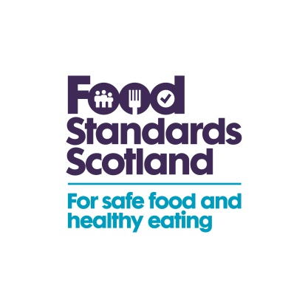

Directors of Environmental Health
Interested Fishery Organisations
Directors of Public Health and Consultants in Public Health Medicine
Fishery Offices
Monday 23rd December 2019

Dear Sir/Madam,

THE FOOD HYGIENE (SCOTLAND) REGULATIONS 2006: OFFICIAL CONTROL BIOTOXIN MONITORING (LIVE BIVALVE MOLLUSCS) PROGRAMME

Please find attached information relating to biotoxin, E coli and phytoplankton samples submitted for testing within Scottish waters for the period ending Friday 20th December 2019.

BIOTOXIN TEST RESULTS (CLASSIFIED AREAS AND COMMERCIAL PROCESSORS)

PHYTOPLANKTON RESULTS

E. COLI TEST RESULTS

Please note the key which accompanies the biotoxin report. This table continues over the page.

The action (closure) levels for toxins in shellfish flesh are as follows:
ASP >20mg Domoic/epi-Domoic acid per kg shellfish flesh
PSP >800µg STX eq. per kg shellfish flesh
Lipophilic toxins (DSP) by MBA - Positive
OA/DTXs/PTXs together >160µg OA eq. per kg shellfish flesh
AZAs >160µg AZA eq. per kg shellfish flesh
YTXs >1mg YTX eq. per kg shellfish flesh
Toxin concentrations ≥ action level
Toxin detected/clinical signs observed below action level

MU = measurement uncertainty
RL = Reporting Limit [either the LOQ of the method for the toxin/species combination or the concentration of the lowest calibration standard depending on which one is the highest.]
PS = Positive
ND = Not Detected
NG = Negative
LOD = Limit of Detection
LOQ = Limit of Quantitation
Insufficient/Unsuitable sample

For details of any Temporary Closure Notices and/or Warning Notices please contact your Local Authority Environmental Health Officer for advice.

The absence of information is not necessarily indicative of the area being free of biotoxins. It remains the responsibility of food business operators to ensure that their products comply with all relevant statutory requirements.

Please note that this report reflects the weekly biotoxin, E coli and Phyto plankton results reported on Tuesday of each week. All the results are posted on our website at:

http://www.foodstandards.gov.scot/food-safety-standards/advice-business-and-industry/shellfish/shellfish-results

Yours faithfully

Caroline Thomson

Shellfish Unit

