Other Forms
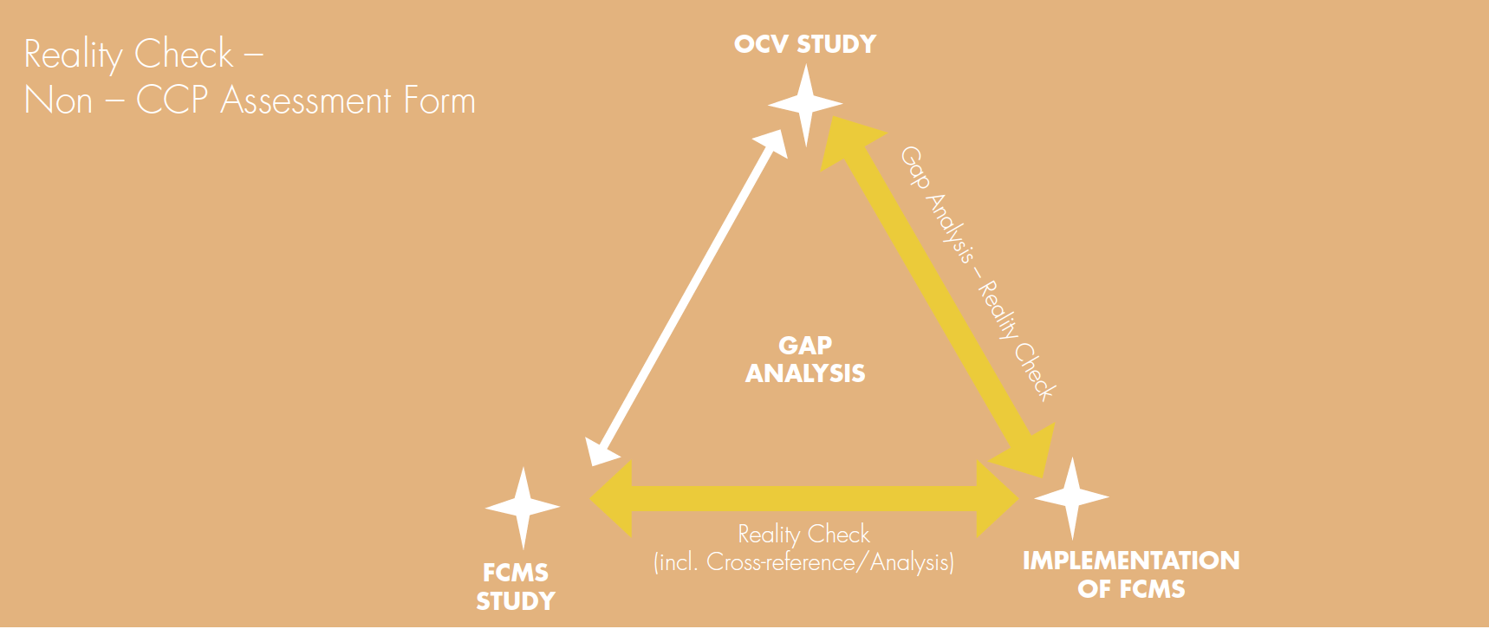
Business Name:
Officer:
Date of Reality Check:
Product:
CCP:

Record Sources of Evidence
Has the Step been correctly identified? (PRP/OPP etc)
Controls and Limits
(Appropriate, achieved in practice)
Monitoring
(Appropriate frequency, trained staff, consistent with written procedure)
Corrective Actions
(Are these being actioned when required, consistent with written procedure)
Records
(Accessible, correct version, completed correctly)
Is the CCP under control?
Evidential Triangulation – record sources of evidence.

