Form - Traceability/Product Recall/Mass Balance
Business Name:
Officer:
Date of Reality Check:
Product:
CCP:
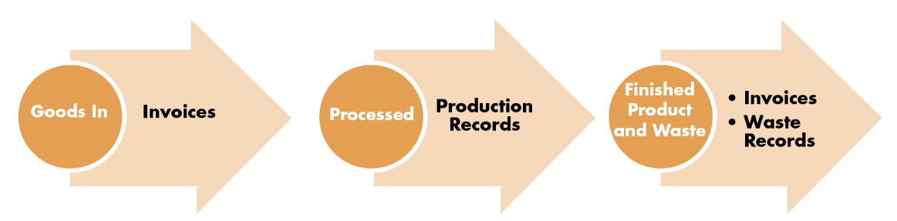

Record Sources of Evidence
Can ingredients be traced back to intake and supplier (reverse trace) or can all products produced with affected product be identified? (forward trace)
Can the FBO identify all product which requires to be recalled?
Mass Balance
Ability to effectively identify and contact customers
Recommended improvements to system

