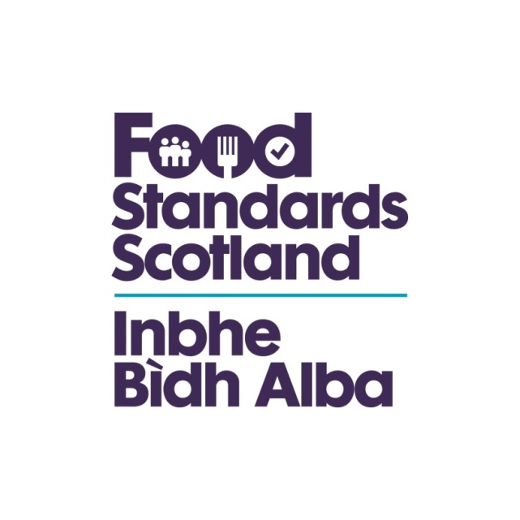
Food Standards Scotland
Audit of Local Authority Implementation of Interventions Food Law Code of Practice
(Scotland)

This document is subject to continual review, please check the FSS website for the latest version.

Food Law Code of Practice (Scotland) 2019

Interventions Food Law Code of Practice (Scotland) 2019

REGISTRATION OF FOOD BUSINESS ESTABLISHMENTS | Answer | Additional Notes
1. Are there established procedures for FBO to follow when applying for the registration of their establishments? |  | (2.1.2)
2. Is there a list of FBO which have been registered? (2.2.1)  Is this available for inspection by the general public at all reasonable times ? Are minimum requirements captured (name FBO, name food business establishment, address food business establishment, scope and nature of the food business)?  How is this maintained? |  | Article 6(2) of Regulation (EC) No 852/2004 provides that Food Business Operators must ensure that the Competent Authority always has up-to-date information on establishments, however the responsibility also rests with Food Authorities for drawing up and keep up to date a list of Food Business Establishments which have been registered with them under Article 31(1)(b) of Regulation (EC) No 882/2004.
3. Is the 28 days registration period before food operations commence achieved? (2.1.3)  4. Is the date of receipt the registration form recorded? (2.3)  5. Is the registration form stored in a file in respect of that Food Business Establishment?  Is the registration form entered in the MIS? (2.3) |  | Is the registration process established and documented?  Is there a registration form in place? (2.1.4)  Is there confirmation to the Food Business Establishment once it is registered? Is the FBO advised on the obligation to notify any subsequent changes to the business? (2.3.2)
7. On receipt of a completed application form, does the LA schedule an inspection of the establishment in accordance with sub-section 3 of this code? (2.3) |  | How does the LA communicate with other CAs regarding activities outside of their enforcement remit? (2.3)
8. Is there consistency and clear guidance on rating as Band 3A following initial or subsequent intervention? In the case of no proactive intervention, is the business informed accordingly? (2.3.1)

INTERVENTIONS | Answer | Additional Notes
1. Does the Authority have an annual Service Plan approved timeously at the appropriate governance level within the LA ? (3.1)  Is this adequately resourced? (3.1) |  | The Service Plan should include a statement in relation to the Food Authority’s approach or policy on Interventions, Enforcement, and Service Delivery.
2. Does the Service Plan include a statement in relation to the Food Authority’s approach or policy on interventions, enforcement and service delivery? (3.1)
3. Does the intervention programme include the food business establishment profile, the number of interventions programmed, an estimate of the number of revisits, and estimation of resources required? (3.1)  Is the inspection programme based on the performance bandings? (3.5) |  | The Interventions Programme should include the Food Business Establishment profile, the number of Interventions programmed, an estimate of the number of revisits that will be made and an estimation of resources required.
4. Does the Service Plan contain details on how new Food Business Establishments are to be included in the Authority’s planned intervention programme? (3.8)
5. Is the Authority’s approach to interventions out-of-hours documented in its Food Service Plan? (3.4) (3.11)
6. Are interventions undertaken assessing all 7 Compliance Categories in order to determine the performance banding of the business? ( this might not be completed when AO is unable to conduct this assessment due to having to deal with a serious issue/s and the business is rated as being a band E where intensive intervention is required) (3.2) |  | Are all 7 compliance categories (Hygiene and Standards) being assessed appropriately and consistently?
7. How are “unannounced” – “announced” element of the inspections being applied? (3.3)
8. Check notes, aid memoire, records produced after Official controls interventions.
Do these include: a) identifying the full scope of the intervention ; b) demonstrate the evidence identified and or examined to demonstrate both compliance and non-compliance with Food Law. (3.4)
9. Does the Food Law Inspection assess all the relevant FLRS Compliance categories? (3.7)
Is a Food Law Inspection form being completed after each Food Law Intervention? (3.7)
10. Is sufficient information to justify the performance band and sufficient evidence for the reasons recorded on the establishment file and MIS being gathered? (3.10)
11. Are interventions achieved within the 28 days period after the scheduled date? (3.9)
12. Is the choice of intervention documented in the Food Business Establishment file and MIS in every case? (3.10)

HOW INTERVENTIONS SHOULD BE CARRIED OUT | Answer
1. Is the inspection form being used to gather and record sufficient information? (4.1) |  | A Food Law Inspection form should be completed for each Food Law Intervention. Food Authorities can develop their own Food Law Intervention Inspection form providing all elements of the relevant compliance categories are considered and assessed. (3.7.1.3)
2. Does opening discussion take place? (4.1) |  | At an appropriate point at the beginning of the Intervention, the Authorised Officer should discuss with the Food Business Operator or representative the purpose and scope of the Intervention, whether there have been any changes in activities since the last visit and what the Authorised Officer intends to do. (4.1.4)
3. Is guidance provided to FBO on how to achieve compliance with Food Law? (4.1)
4. At the conclusion of every intervention, does the AO document and discuss any contravention of Food Law with the Food Business Operation highlighting: (4.1)  - any corrective action necessary  - the time-scale for corrective action  - any further action the AO intends to take and any recommendations of best and/or good practice. |  | In the closing discussion and in subsequent reports or correspondence, Authorised Officers should clearly differentiate between action required to comply with legal requirements and recommendations of best and/or good practice. (4.1.11)
5. Is protective clothing and equipment being provided? What are the arrangements for these provisions? (4.2)

FOOD LAW RATING SYSTEM (5) | Answer
1. Are GROUP 1 business properly identified? |  | 5.10 Scoring System and rules  Auditors will choose a number of establishments in each group and validate the adequacy of the group category (consistency)  Validate scoring / consistency from review of reports.
2. Are GROUP 2 business properly identified?
3. Are GROUP 3 business properly identified?
4. Are there clear guidance (other than the intervention code) on how to approach and conduct this grouping exercise?
5. Are the definitions of Compliance levels consistently applied and scored ?
6. Are scoring system and rules consistently applied? |  | Any Food Business with a single Serious (5) Non- compliance automatically gets rated a Band E. The reassessment of a Business in Band E can occur at a visit earlier than the 1 month if the officer is satisfied the serious non-compliance has been rectified. This is only applicable to Band E.  Any Food Business which at the previous intervention was rated a Band E can only be promoted to Band D regardless of the average scoring.  Any Food Business rated as a Band B on three consecutive occasions should be promoted automatically to a Band A (Sustained Compliance) for all 3 Business Groups.  Where any of the seven Compliance Categories (not including Food Safety Management System and Confidence in Management) within the Compliance Matrix is deemed “non-applicable” for example no cross contamination or composition due to all products being pre-packaged then the officer should score that compliance category as “Non-Applicable”. The average score will then be based on the average of the remaining compliance categories
7. Are the scoring system and rules being applied appropriately? |  | Are there sufficiently detailed notes including an appropriate aide memoire, any contemporaneous notes, or similar, of Official Control Interventions produced and retained. These shall include: Identifying the full scope of the Official Control Intervention. b. Demonstrate the evidence identified and or examined to demonstrate both compliance and non-compliance with Food Law.  Does the evidence identified and examined match the risk rating.

ACTION FOLLOWING AN INTERVENTION | Answer
1. Is the outcome of the intervention always reported in writing? (6.2)
2. Is the information detailed in Annex 6 of the Food Law Code of Practice (Scotland) 2019 included in the report? ( only applies to official control inspection or audits) (6.1)  a) Trading name and address of the business, and registered address if different:  b) Name of the Food Business Operator / food business proprietor:  c) Type of business:  d) Name(s) of person(s) seen and/or interviewed:  e) Date and time of intervention:  f) Type of intervention  g) Specific Food Law under which intervention conducted:  h) Areas inspected/audited (to be specified):  i) Documents and/or other records examined (to be specified):  j) Samples taken (to be specified):  k) Key points discussed during the visit (to be specified):  l) Action to be taken by the Food Authority (to be specified):  Signed by: Name in capitals: Designation of Authorised Officer: Contact details of Authorised Officer: Contact details of senior officer in case of dispute: Date: Food Authority name and address: |  | Food Law Code of Practice (Scotland) 2019 Annex 6
3. Is the establishment record files and/or management information software updated after each intervention with: (6.2)
a. Information on the size and scale of the business and its customer base;
b. Information on the type of food activities undertaken by the business, including any special equipment, processes or features;
c. Copies of any relevant correspondence with the business, including documentation associated with Approvals, complaints or licensing;
d. Copies of food sample analysis and / or examination results;
e. A system of flagging for significant or serious issues, including details of any noncompliance to be reviewed at future interventions.
f. Information about the food handling practices and processes observed by the Authorised Officer during the intervention visit in particular with regard to personal hygiene and cross contamination.

