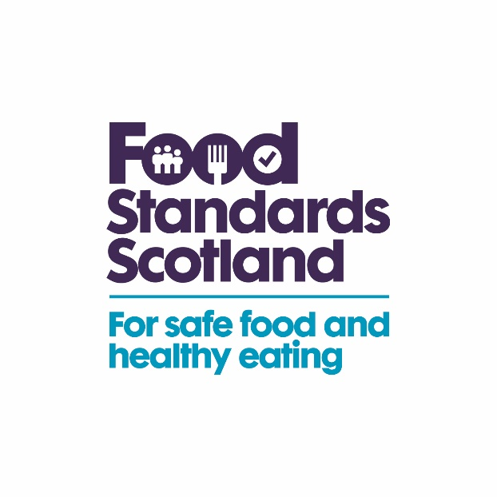

FSS Funded LA Food Sampling Programme 2024-25

|  |  |  |  |
| --- | --- | --- | --- |
| **Food type** | **Premises type** | **Testing parameters** | **Samples** |
| Imported whole cantaloupe melon | Retailers | Salmonella | 63 |
| Cut fruit salad | Retailers | *Listeria monocytogenes*, Salmonella | 63 |
| Imported tomatoes | Retailers | Salmonella, Shiga toxin-producing *E. coli* (STEC) | 63 |
| Houmous | Retailers | *Listeria monocytogenes*, Salmonella | 63 |
| Sushi | Retailers | *Bacillus cereus, Listeria monocytogenes, Staphylococcus aureus* | 63 |
| Infant formula | Retailers | *Cronobacter sakazakii* | 63 |
| Non-wheat cereal products | Retailers | Tropane alkaloids (atropine and scopolamine) | 46 |
| Domestic fresh fin-fish, cephalopods and crustaceans | Manufacturers, Processors, Retailers | Dioxins, PCBs, PFAS | 26 |
| Cinnamon and Turmeric | Retailers | Lead | 46 |
| Nuts | Retailers | Aflatoxins | 46 |
| Honey | Retailers | Diastase, Hydroxymethylfurfural (HMF) | 26 |
| Non-GM maize products (flour, tortillas, corn bread) | Retailers | GM event MIR162 | 46 |
| Products containing mince-meat labelled as a single particular species | Retailers | Meat speciation | 46 |
| Lattes/milky coffees | Caterers | Soya and almond (allergens) | 46 |
| Pre-packed for direct sale (PPDS) products | Retailers and Caterers | Milk, Gluten (allergens) | 46 |