Kitchen Crimes- Social Media interaction

- Throughout the kitchen crimes campaign, Food Standards Scotland will be Tweeting and posting on Facebook, Twitter and Instagram.

- If you would like to show your support, please connect with us on Twitter and Instagram (@FSScot) and Facebook (www.facebook.com/foodstandardsscotland).

- Shares and retweets are welcomed, and if you would like to post yourself, please find a sample Tweet which you are welcome to use:

Do you commit any ‘kitchen crimes’? Check out the latest @FSScot food safety campaign to see (URL] #forsafefood #kitchencrimes

- If you would like to use our campaign imagery, please utilise the downloadable images from the toolkit home page and use the recommended accompanying text as shown in the 5 example posts below:

Post 1:

Picture: Chicken Washer

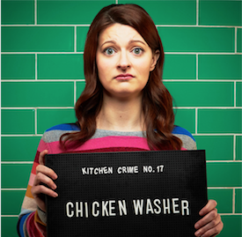
Copy:
Did you know there are 20 common kitchen crimes? Check your food safety record in Food Standards Scotland’s kitchen crime quiz. Visit http://bit.ly/2qK64mT

Post 2:

Picture: Under Cooker

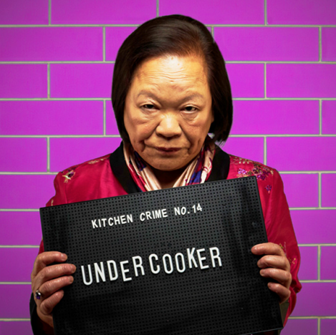

Copy:
Do you commit any kitchen crimes? Not following good food safety practices at home could potentially lead to food poisoning. Check your food safety record by playing the Food Standards Scotland’s kitchen crime quiz. Visit https://bit.ly/2AOSwci

Post 3:

Picture: Label Snubber

Copy:
Less than a third of Scots (31%) follow the ‘use by’ date as the best way to check whether food is safe to eat or not. How do you check? Find out more on Food Standards Scotland’s website and play the kitchen crime quiz. Visit
https://bit.ly/2AOSwci

Post 4:

Picture: Counter Melter

Copy:
There are 20 common kitchen crimes that can cause food poisoning. Did you know that 33% of people would leave frozen meat to defrost at room temperature? Are you a ‘counter melter’? Check your record today. Visit http://bit.ly/2qK64mT

Post 5:

Facebook Post:

YouTube Link: http://bit.ly/2FiXO0D

Copy: Food Standards Scotland is cracking down on kitchen crimes again. Its food safety campaign raises awareness of 20 ‘Kitchen Crimes’ to help reduce the risk of food poisoning. Are you guilty of any? Visit http://bit.ly/2qK64mT

Twitter Post:

Copy: Food Standards Scotland is cracking down on kitchen crimes again. Its food safety campaign raises awareness of 20 ‘Kitchen Crimes’ to help reduce the risk of food poisoning. Are you guilty of any? Visit http://bit.ly/2qK64mT

