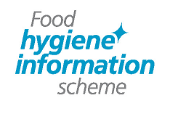 | Food Hygiene Information Scheme  Appeal form

Notes for businesses
- As the food business operator of the establishment you have a right to appeal the outcome of your food hygiene inspection if you do not agree that the outcome reflects the hygiene standards and management controls found at the time of the inspection.
- You have 14 days (including weekends and bank holidays) from the date of receipt of the notification letter to lodge an appeal.
- Please use the form below and return it to the Lead Officer for Food from your local authority – contact details are provided with the written notification of the outcome of your food hygiene inspection.
- The Lead Officer for Food will review the outcome of your food hygiene inspection and communicate the outcome of your appeal to you within seven days.

 | Food business operator/proprietor
 | Business name
 | Business addresses
 | Business tel no |  |  |  |  |  |  |  |  |  |  |  | Business email
 | Date of inspection |  |  |  |  |  |  |  |  |  |  |  | Outcome of inspection
 | Date notified of outcome

I do not agree with the outcome of the food hygiene inspection given by the food safety officer because (please explain below):

Compliance with food hygiene and safety procedures

 | Signed
 | Name in capitals
 |  | Position |  |  |  |  |  |  |  | Date

Please now return this form to your local authority.

