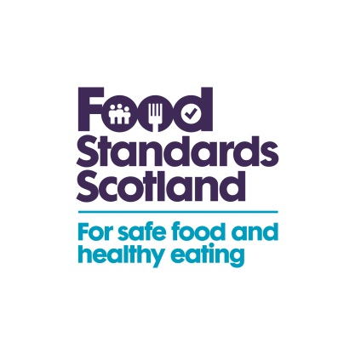 | T: 01224-285109  M-07876 131648  E: raymond.pang@fss.scot
13th July 2016

Dear Interested Parties

For Action:
Consultation on the safety and shelf-life of vacuum and modified atmosphere packed chilled foods with respect to non-proteolytic Clostridium botulinum.

I am writing to inform you that the FSS and the FSA guidance document above has undergone a detailed routine review and has been updated accordingly.

The guidance is intended for all interested parties and use by manufacturers and retailers of chilled vacuum and modified atmosphere packed (VP/MAP) foods and to assist in the practical development of HACCP (Hazard Analysis Critical Control Point) for these foods. It is designed to meet the needs of all levels of expertise, from technical managers in large enterprises to small businesses and individuals. The guidance is also designed to help Food Law Enforcement Officers carrying out their enforcement duties.

The bulk of the changes are summarised below;

• Clarification that the scope of the guidance covers all chilled VP/MAP foods. It is clarified that this includes raw meat, which has always been the case but this is now reflected in the Q&A in response to stakeholder queries on whether the guidance applies to all VP/MAP chilled raw and ready-to-eat food, including raw meat.

• Clarification on the advice that heat treatment of food should ideally be in a sealed pack including changes to the relevant flow diagram to make this clearer.

• New section on “Risks from other pathogens” there had previously been no mention of Listeria monocytogenes as the VP/MAP guidance applies to non-proteolytic C. botulinum only. This is still the case however, this has caused confusion with separate guidance for the control of Listeria. This has been clarified in the guidance that all pathogens should be considered in the production of a safe food.

• Changes to links and legislation (updated where necessary including where have been changes or updates to the legislation).

• Clarification on the use of, and interpretation of results, of challenge testing when VP/MAP foods with a shelf-life greater than 10 days do not fulfil any of the controlling factors specified in the guidance.

• Clarification on the use of nitrites as a controlling factor.

During our review we have not identified any major impacts to industry and consequently not produced an impact assessment. However, you are invited to comment on the proposed guidance document prior to the final version being published on our website, in particular if you consider that there will be any potential impacts arising from the revisions made. I would be very grateful if you could send comments to the following email addresses by 25th August 2016.

To: Enforcement@fss.scot
Cc: LAHygieneEnquiries@foodstandards.gsi.gov.uk

Yours sincerely

Raymond Pang
Senior Enforcement Manager
Food Standards Scotland

