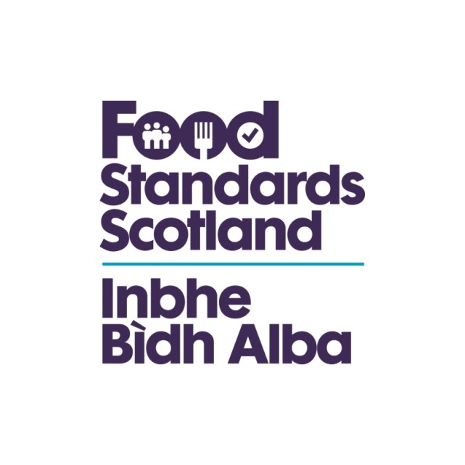
LA name & OCD Number
Food Standards Scotland
Local Authority Food Law Enforcement Services
Capacity and Capability Audit
Regulation (EU)2017/625 Checklist – Article 1

Regulation (EU) 2017/625 Article 1(2) Subject matter and scope
This Regulation shall apply to the official controls performed for the verification of compliance with the rules, whether established at Union level or by the Member States, to apply Union legislation, in the areas of:
(a) food and food safety, integrity and wholesomeness at any stage of production, processing and distribution of food, including rules aimed at ensuring fair practices in trade and protecting consumer interests and information, and the manufacture and use of materials and articles intended to come into contact with food;
(b) deliberate release into the environment of Genetically Modified Organisms (GMOs) for the purpose of food and feed production;
(c) feed and feed safety at any stage of production, processing and distribution of feed and the use of feed, including rules aimed at ensuring fair practices in trade and protecting consumer health, interests and information;
(d) animal health requirements;
(e) prevention and minimisation of risks to human and animal health arising from animal by-products and derived products;
(f) welfare requirements for animals;
(g) protective measures against pests of plants;
(h) requirements for the placing on the market and use of plant protection products and the sustainable use of pesticides, with the exception of pesticides application equipment;
(i) organic production and labelling of organic products;
(j) use and labelling of protected designations of origin, protected geographical indications and traditional specialities guaranteed.
Regulation (EU) 2017/625 Article 1(2) Subject matter and scope
Question | Answer | Comments/Evidence | Auditors Notes
Is the LA enforcing the Regulation? | Yes/No |  | Capture the areas covered in broad terms  Include EU and Domestic aspects & legislation  Integrated OC’s or stand alone  Complete agri-food chain or parts  Integrity and fraud ready  Food contact materials  GMO’s considered and recorded  Fair practices being enforced

