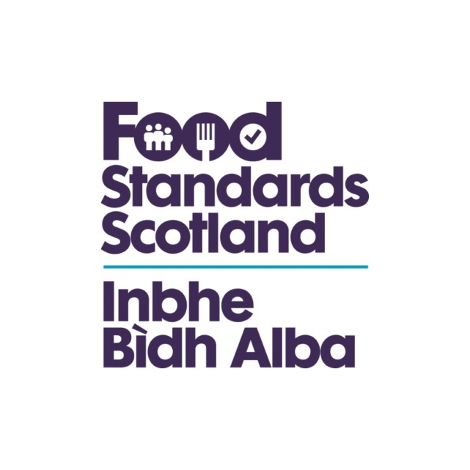
LA name & OCD Number
Food Standards Scotland
Local Authority Food Law Enforcement Services
Capacity and Capability Audit
Regulation (EU) 2017/625 Checklist – Article 138

Regulation (EU) 2017/625
Article 138
Actions in the event of established non-compliance
1. Where the non-compliance is established, the competent authorities shall take:
(a) any action necessary to determine the origin and extent of the non- compliance and to establish the operator’s responsibilities; and
(b) appropriate measures to ensure that the operator concerned remedies the non-compliance and prevents further occurrences of such non- compliance.
When deciding which measures to take, the competent authorities shall take account of the nature of that non-compliance and the operator’s past record with regard to compliance.
2. When acting in accordance with paragraph 1 of this Article, competent authorities shall take any measure they deem appropriate to ensure compliance with the rules referred to in Article 1(2), including, but not limited, to the following:
(a) order or perform treatments on animals;
(b) order the unloading, transfer to another means of transport, holding and care of animals, quarantine periods, the postponement of the slaughter of animals, and, if necessary, order that veterinary assistance be sought;
(c) order treatments on goods, the alteration of labels or corrective information to be provided to consumers;
(d) restrict or prohibit the placing on the market, the movement, the entry into the Union or the export of animals and goods; and prohibit their return to the Member State of dispatch or order their return to the Member State of dispatch;
(e) order the operator to increase the frequency of own controls;
(f) order certain activities of the operator concerned to be subject to increased or systematic official controls;
(g) order the recall, withdrawal, removal and destruction of goods, authorising, where appropriate, the use of the goods for purposes other than those for which they were originally intended;
(h) order the isolation or closure, for an appropriate period of time, of all or part of the business of the operator concerned, or its establishments, holdings or other premises;
order the cessation for an appropriate period of time of all or part of the activities of the operator concerned and, where relevant, of the internet sites it operates or employs;
(j) order the suspension or withdrawal of the registration or approval of the establishment, plant, holding or means of transport concerned, of the authorisation of a transporter or of the certificate of competence of the driver;
(k) order the slaughter or killing of animals provided that this is the most appropriate measure to safeguard human health as well as animal health and welfare.
3. The competent authorities shall provide the operator concerned, or its representative, with:
(a) written notification of their decision concerning the action or measure to be taken in accordance with paragraphs 1 and 2, together with the reasons for that decision; and
(b) information on any right of appeal against such decisions and on the applicable procedure and time limits with respect to such right of appeal.
4. All expenditure incurred under this Article shall be borne by the responsible operators.
5. The competent authorities, in the case of issuance of false or misleading official certificates or in the case of abuse of official certificates, shall take appropriate measures, including:
(a) the temporary suspension of the certifying officer from its duties;
(b) the withdrawal of the authorisation to sign official certificates;
(c) any other measure to prevent a reoccurrence of the offences referred to in Article 89(2).
Question | Answer | Comments/Evidence | Auditors Notes
Has the Authority followed or had regard to the Scottish Regulators Code of Compliance? | Yes/No
Does the Authority have a written enforcement policy? | Yes/No
Has the appropriate Member forum approved the policy? | Yes/No |  | The committee minutes should be available to verify this approval. The forum chosen should ensure that the policy is made public.
Does the LFO know and use these? | Yes/No
Does the Enforcement Policy cover:
Enforcement options and the circumstances in which they should be used? | Yes/No
The internal appeals mechanism? | Yes/No
Emphasis on proportionate enforcement based on risk? | Yes/No
Include reference to the involvement of home and originating authorities? | Yes/No
The PF Prosecution Code and Code requirements in deciding to report to the Procurator Fiscal? | Yes/No
Human Rights Act? | Yes/No
How are officers aware of the contents of the policy? | Yes/No
Is there evidence of it being implemented? | Yes/No |  | This evidence may be in the form of coversheets on prosecutions or notes in relation to follow up on inspections demonstrating that the policy has been considered, or it may be obtained through officer interview
Have any monitoring found any enforcement decisions made outside the enforcement policy guidelines? | Yes/No
Have these reasons been documented? | Yes/No
Has the policy or a summary been published? | Yes/No
Is it made available to the public and businesses? And how is this done? | Yes/No
Is it made available to the public and businesses? And how is this done? | Yes/No
Have staff been trained in these procedures? | Yes/No
Do the procedures cover
Prosecutions? Has the Authority acted in accordance with its procedure/ policy/official guidance? | Yes/No
Emergency prohibitions? | Yes/No
Has the Authority acted in accordance with its procedure/ policy/official guidance? | Yes/No
Hygiene Emergency prohibitions?  Has the Authority acted in accordance with its procedure/ policy/official guidance? | Yes/No
Voluntary closures?  Has the Authority acted in accordance with its procedure/ policy/official guidance? | Yes/No
Detention and seizure?  Has the Authority acted in accordance with its procedure/ policy/official guidance? | Yes/No |  | Including use of Regulation 27 and Regulation 9 Food Hygiene (Scotland ) Regulations 2006
Voluntary surrender?  Has the Authority acted in accordance with its procedure/ policy/official guidance? | Yes/No
Hygiene Improvement Notices?  Has the Authority acted in accordance with its procedure/ policy/official guidance? | Yes/No
Remedial Action Notices and Reg 9 notices  Has the Authority acted in accordance with its procedure/ policy/official guidance? | Yes/No
Notices served to deal with illegally imported POAO products?  Has the Authority acted in accordance with its procedure/ policy/official guidance? | Yes/No |  | Authorities must take action to deal with illegally imported products of animal origin (POAO)  The Trade in Animals and Related Products (Scotland) Regulations 2012 • 2012 No. 177

