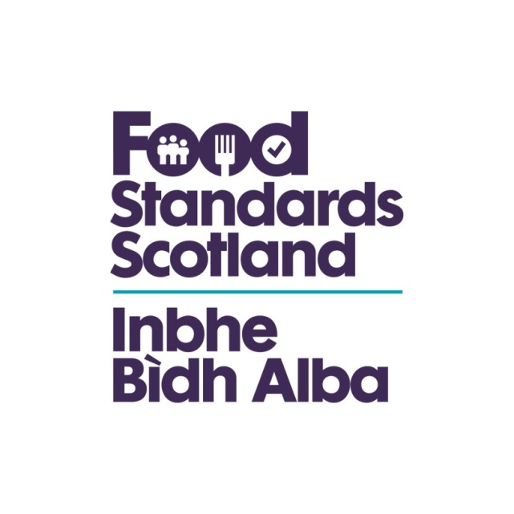
LA name & OCD Number
Food Standards Scotland
Local Authority Food Law Enforcement Services
Capacity and Capability Audit
Regulation (EU) 2017/625 Checklist – Article 105

Regulation (EU) 2017/625 Article 105 Assistance without request in the event of non-compliance

1. When the competent authorities in a Member State become aware of a case of non-compliance, and if such non-compliance may have implications for another Member State, they shall notify such information to the competent authorities of that other Member State without being requested to do so and without undue delay.
2. The competent authorities notified in accordance with paragraph 1 shall:
(a) acknowledge receipt of the notification without undue delay;
(b) where the notifying competent authority so specifies, indicate within ten working days from the date of receipt of the notification:
(i) what investigations they intend to carry out; or
(ii) the reasons why they consider that no investigations are necessary; and
(c) where investigations referred to in point (b) are considered necessary, investigate the matter and inform the notifying competent authorities without delay of the results and, where appropriate, of any measures taken.

Question | Answer | Comments/Evidence | Auditor’s Notes
Has the Authority followed or had regard to the Scottish Regulators Code of Compliance? | Yes/No
Does the Authority have a written enforcement policy? | Yes/No
Does the LFO know and use these? | Yes/No
Does the Enforcement Policy cover?
- Enforcement options and the circumstances in which they should be used? | Yes/No
- The internal appeals mechanism? | Yes/No
- Emphasis on proportionate enforcement based on risk? | Yes/No
- Include reference to the involvement of home and originating authorities? | Yes/No
- The PF Prosecution Code and Code requirements in deciding to report to the Procurator Fiscal? | Yes/No
- Human Rights Act? | Yes/No
How are officers aware of the contents of the policy?
Is there evidence of it being implemented? | Yes/No |  | This evidence may be in the form of coversheets on prosecutions or notes in relation to follow up on inspections demonstrating that the policy has been considered, or it may be obtained through officer interview
Has any monitoring found any enforcement decisions made outside the enforcement policy guidelines? | Yes/No
Have these reasons been documented? | Yes/No
Has the policy or a summary been published? | Yes/No
Is it made available to the public and businesses? And how is this done? | Yes/No
Does the LA have documented procedures for formal follow up/  enforcement actions? | Yes/No
Have staff been trained in these procedures? | Yes/No
Do the procedures cover:
- Prosecutions?  Has the Authority acted in accordance with its procedure/ policy/official guidance? | Yes/No
- Emergency prohibitions?  Has the Authority acted in accordance with its procedure/ policy/official guidance? | Yes/No
- Hygiene Emergency prohibitions?  Has the Authority acted in accordance with its procedure/ policy/official guidance? | Yes/No
- Voluntary closures?  Has the Authority acted in accordance with its procedure/ policy/official guidance? | Yes/No
- Detention and seizure?  Has the Authority acted in accordance with its procedure/ policy/official guidance? | Yes/No |  | Including use of Regulation 27 and Regulation 9 Food Hygiene (Scotland ) Regulations 2006
- Voluntary surrender?  Has the Authority acted in accordance with its procedure/ policy/official guidance? | Yes/No
- Hygiene Improvement notices?  Has the Authority acted in accordance with its procedure/ policy/official guidance? | Yes/No
- Remedial Action Notices and Reg 9 notices?  Has the Authority acted in accordance with its procedure/ policy/official guidance? | Yes/No
- Notices served to deal with illegally imported POAO products?  Has the Authority acted in accordance with its procedure/ policy/official guidance? | Yes/No |  | Authorities must take action to deal with illegally imported products of animal origin (POAO)  The Trade in Animals and Related Products (Scotland) Regulations 2012  - 2012 No. 177

