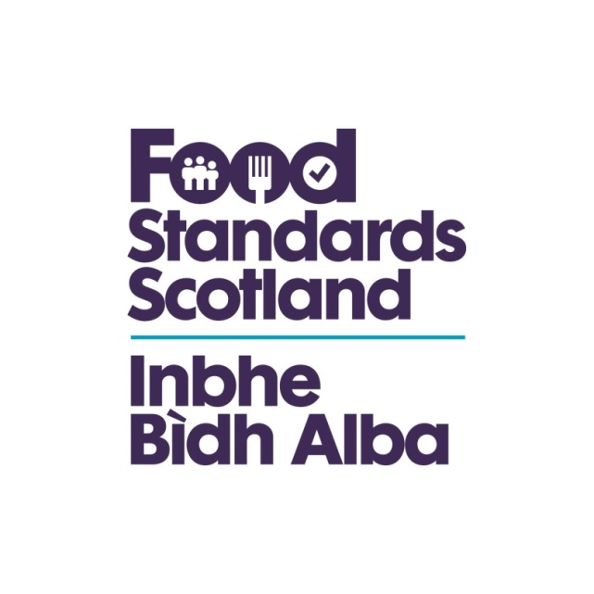
LA name & OCD Number
Food Standards Scotland
Local Authority Food Law Enforcement Services
Capacity and Capability Audit
Regulation (EU) 2017/625 Checklist- Article 9

Regulation (EU) 2017/625
Article 9
General rules on official controls
1. Competent authorities shall perform official controls on all operators regularly, on a risk basis and with appropriate frequency, taking account of:
(a) identified risks associated with:
(i) animals and goods;
(ii) the activities under the control of operators;
(iii) the location of the activities or operations of operators;
(iv) the use of products, processes, materials or substances that may influence food safety, integrity and wholesomeness, or feed safety, animal health or animal welfare, plant health or, in the case of GMOs and plant protection products, that may also have an adverse impact on the environment;
(b) any information indicating the likelihood that consumers might be misled, in particular as to the nature, identity, properties, composition, quantity, durability, country of origin or place of provenance, method of manufacture or production of food;
(c) operators’ past record as regards the outcome of official controls performed on them and their compliance with the rules referred to in Article 1(2);
(d) the reliability and results of own controls that have been performed by the operators, or by a third party at their request, including, where appropriate, private quality assurance schemes, for the purpose of ascertaining compliance with the rules referred to in Article 1(2); and
(e) any information that might indicate non-compliance with the rules referred to in Article 1(2)

4. Official controls shall be performed without prior notice, except where such notice is necessary and duly justified for the official control to be carried out. As regards official controls upon request from the operator, the competent authority may decide whether the official controls are to be performed with or without prior notice. Official controls with prior notice shall not preclude official controls without prior notice.

6. Competent authorities shall perform official controls in the same manner, while taking account of the need to adapt the controls to the specific situations, irrespective of whether the animals and goods concerned are:
(a) available on the Union market, whether originating in the Member State where the official controls are performed or in another Member State;
(b) to be exported from the Union; or
(c) entering the Union.
7. To the extent strictly necessary for the organisation of the official controls, Member States of destination may require operators that have animals or goods delivered to them from another Member State to report the arrival of such animals or goods.
Question | Answer | Comments/Evidence | Auditor’s Notes
Is there an Intervention Programme that meets all the requirements of the current Food Law Code of Practice. In particular does it include an intervention programme for all food establishments in the area  Are Inspections being carried out on a risk basis and at a frequency of not less than that set out in the Food Law Code of Practice  Food Law rating (FLRS) used?  Does the LA have an Alternative Enforcement Strategy | Yes/No | Review the Service Plan to ensure the Intervention Programme complies with the requirements of the Food Law Code of Practice.  If yes is this Strategy clearly documented. | The Service Plan should have identified the planned programme and. include all food establishments within the LA area. The auditor should verify from the computer/file records that:  a) Premises are being risk-rated correctly;  b) Premises are receiving inspections according to their risk category and no later than 28 days after they are due except in circumstances outside of the control of the Authority such as seasonal businesses(IC 3.8 & 3.9 & 5). Internal monitoring reports of inspections due, and inspections overdue should be requested, and auditors should verify that inspections are up to date. (IC 3.1.5).  Of the current intervention programme how many food establishments are within the remit of the AES. And not due an intervention.  If a business is already registered and has previously been included in an AES in accordance with CP 4.12 and 27.16, the Lead Food Officer has discretion to use historical information to determine whether a business can be awarded Sustained Compliance for a Band 3A (i.e.place business on a 60 month intervention frequency or choose not to undertake a proactive intervention) (IC 2.3.1.3)

