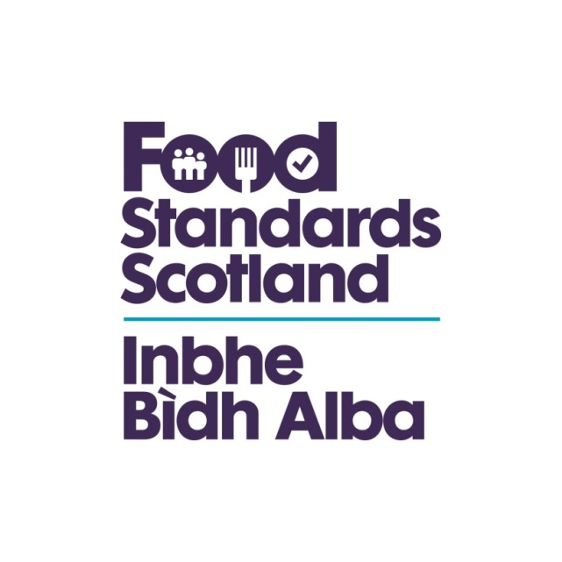
LA name & OCD Number
Food Standards Scotland
Local Authority Food Law Enforcement Services
Capacity and Capability Audit
Regulation (EU) 2017/625 Checklist – Article 34

Regulation (EU) 2017/625
Article 34(1),(2),(4) and (5)
Methods used for sampling, analyses, tests and diagnoses
1. Methods used for sampling and for laboratory analyses, tests and diagnoses during official controls and other official activities shall comply with Union rules establishing those methods or the performance criteria for those methods.
2. In the absence of the Union rules as referred to in paragraph 1, and in the context of official controls and other official activities, official laboratories shall use one of the following methods according to the suitability for their specific analytical, testing and diagnostic needs:
(a) available methods complying with relevant internationally recognised rules or protocols including those that the European Committee for Standardisation (CEN) has accepted; or
relevant methods developed or recommended by the European Union reference laboratories and validated in accordance with internationally accepted scientific protocols;
(b) in the absence of the suitable rules or protocols, as referred to in point (a), methods which comply with relevant rules established at national level, or, if no such rules exist, relevant methods developed or recommended by national reference laboratories and validated in accordance with internationally accepted scientific protocols; or
relevant methods developed and validated with inter or intra- laboratory methods validation studies in accordance with internationally accepted scientific protocols.
4. Wherever possible, methods used for laboratory analyses shall be characterised by the relevant criteria set out in Annex III.
5. Samples shall be taken, handled and labelled in such a way as to ensure their legal, scientific and technical validity.
Question | Answer | Comments/Evidence | Auditor’s Notes
Does the Authority have a documented sampling policy? | Yes/No
Does the Authority have a sampling procedure? | Yes/No
Does the sampling policy take into account:
A risk based approach? | Yes/No
Home Authority premises? | Yes/No
Originating Authority premises? | Yes/No
Process monitoring? | Yes/No
Surveys – national & regional? | Yes/No
Special investigations? | Yes/No
Does the sampling procedure cover the Code requirements? | Yes/No |  | Equipment. Procurement, size, methods, sealing, labelling, bagging, documentation, storage and transport, results action, traceability & continuity, link to FAFA etc, contact & discussion with PA or FE
Does the LA have a documented sampling programme? | Yes/No
Was the programme developed in consultation with the PA/FE? | Yes/No
Is the programme in accordance with the sampling policy? | Yes/No
Is the sampling programme being implemented? | Yes/No |  | Auditors should note that monitoring returns will also give an idea of activity prior to the audit. If the LA has not met its programme, any review carried out with the PA/FE should be checked to determine the reasons
Has appropriate action followed sample results that were not considered satisfactory? | Yes/No |  | The Auditor will need to examine records of sampling activity. Where samples have been unsatisfactory, the premises files/interviews with officers should establish whether appropriate action has been taken. The PA/FE reports will give an indication whether the food met legal requirements and if further investigation was necessary
Are all microbiological food samples submitted to an Official Control laboratory? | Yes/No |  | Details of the Public Analyst and the Food Examiner should be within the service plan information and provided with the PVQ information. The List of official labs can be found at http://www.food.gov.uk/enforcement/foodsampl ing/foodcontrollabs#h_4

