Appendix 2. Nutrient content of plant-based milk drinks and plant-based meat products available in Scotland

Methods

Using Rvest and RSelenium packages in R, data were webscraped from an online shopping site. Nutrient values were scraped from the nutrient information available on the site. The following nutrient declarations are mandatory for prepacked food: energy, fat, saturated fat, carbohydrates, sugars, protein, and salt. While additional nutrient information can be provided, such as fibre and certain vitamins or minerals present in significant amounts, these are not mandatory and so the nutrient information available on the site varied across products. In order to align with the key nutrients analysed in this report, as well as the Scottish Dietary Goals, we presented nutrient information, when available, for the following: total energy, fat, saturated fat, sugar, carbohydrates, salt, fibre, protein, calcium, iron, iodine, selenium, zinc, and vitamin B₁₂.

For plant-based milk drinks, the search term 'Dairy Free Milk' was used and for plant-based meat alternatives, the following terms were used: 'Vegetarian Sausage, ‘Tofu', 'Vegetarian Chicken', 'Vegetarian Meat Slices', 'Vegetarian Burger', 'Vegetarian Bacon', 'Vegetarian Mince', 'Vegetarian Meatballs', and 'Vegetarian Pie'. These search terms were based on the most commonly reported plant-based meat alternatives in the Scottish Health Survey (2021). Additional nutrient information for plant-based milk drinks available at another common retailer in Scotland were manually gathered as that particular retailer does not provide nutrient information online.

Data were imported into Excel and duplicates and items containing meat were excluded. Data were cleaned to ensure each nutrient had been imported accurately. A total of 55 plant-based milk drinks and 160 plant-based meat alternatives were identified.

Nutrient values from the UK Nutrient Databank were included in figures as red lines to enable comparisons of values used in composite food items for the simulation to products available in Scotland as of July 2023. For soya milk drinks, lines for both sweetened (blue) and unsweetened (red) soya milk drinks from the UK Nutrient Databank were included. Where no Nutrient Databank values were available, none were added (e.g., the Mixed plant-based milk drink category). For values where multiple Nutrient Databank values were available, the closest match was used (e.g., 'Vegetarian chicken-style pieces/strips (e.g., Quorn)' was selected as the Nutrient Databank value for plant-based chicken instead of 'Vegetarian chicken-style nuggets/goujons, in breadcrumbs (e.g., Quorn nuggets)' as it more closely matched the webscraped results).

Results
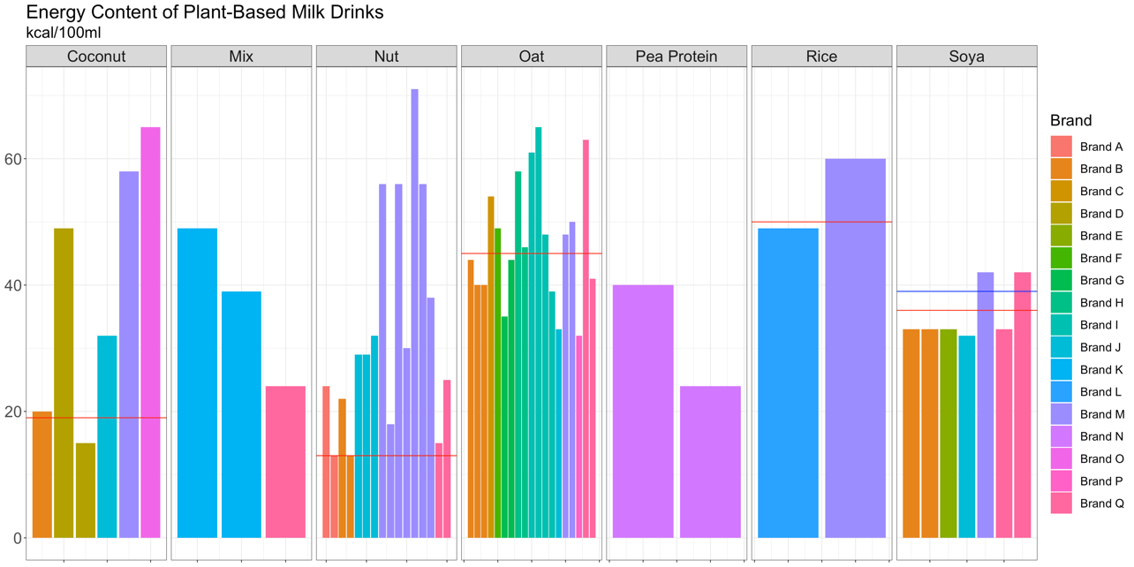

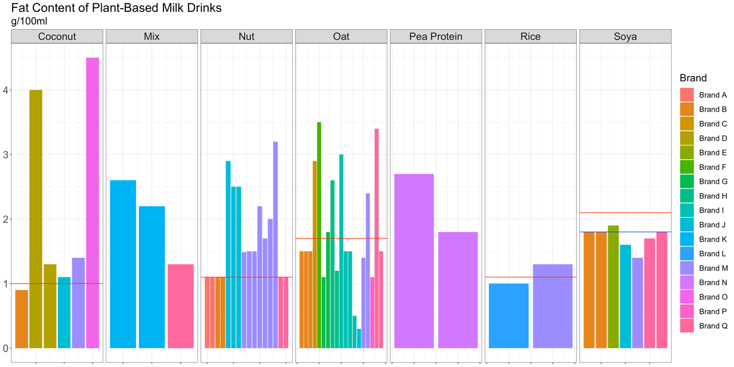

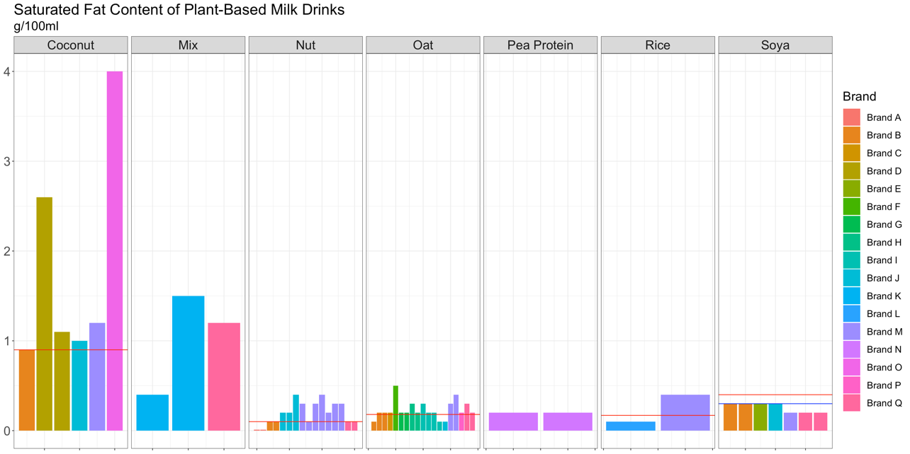

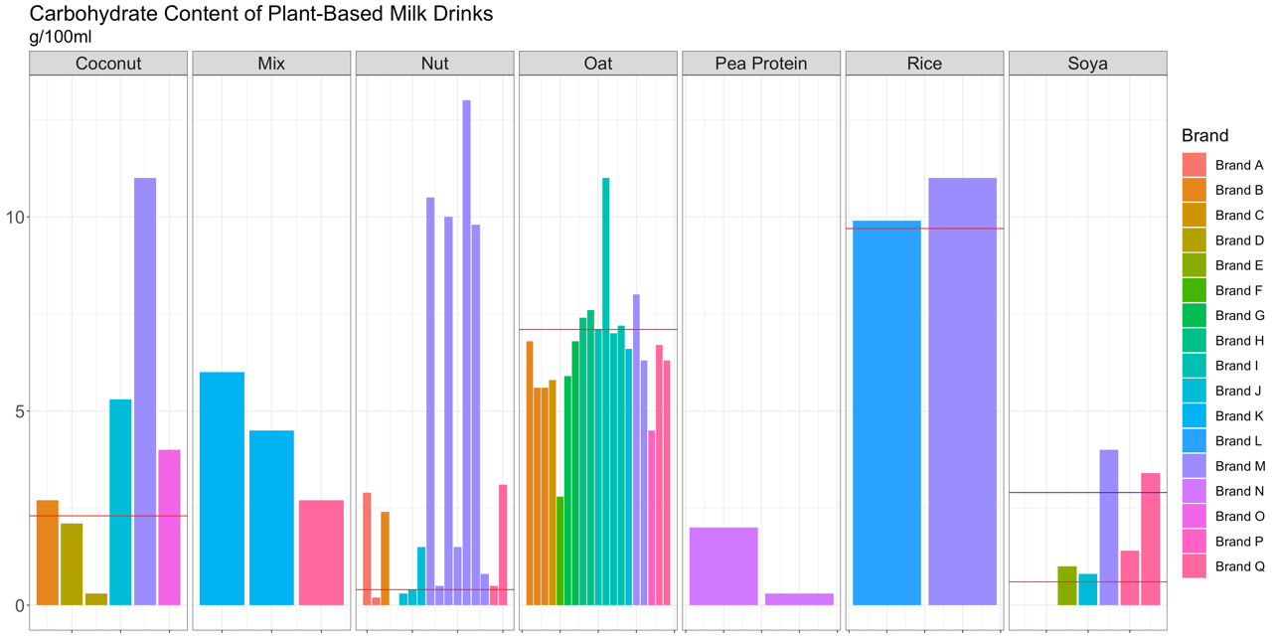

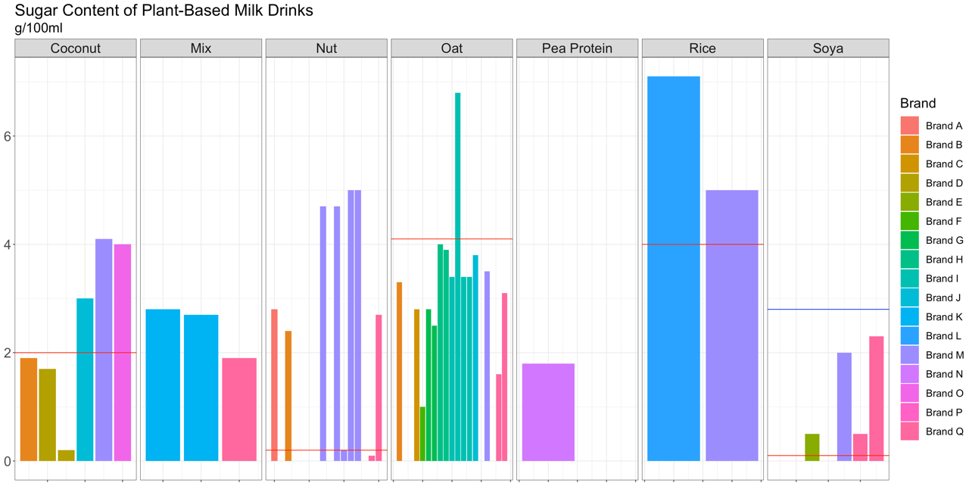

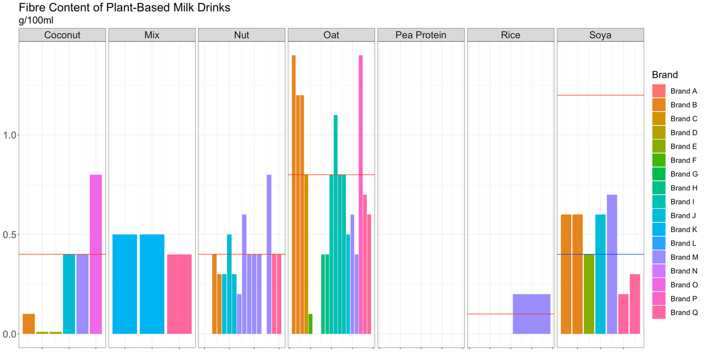

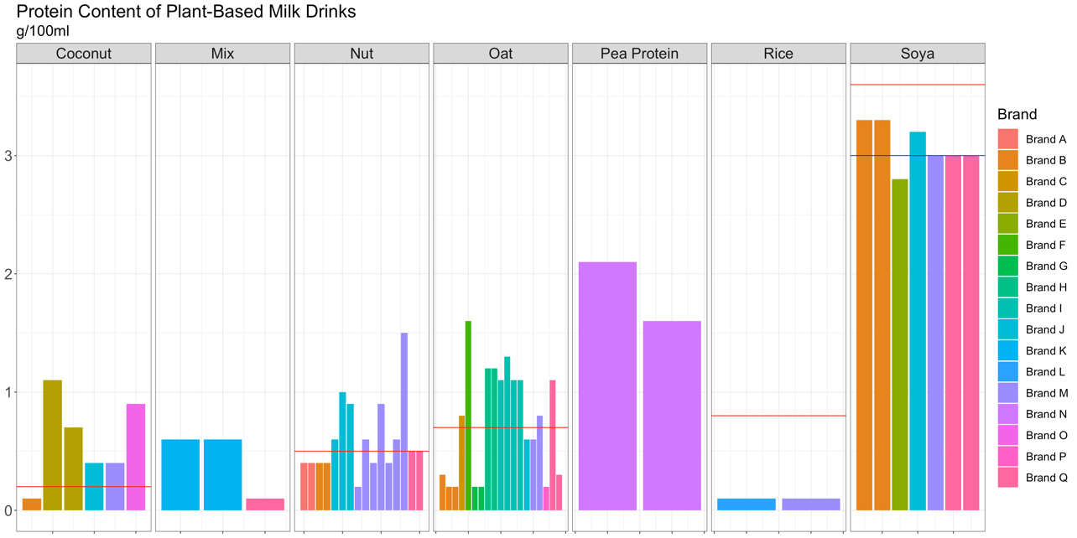

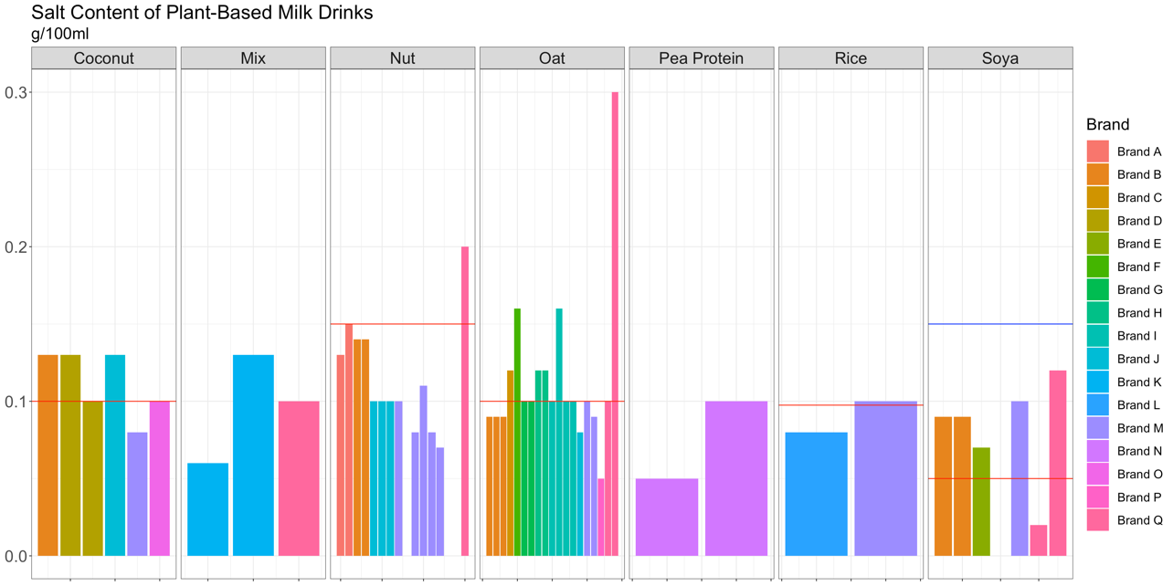

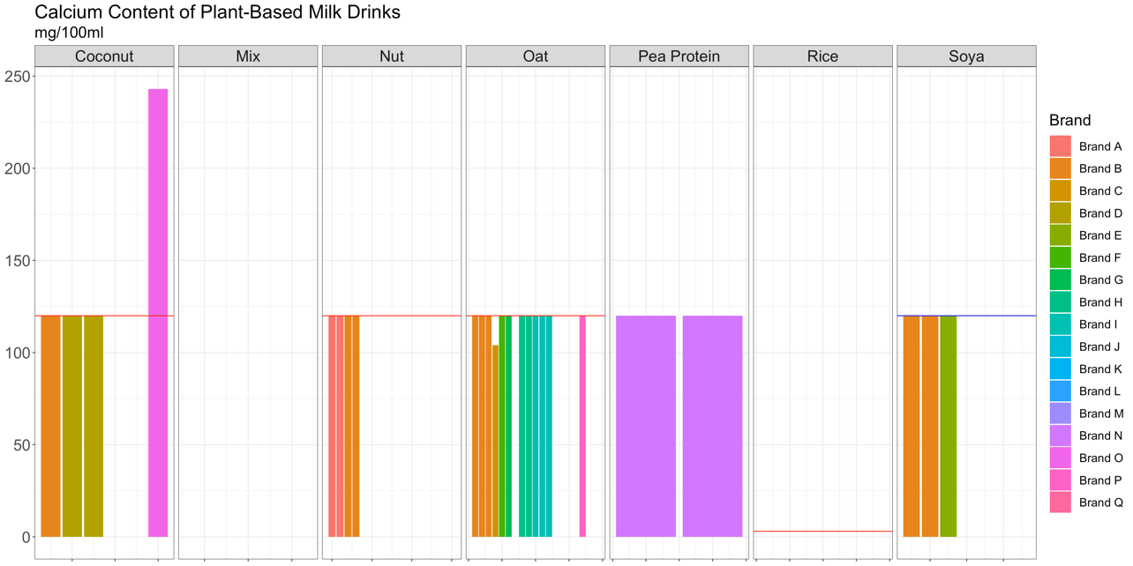

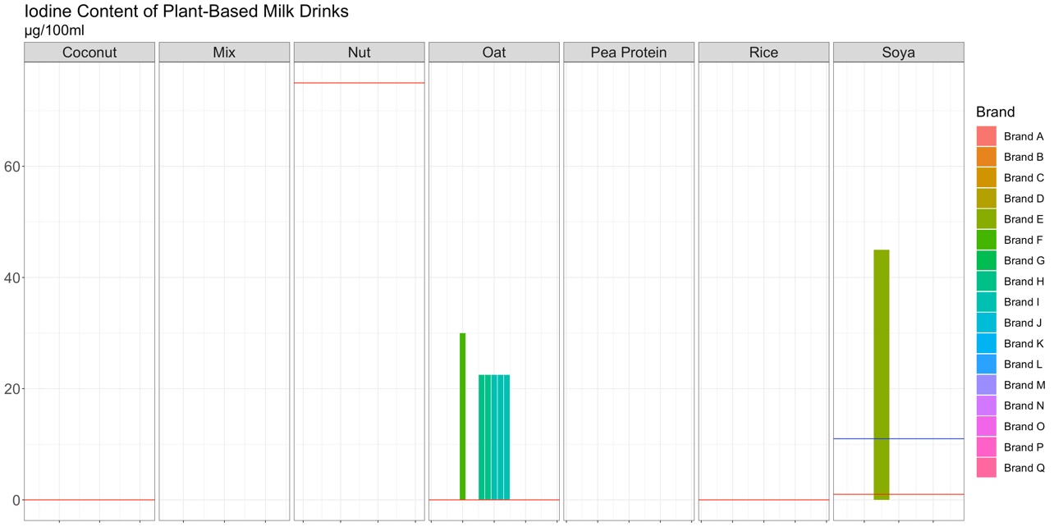

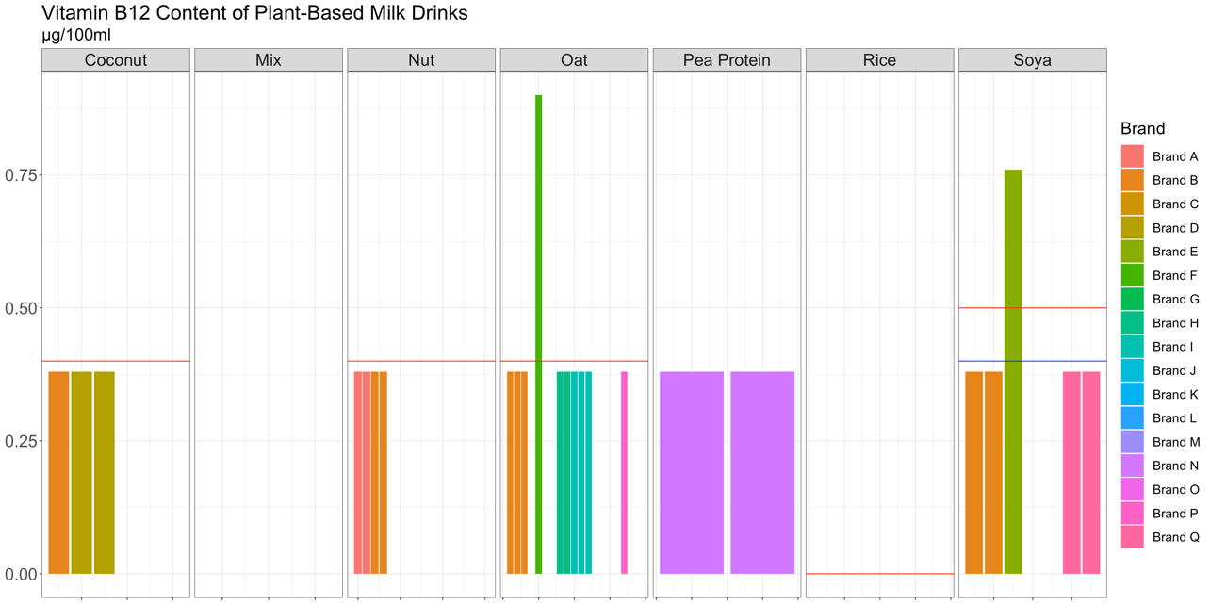

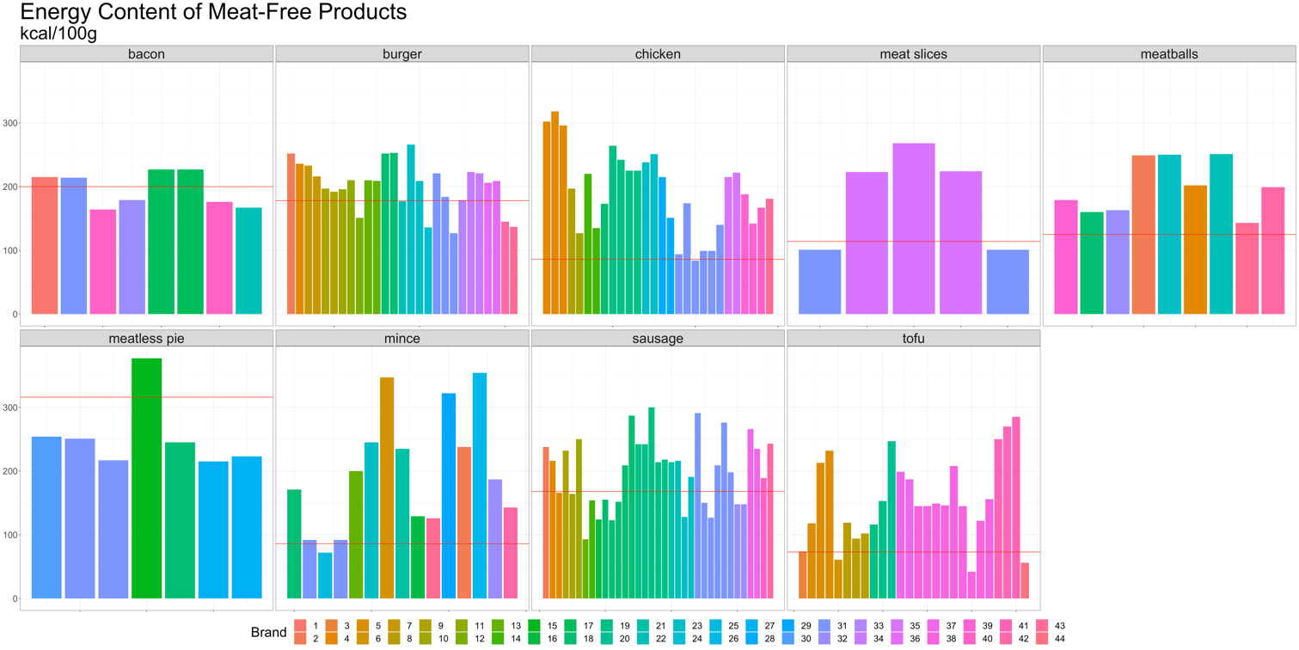

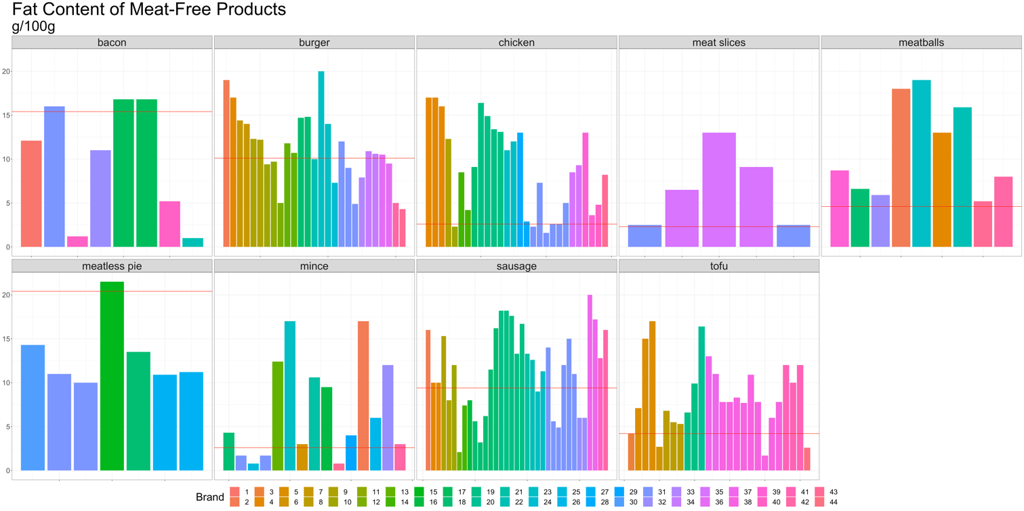

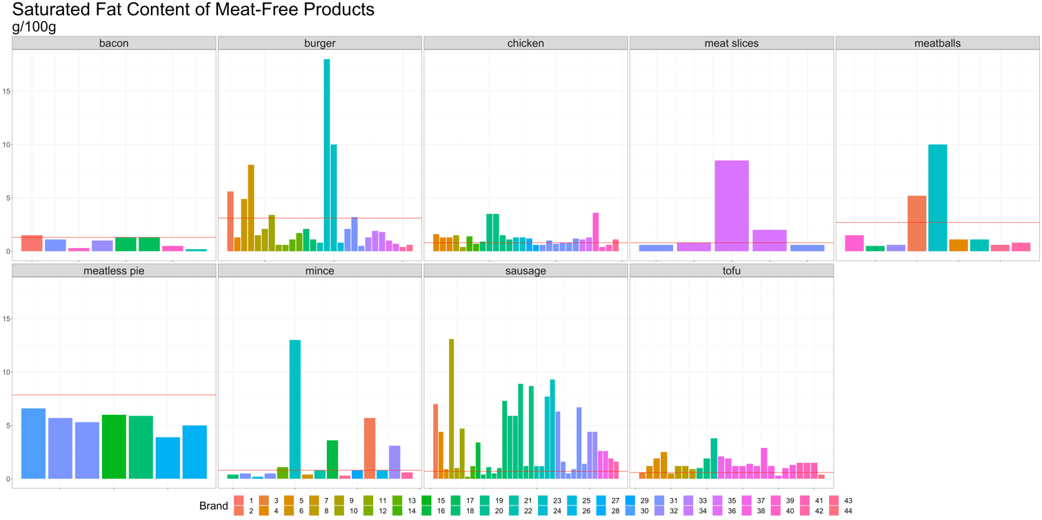

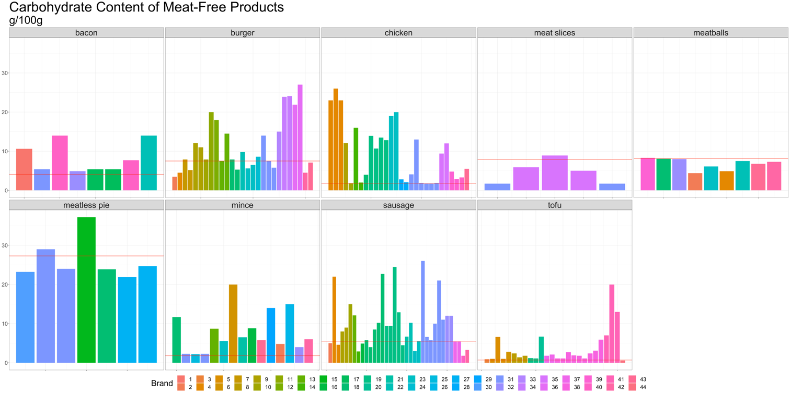

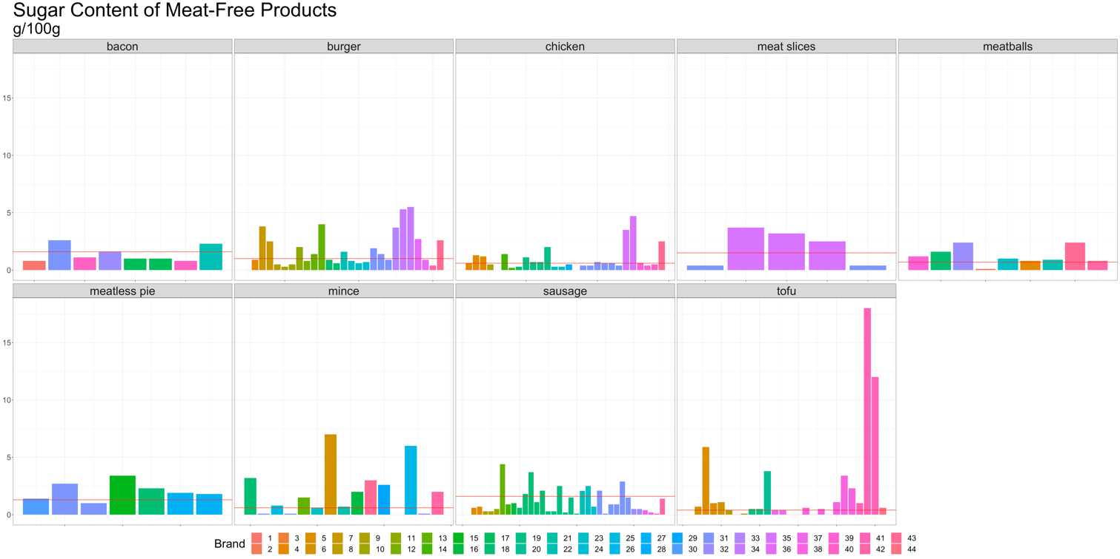

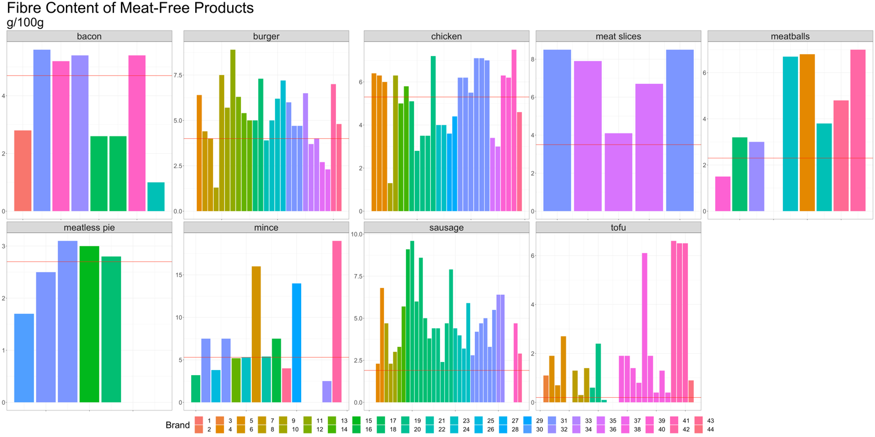

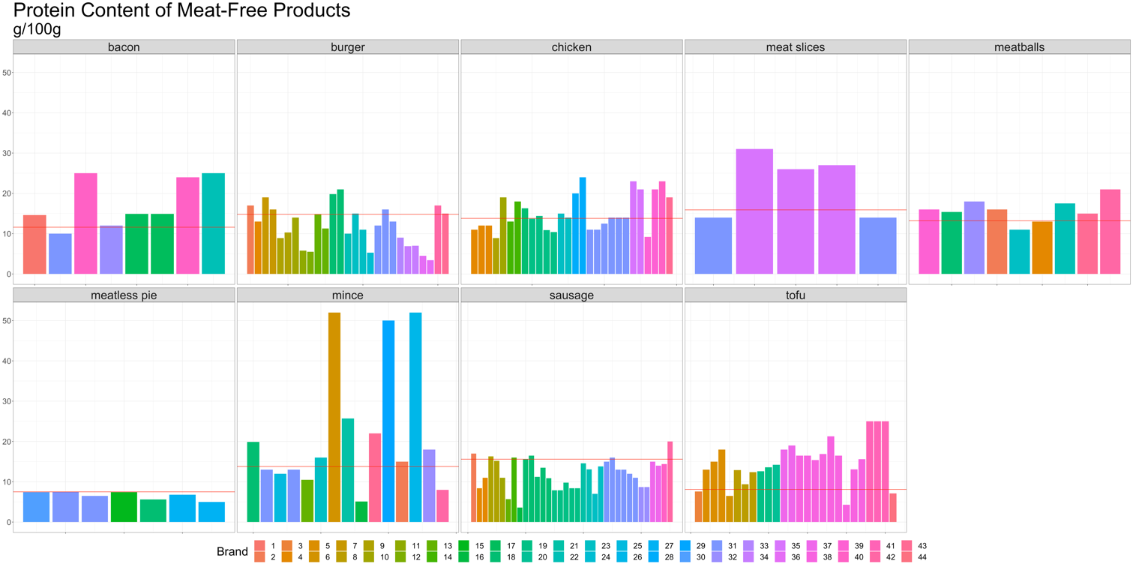

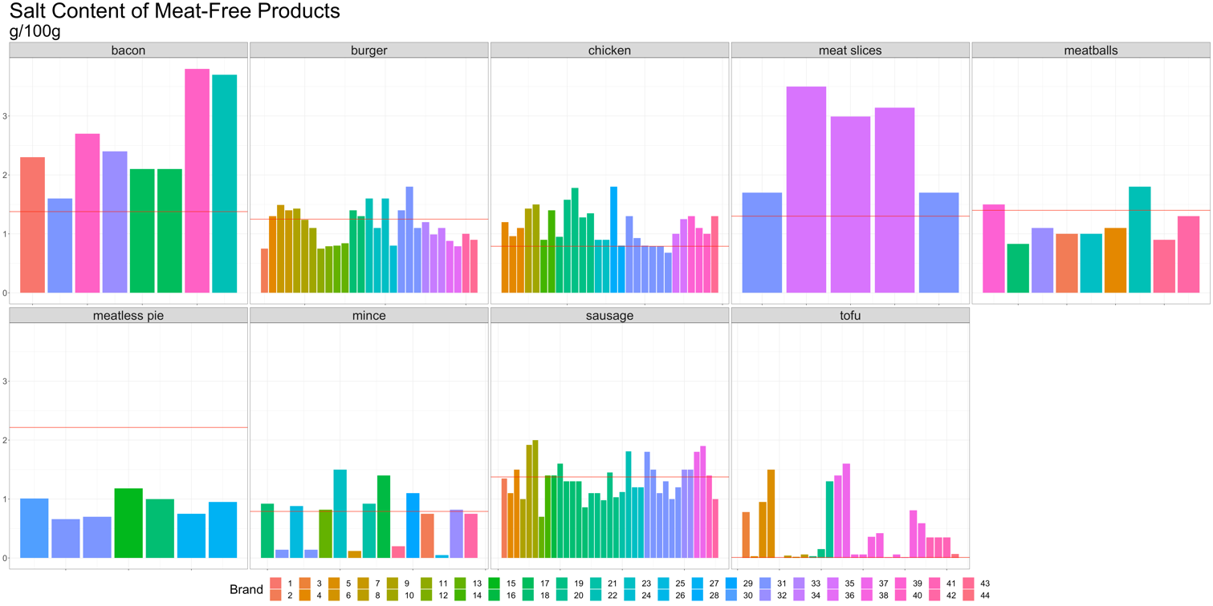
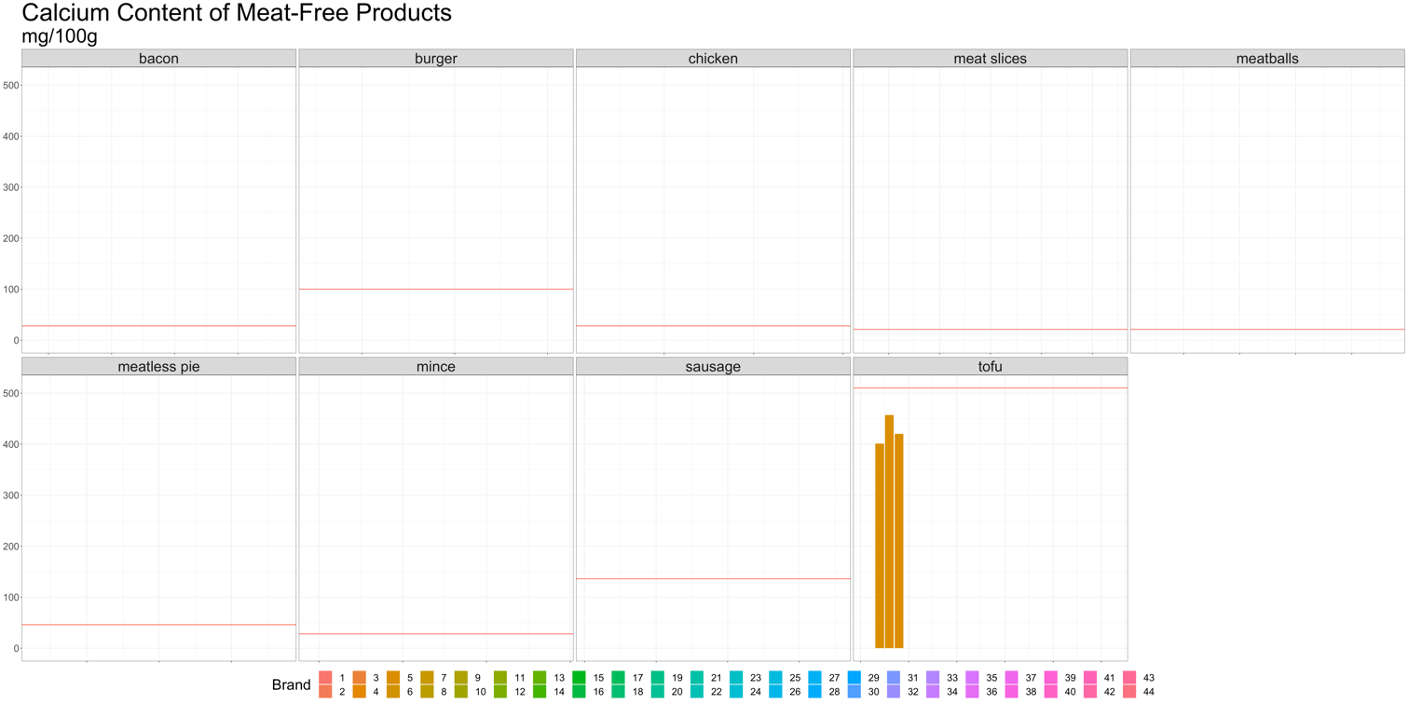

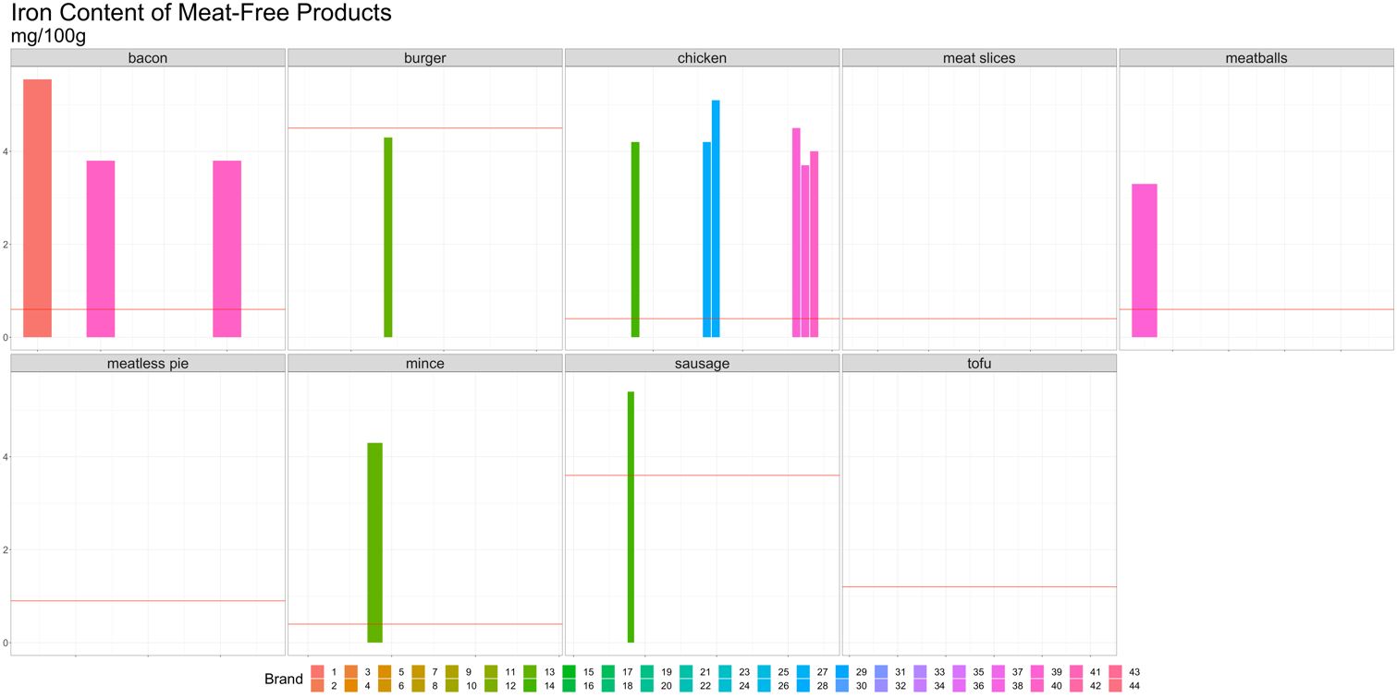
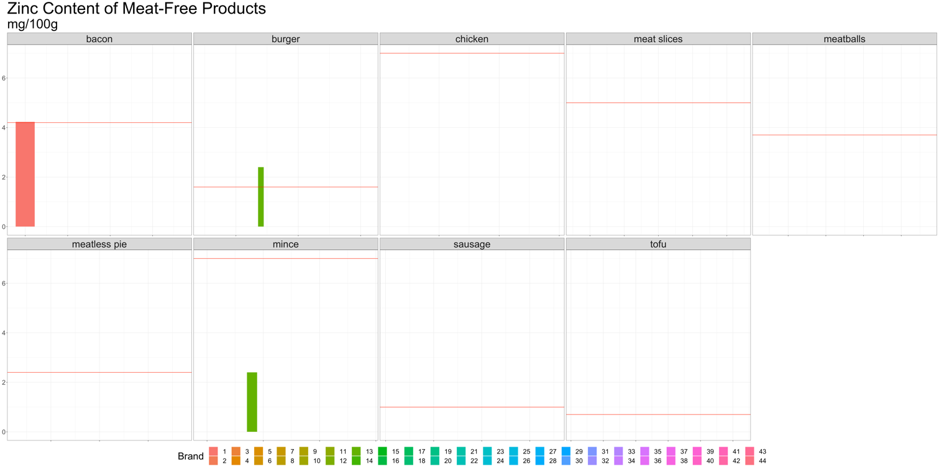

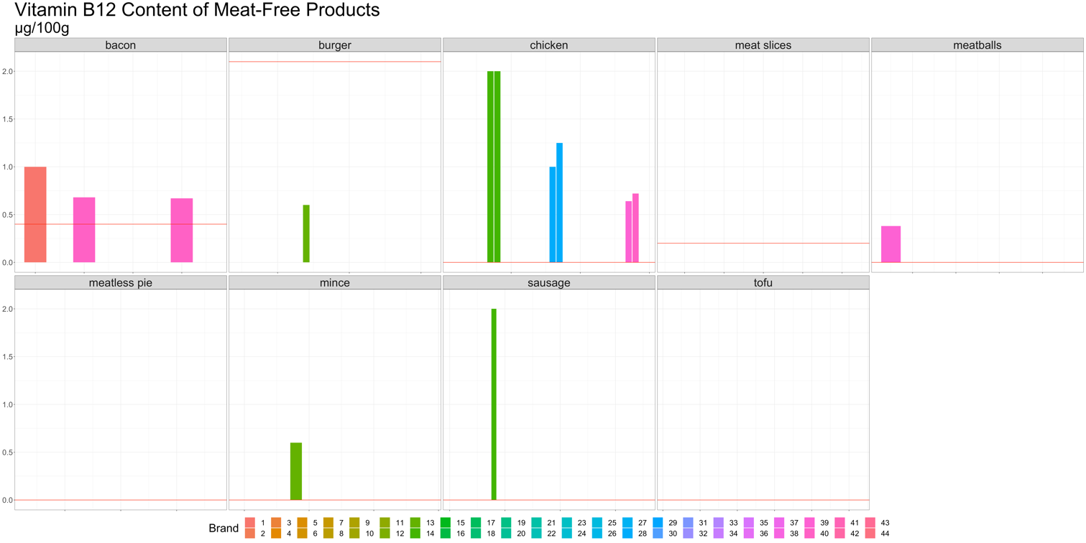

https://www.food.gov.uk/business-guidance/nutrition-labelling

