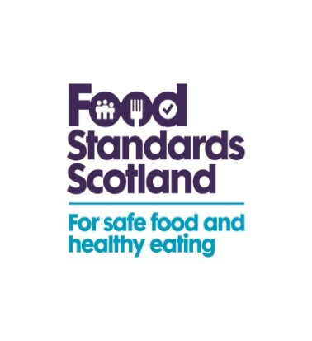
ALLERGY ALERT

Ref: BW-2015 Date: 26 November 2015

Glasgow Sandwich Company, also known as AAA Foods, has recalled products due to undeclared milk and egg

Glasgow Sandwich Company, also known as AAA Foods, has recalled packets of its Chicken Tikka Mayonnaise / Chicken Sweetcorn Mayonnaise / Tandoori Chicken / Chicken Balti / Peri Peri Chicken sandwiches and wraps because of undeclared allergen information.

The labelling for these products does not declare milk (lactose) or egg. This means the products are a possible health risk for anyone with an allergy or intolerance to milk (or its constituents) or egg.

Product details:
Chicken Tikka Mayonnaise
Chicken Sweetcorn Mayonnaise
Tandoori Chicken
Chicken Balti
Peri Peri Chicken

Brand name: AAA Foods

‘Use by’ date: All products up to and including 30 November 2015.

Risk: Milk and Egg

Our advice to consumers:
If you have bought any of the above products and have an allergy or intolerance to milk (or its constituents) or egg, please do not eat these products. Instead, return it to the shop for a full refund.

Action taken by the company:
The company has recalled the above products from sale and has contacted the relevant allergy support organisations, which will tell their members about the recall.

