Kitchen Crimes- Social Media interaction

- Throughout the kitchen crimes campaign, Food Standards Scotland will be Tweeting and posting on Facebook, Twitter and Instagram.

- If you would like to show your support, please connect with us on Twitter and Instagram (@FSScot) and Facebook (www.facebook.com/foodstandardsscotland).

- Shares and retweets are welcomed, and if you would like to post yourself, please find a sample Tweet which you are welcome to use:

Do you commit any ‘kitchen crimes’? Check out the latest @FSScot food safety campaign to see (URL] #forsafefood #kitchencrimes

- If you would like to use our campaign imagery, please utilise the downloadable images from the toolkit home page and use the recommended accompanying text as shown in the 4 example posts below:

Post 1:

Picture: Chicken Washer

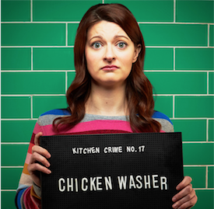
Copy:
Did you know there are 20 common kitchen crimes? Check your food safety record in Food Standards Scotland’s kitchen crime quiz. Visit http://bit.ly/2qK64mT

Post 2:

Picture: Dodgy Chiller

Copy:
There are 20 common kitchen crimes and most of us are commiting 9! Are you a dodgy chiller? Check your food safety record in Food Standard Scotland’s kitchen crime quiz. Visit http://bit.ly/2qK64mT

Post 3:

Picture: Under Cooker

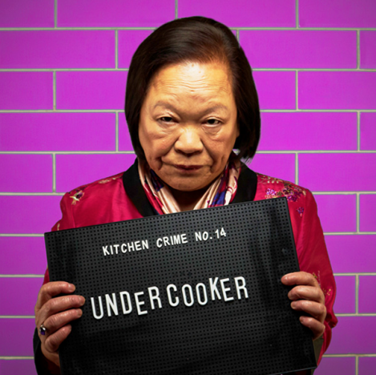

Copy:
There are 20 common kitchen crimes that can cause food poisoning, did you know germs can survive if food is not cooked through? Are you an ‘undercooker’? Check your record today. Visit http://bit.ly/2qK64mT

Post 4:

Facebook Post:

YouTube Link: http://bit.ly/2FiXO0D

Copy: Food Standards Scotland has launched their new campaign to reduce the risk of food poisioning by raising awareness of 20 ‘Kitchen Crimes’. Are you guilty of any? Visit http://bit.ly/2qK64mT

Twitter Post:

Copy: Food Standards Scotland has launched their new campaign to reduce the risk of food poisioning by raising awareness of 20 ‘Kitchen Crimes’. Are you guilty of any? Watch the video and find out: http://bit.ly/2FiXO0D

