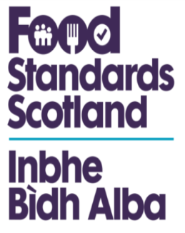

Publication of Personal Data

Please note that Food Standards Scotland may publish details that you supply in legitimate pursuit of the functions of the organisation.

As the publication of responses in full may include personal data (such as your full name and contact address details), would you please let us know if you object to us using this information.

Please tick the box below, complete the relevant details and return this form (together with your response) to indicate your objection.

I do not agree to the publication of my personal details.

* If no objection is received we will assume that you consent to full disclosure of your personal details and these may be published.

Full Name

Full postal address

To comply with the Data Protection Act 1998, it is essential that we keep our records up to date. Would you therefore please inform us if your personal details change in any way.
This form has been issued by: | Food Standards Scotland
If you have any queries, please contact: | Russell Napier, Pilgrim House, Old Ford Road, Aberdeen, AB11 5RL

General information about the most recent Data Protection Act can be viewed on the Information Commissioner’s Office website at www.dataprotection.gov.uk.
For general enquiries you may contact Tel: 01625 545745

