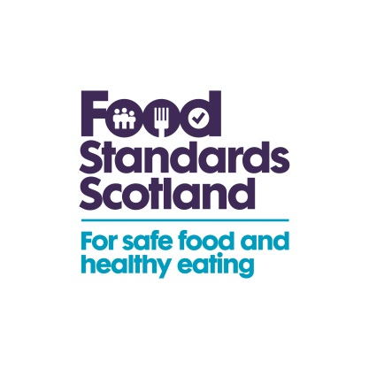 | T: 01224-285175  E: jacqueline.angus@fss.scot
To: Lead Food Officers
Cc: REHIS, CoSLA, SFELC

18 May 2015
FSS/ENF/15/004

Dear Colleague,

National Co-ordinated Food Sampling Programme in Scotland 2015/16

Food Standards Scotland (FSS) is making funding available to Scottish local authorities (singly or coordinated through liaison groups) for sampling and surveillance of food. I am writing to invite you to submit an application for funding to support the sampling programme. Applications must be received by 5pm on 12 June 2015. Any bid application should represent additional sampling over and above your own sampling programme.

This programme aims to provide a co-ordinated, risk-based approach for sampling, and covers both imported and UK-produced food, where relevant. Information on specific priorities for sampling is included in Annex A. These priorities were subject to a recent consultation. We strongly encourage collaboration between interested parties to ensure there is sufficient geographical spread and sample numbers which will result in valid outcomes, meeting the needs of FSS. We would be happy to attend a meeting of interested parties if that would be beneficial.

All parties applying for funding must use UK Food Surveillance System (UKFSS) to enable results to be available in real time, and to help ensure any necessary action is taken promptly.

Please do not include VAT in your bid figures as sample funding is outside the scope of VAT. If you have any queries about this, please do not hesitate to contact me (Jacqueline.angus@fss.scot, 01224 285175) or my colleague Lynne Reid (lynne.reid@fss.scot, 01224 285113).

Yours faithfully

Jacqui Angus
Food Standards Scotland

